Screen Change Examples

With UCSF’s new Chart of Account, “fund” will no longer be a valid means to search and “project ID” will be. From a user experience, we would like our end users not to be confused by the ability to search by fund. Change designated drop down values and labels in the online system to be configurable.

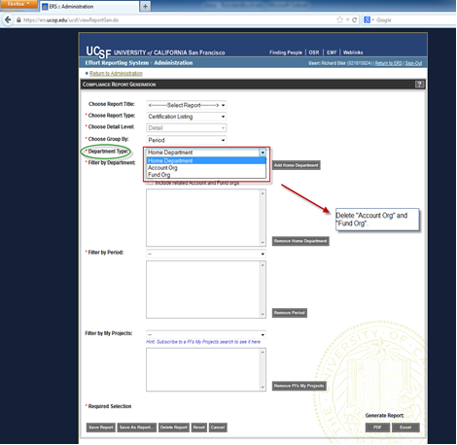

Compliance Report Generation: Make the values in the Department Type drop down list configurable

**Objects: ReportGenForm.java, CreateReportGenAction.javsa, ViewReportGenAction.java, viewReportGen.jspf**

**ERSConfig.xml**

<search-alternate-filter4-visible>true</search-alternate-filter4-visible>

**ViewReportGenAction.java**

searchAfilt4 = (String)session.getServletContext().getAttribute(ERSConstants.SEARCH_ALT_FILT4);

** need default value if tag is missing from ERSConfig.xml

**private** List<ListValueBean> getOrgTypeSelectList() {

List<ListValueBean> aList = **new** ArrayList<ListValueBean>();

ListValueBean bean1 = **new** ListValueBean();

**if** (!searchAfilt4.equals("true"))

{

bean1.setId(ERSConstants.*CR_ORG_TYPE_HOME_DEPT*);

bean1.setValue("Home Department");

aList.add(bean1);

ListValueBean bean2 = **new** ListValueBean();

bean2.setId(ERSConstants.*CR_ORG_TYPE_ACCT_ORG*);

bean2.setValue("Account Org") ;

aList.add(bean2);

}

ListValueBean bean3 = **new** ListValueBean();

bean3.setId(ERSConstants.*CR_ORG_TYPE_FUND_ORG*);

bean3.setValue("Fund Org");

aList.add(bean3);

**return** aList;

}

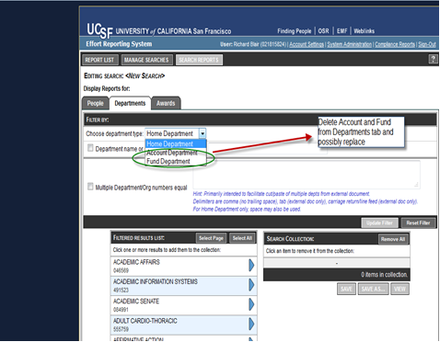

Search Reports>Department tab: Make the search values in the Choose Department Type drop down list configurable

Webroot > tiles > **definelist_filter_depts.jspf**

**Tiles-defs.xml**

<definition name="**filter_panel_depts**"

path="/tiles/**definelist_filter_depts.jspf**">

</definition>

<definition name="list.define.depts.page"

extends="list.define.page">

<put name="tab_context" value="departments" />

<put name="filter_panel" value="filter_panel_depts"

type="definition" />

<put name="search_list"

value="/tiles/definelist_list_depts.jspf" />

<put name="results_list"

value="/tiles/definelist_results_depts.jspf" />

</definition>

**definelist.jspf**

<c:when test="${tab_context == 'departments'}">

<tiles:insert definition="**filter_panel_depts**" />

</c:when>

**Struts-config.xml**

<action path="/defineRptListByDept" name="deptFilterForm"

scope="request" type="**edu.ucop.ers.struts.action.FilterByDept**">

<forward name="list.define.dept" path="list.define.depts.page" />

</action>

**definelist_filter_depts.jspf**

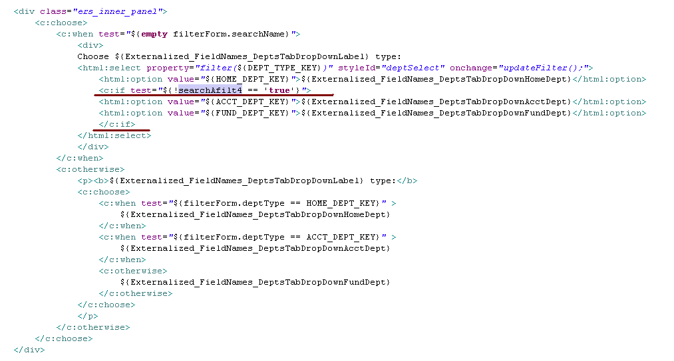

Search Report GUI Change Example:

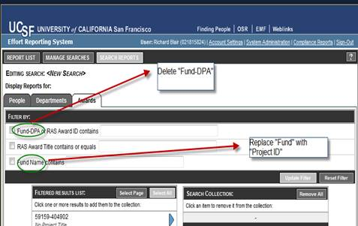

Search Reports>Awards tab: Make the ‘Filter By’ selections configurable

**UCSF to Change their externalized labels**

**ExternalizedStrings.xml**

<!-- labels for the search tabs -->

<PeopleTabLabel>People</PeopleTabLabel>

<DeptsTabLabel>Departments</DeptsTabLabel>

<DeptsTabDropDownLabel>department</DeptsTabDropDownLabel>

<DeptsTabDropDownHomeDept>Home Department</DeptsTabDropDownHomeDept>

<DeptsTabDropDownAcctDept>Account Department</DeptsTabDropDownAcctDept>

<DeptsTabDropDownFundDept>Fund Department</DeptsTabDropDownFundDept>

<DeptsTabFilterLabel>Department</DeptsTabFilterLabel>

<PrimaryTabLabel>Projects</PrimaryTabLabel>

🡺 **<PrimaryFilter1Label>Project ID</PrimaryFilter1Label>**

**🡺 <PrimaryFilter2Label>Project Name</PrimaryFilter2Label>**

**🡺 <PrimaryFilter3Label>Sponsor Award #</PrimaryFilter3Label>**

<AlternateTabLabel>Awards</AlternateTabLabel>

<AlternateFilter1Label>Campus Award #</AlternateFilter1Label>

<AlternateFilter2Label>Award Title</AlternateFilter2Label>

<AlternateFilter3Label>Sponsor Award #</AlternateFilter3Label>

definelist.jspf

<c:choose>

<c:when test=*"*${tab_context == 'departments'}*"*>

<tiles:insert definition=*"filter_panel_depts"* />

</c:when>

<c:when test=*"*${tab_context == 'funds'}*"*>

<tiles:insert definition=*"filter_panel_fau"* />

</c:when>

**<c:when test=*"*${tab_context == 'projects'}*"*>**

<tiles:insert definition=*"filter_panel_projects"* />

</c:when>

<c:when test=*"*${tab_context == 'altprojects'}*"*>

<tiles:insert definition=*"filter_panel_altprojects"* />

</c:when>

<c:when test=*"*${tab_context == 'people'}*"*>

<tiles:insert definition=*"filter_panel_people"* />

</c:when>

tiles-defs.xml

<definition name="filter_panel_projects"

path="/tiles/**definelist_filter_projects.jspf**">

</definition>

**definelist_filter_projects.jspf**

<div class=*"ers_inner_panel"*>

<html:checkbox property=*"filter(*${FILTER_BY_ID}*)"*

styleId=*"projIdCheck"* value=*"Y"* onclick=*"checkChange('projId');"*/>

<label for=*"projIdCheck"*>${**Externalized_FieldNames_PrimaryFilter1Label**}</label> contains

<html:text property=*"filter(*${PROJ_ID_KEY}*)"* styleId=*"projId"* style=*"width: 281px"* size=*"20"* onkeyup=*"fieldKey(event,this);"* />

</div>

<div class=*"ers_inner_panel"*>

<html:checkbox property=*"filter(*${FILTER_BY_NAME}*)"* styleId=*"projTitleCheck"*

value=*"Y"* onclick=*"checkChange('projTitle');"* />

<label for=*"projTitleCheck"*>${**Externalized_FieldNames_PrimaryFilter2Label**}</label> contains or equals&nbsp;

<html:text property=*"filter(*${PROJ_NAME_KEY}*)"* styleId=*"projTitle"*

style=*"width: 281px"* size=*"20"* onkeyup=*"fieldKey(event,this);"* />

</div>

<c:if test=*"*${searchPfilt3 == '**true**'}*"*>

<div class=*"ers_inner_panel ers_last_panel"*>

<html:checkbox property=*"filter(*${FILTER_BY_CONTRACT_ID}*)"* styleId=*"contractNumCheck"* value=*"Y"* onclick=*"checkChange('contractNum');"*/>

<labelfor=*"contractNumCheck"*>${**Externalized_FieldNames_PrimaryFilter3Label**}</label>

Contains

<html:text property=*"filter(*${CONTR_ID_KEY}*)"* styleId=*"contractNum"*

style=*"width: 281px"* size=*"20"* onkeyup=*"fieldKey(event,this);"* />

</div>

</c:if>

Add Permissions GUI

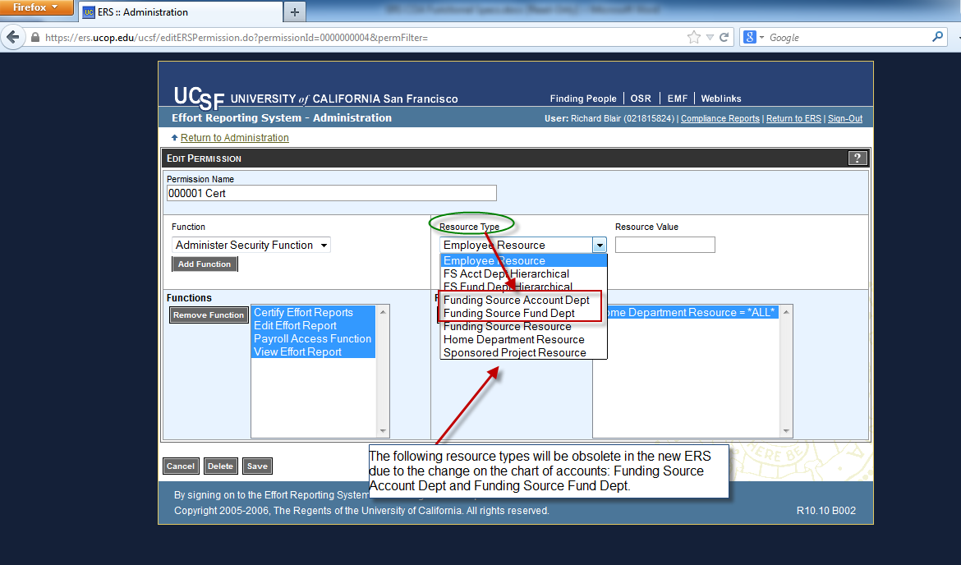

**Question: Will FS Fund Dept Hierarchical also be obsolete? YES**

**editERSPermission.jspf**

<table>

<tr>

<td class=*"small"*>Resource Type</td>

<td class=*"small"*>Resource Value</td>

</tr>

<tr>

<td>

**<html:select property=*"resourceTypeSelect"* styleId=*"resourceTypeList"*>**

**<html:optionsCollection property=*"resourceTypeList"***

**value=*"resTypeCd"* label=*"resTypeName"*/>**

**</html:select>**

</td>

<td>

<input type=*"text"* name=*"resourceValue"* id=*"resourceValue"*

style="width: *120px*" class=*"ers_field"* size=*"10"*

onfocus="hiliteField(this);" onblur="unHiliteField(this);"/>

</td>

**PermissionAdminAction.java**

**protected** List getResourceTypeList(HttpSession session) {

String searchAfilt4 = (String)session.getServletContext().getAttribute(ERSConstants.*SEARCH_ALT_FILT4*);

**if**(searchAfilt4==**null**) searchAfilt4="false";

List<String> omitReources = **new** ArrayList();

**if** (searchAfilt4.equals("true"))

{

omitReources.add("FS Acct Dept Hierarchical");

omitReources.add("FS Fund Dept Hierarchical");

omitReources.add("Funding Source Account Dept");

omitReources.add("Funding Source Fund Dept");

}

List<ResourceType> rtList = **null**;

ResourceTypeDAO rtdao = **new** ResourceTypeDAO();

rtList = rtdao.findAll();

// remove unwanted resources

Iterator it = omitReources.iterator();

**while**(it.hasNext())

{

String s1 = (String)it.next();

Iterator it2 = rtList.iterator();

**while**(it2.hasNext())

{

ResourceType rt = (ResourceType)it2.next();

String s2 = rt.getResTypeName();

**if** (s1.equals(s2))

it2.remove();

}

}

**if**(rtList != **null**)

GenericListSorter.*sortBy*("resTypeName", rtList, **false**);

**return** rtList;

}