First pass thru this document (steps 1-9) was completed in January 2018 by Gerry Mulligan and Larry Scott.
The ERS implementation priority was changed from UCSD to UCSB. This document (as is) was cloned and used as a starting point for the UCSB migration document. When ERS UCSD is implemented, compare this document to the ERS UCSB document to ensure completeness.

TO DO: Notice steps 7B, 7C, 7D deal with off quarter reporting. UCSD does not have off quarter reporting periods. 7B, 7C, and 7D should be adjusted accordingly.

Version Summary

Version | Date | Author | Description
1.1 | Feb 6 2018 | G Mulligan | Initial document – Copied from UCLA migration document and updated for DB2
 |  |  | Values in Step 7K need to be double-checked
1.2 | Feb 7, 2018 | LScott | Add step 7L - ‘Over The Cap’ and ‘Salary Cap’ to ERSEarnings table

This document provides step-by-step instructions to upgrade a DB2 ERS 10.12 B009 database to ERS 11.0 format. Due to dependencies, this document must be executed in the order presented. See related documents for IBM DB2 databases and Oracle databases.

Recommendation: Execute these database SQL commands individually and verify that each statement completes successfully before proceeding to the next statement. This is a longer, but more thorough approach. If statements are executed in blocks, it is easy to miss an error which may have a cascading (bad) effect as more SQL statements are executed.

Step 1: UCSD Database Upgrade Prerequisite
Before starting this database upgrade process, make sure your ERS instance is running at release level
ERS 10.12 B009 before proceeding with the following steps.

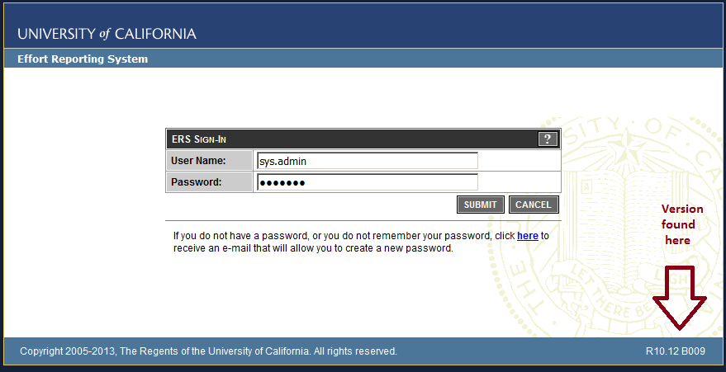

If needed, the UCOP ERS program support staff can provide a custom ERS upgrade script (eliminating the need to perform all interim releases) to get your database to ERS 10.12 B009 format.

Modified script, Converted script (DB2 - UCSD) - queried all keys on the table named in each statement below. See p:\PROJECTS\ers\sql use in dbvisualizer\ Select all from SYSCAT.TABCONST 05.txt
select distinct TC.tabname, TC.constname, TC.type, SKCU.colname
from sysCAT.tabconst TC
,sysibm.syskeycoluse SKCU
where TC.tabschema = TC.tabschema and TC.constname like SKCU.constname and TC.tabname = SKCU.tbname
and SKCU.tbcreator = 'GMULLIGA' and SKCU.constname like 'ERS%'
and SKCU.tbname = 'ERSUSER'

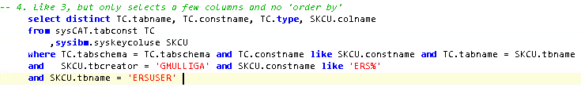

For example, running the above sql for the first ALTER statement returns this:
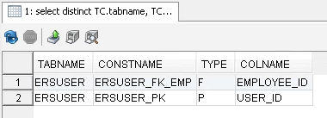

So I changed the constraint name in the first ALTER to ERSUser_FK_EMP
Original SQL Server: ALTER TABLE ERSUser DROP CONSTRAINT ERSUser_FK;
Modified for Db2: ALTER TABLE ERSUSER DROP CONSTRAINT ERSUser_FK_EMP;

Step 2: Employee Update from char(9) to varchar(11)

-- ALTER TABLE ERSUser DROP CONSTRAINT ERSUser_FK;
ALTER TABLE ERSUSER DROP CONSTRAINT ERSUser_FK_EMP;

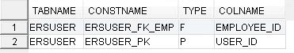

-- ALTER TABLE ERSPILOTPARTICIPANT DROP CONSTRAINT ERSPilotPart_FK_Emp;
ALTER TABLE ERSPILOTPARTICIPANT DROP CONSTRAINT ERSPilotPart_FK_E;

ERSPILOTPARTICIPANT also has a foreign key ERSPILOTPART_FK_RP on PERIOD_ID

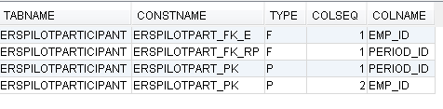

-- ALTER TABLE ERSPossibleER DROP CONSTRAINT ERSPossibleER_FK;
ALTER TABLE ERSPOSSIBLEER DROP CONSTRAINT ERS_PER_FK_EMP;

ERSPOSSIBLEER also has a foreign key ERS_PER_FK_RPT_PER on PERIOD_ID

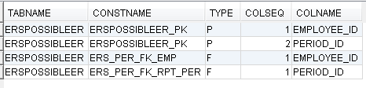

-- ALTER TABLE ERSPI DROP CONSTRAINT ERSPI_FK_EMP;
ALTER TABLE ERSPI DROP CONSTRAINT ERSPI_FK_EMP;

ERSPI also has a foreign key ERSPI_FK_SP on SP_ID
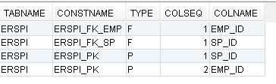
-- ALTER TABLE ERSLatePay DROP CONSTRAINT ERSLatePay_FK;
ALTER TABLE ERSLATEPAY DROP CONSTRAINT ERSLatePay_FK;

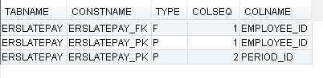

Dept&&
-- ALTER TABLE ERSOrgDept DROP CONSTRAINT ERSOrgDept_FK1
ALTER TABLE ERSORGDEPT DROP CONSTRAINT ERS_ORGDEPT_FK1
ERSORGDEPT also has a foreign key ERS_ORGDEPT_FK2 on DEPT_ID
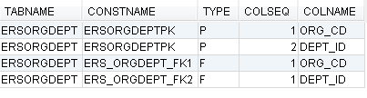

ALTER TABLE ERSLatePay_Temp DROP CONSTRAINT ERSLatePay_TEMP_FK; -- (might not exist)
Does not exist in UCSB
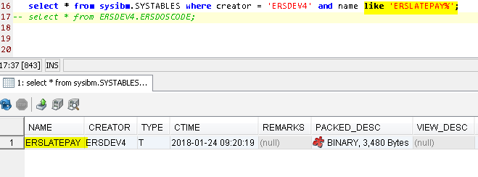

-- ALTER TABLE ERSExcludeUserToken DROP CONSTRAINT ERSExcludeUserToken_FK;
ALTER TABLE ERSEXCLUDEUSERTOKEN DROP CONSTRAINT ERS_EUTOKEN_FK_EMP;
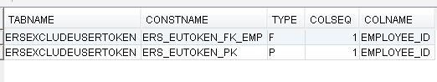

-- ALTER TABLE ERSEarnings DROP CONSTRAINT ERSEarnings_FK;
ALTER TABLE ERSEARNINGS DROP CONSTRAINT ERSEARN_FK_EMP;
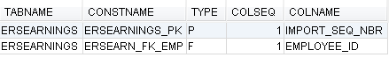

-- ALTER TABLE ERSCSEmpl DROP CONSTRAINT ERSCSEmpl_FK1;
ALTER TABLE ERSCSEMPL DROP CONSTRAINT ERSCSEMPL_FK_EMP;
ERSCSEMPL also has a foreign key ERSCSEMPL_FK_FS on FS_ID
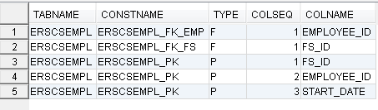

-- ALTER TABLE ERSCriteriaEmployee DROP CONSTRAINT ERSCriteriaEmployee_FK;
ALTER TABLE ERSCRITERIAEMPLOYEE DROP CONSTRAINT ERS_CE_FK_EMP;
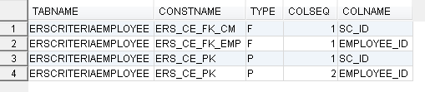

-- ALTER TABLE ERSEmpl DROP CONSTRAINT ERSEmpl_PK;
ALTER TABLE ERSEMPL DROP CONSTRAINT ERSEmpl_PK;

ERSEMPL also has a foreign key ERSEMPL_FK on DEPT_ID
ERSEMPL also has a foreign key ERSEMPL_FK1 on SCH_ID
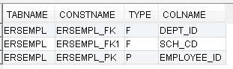

-- ALTER TABLE ERSEmpl ADD PPS_EMPLOYEE_ID CHAR(9);
ALTER TABLE ERSEMPL ADD PPS_EMPLOYEE_ID CHAR(9);
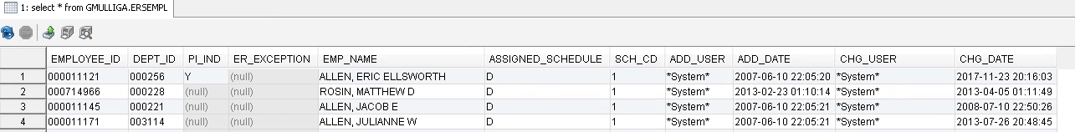

-- UPDATE ERSEmpl set pps_employee_id = employee_id;
UPDATE ERSEMPL set pps_employee_id = employee_id;

-- ALTER TABLE ERSEmpl ALTER COLUMN PPS_EMPLOYEE_ID CHAR(9) NOT NULL;
ALTER TABLE ERSEMPL ALTER COLUMN PPS_EMPLOYEE_ID SET DATA TYPE CHAR(9) NOT NULL;
- first had -104, then added 'SET DATA TYPE' but it will still fail cause of NOT NULL.
Must run a second command to SET NOT NULL like this:
ALTER TABLE ERSEMPL ALTER COLUMN EMPLOYEE_ID SET DATA TYPE varchar(11);
ALTER TABLE ERSEMPL ALTER COLUMN EMPLOYEE_ID SET NOT NULL;

-- ALTER TABLE ERSEmpl ALTER COLUMN EMP_NAME varchar(120);
ALTER TABLE ERSEMPL ALTER COLUMN EMP_NAME SET DATA TYPE varchar(120);
- first had -104, then added 'SET DATA TYPE' to make it work.

-- ALTER TABLE ERSEmpl ALTER COLUMN EMPLOYEE_ID varchar(11) not null;
ALTER TABLE ERSEMPL ALTER COLUMN EMPLOYEE_ID SET DATA TYPE varchar(11) not null;

- first had -104, then added 'SET DATA TYPE' but it will still fail cause of NOT NULL.
Must run a second command to SET NOT NULL like this:
ALTER TABLE ERSEMPL ALTER COLUMN EMPLOYEE_ID SET DATA TYPE varchar(11);
ALTER TABLE ERSEMPL ALTER COLUMN EMPLOYEE_ID SET NOT NULL;

-- DROP INDEX ERSEarnings.ERSEARNINGS_IDX
DROP INDEX ERSEARNINGS_IDX

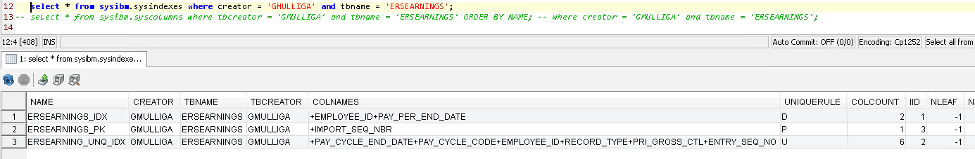

-- DROP INDEX ERSEarnings. ERSEARNINGS_UNIQUE_IDX
DROP INDEX ERSEARNING_UNQ_IDX

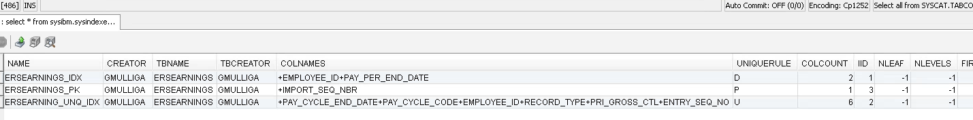

-- ALTER TABLE ERSEarnings ALTER COLUMN Employee_ID varchar(11);
ALTER TABLE ERSEARNINGS ALTER COLUMN Employee_ID SET DATA TYPE varchar(11);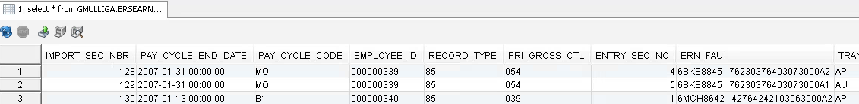

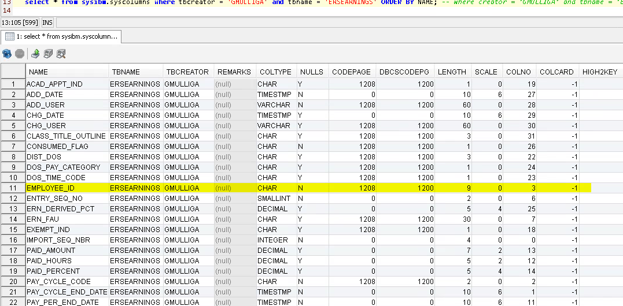

--CREATE NONCLUSTERED INDEX ERSEARNINGS_IDX
-- ON ERSEarnings (Employee_ID ASC, Pay_Per_End_Date ASC);

CREATE INDEX ERSEARNINGS_IDX
ON ERSEARNINGS (Employee_ID ASC, Pay_Per_End_Date ASC);

1/29/2018:
1. We ran this:
-- CREATE INDEX ERSEARNINGS_IDX
ON ERSEARNINGS (Employee_ID ASC, Pay_Per_End_Date ASC);
At first it failed with SQLCODE -668, SQLSTATE 50716 running

2. Larry remembered he had previously had to run REORG before it would let him create indexes. So
we ran this:
CALL SYSPROC.ADMIN_CMD ('REORG TABLE ERSEARNINGS');
It ran for 3-4 minutes and returned successfully.

3. We ran:
CREATE INDEX ERSEARNINGS_IDX
ON ERSEARNINGS (Employee_ID ASC, Pay_Per_End_Date ASC);
That ran for a few minutes, then finished successfully
We resumed here on Tuesday 1/30:

-- ALTER TABLE ERSCSEmpl DROP CONSTRAINT ERSCSEmpl_PK
ALTER TABLE ERSCSEMPL DROP CONSTRAINT ERSCSEmpl_PK
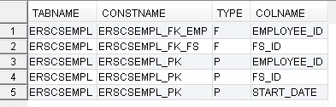

-- ALTER TABLE ERSCSEmpl ALTER COLUMN EMPLOYEE_ID varchar(11) NOT NULL;
GM: This threw a 07:17:30 [ALTER - 0 row(s), 0.000 secs] [Error Code: -104, SQL State: 42601] DB2 SQL error: SQLCODE: -104, SQLSTATE: 42601, SQLERRMC: ALTER TABLE ERSCSEMPL ALTER COLUM;BEGIN-OF-STATEMENT;<create_variable>

Fixed by separating into two statements:

ALTER TABLE ERSCSEMPL ALTER COLUMN EMPLOYEE_ID SET DATA TYPE varchar(11);
ALTER TABLE ERSCSEMPL ALTER COLUMN EMPLOYEE_ID SET NOT NULL;

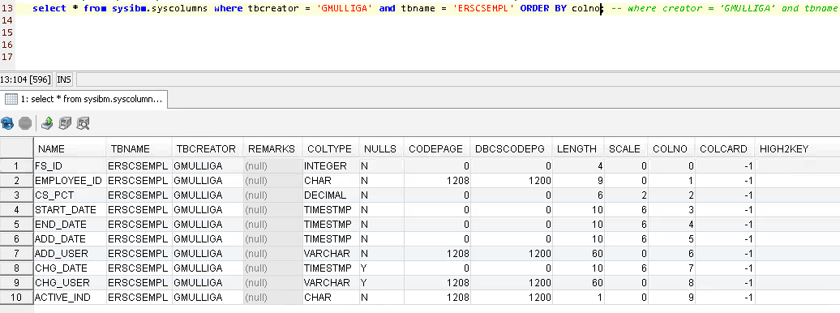

-- ALTER TABLE ERSCSEmpl ADD CONSTRAINT ERSCSEmpl_PK
-- PRIMARY KEY NONCLUSTERED (FS_ID ASC, Employee_ID ASC, Start_Date ASC)

ALTER TABLE ERSCSEMPL ADD CONSTRAINT ERSCSEmpl_PK
PRIMARY KEY NONCLUSTERED (FS_ID ASC, Employee_ID ASC, Start_Date ASC)

GM: failed with 7:20:26 [ALTER - 0 row(s), 0.000 secs] [Error Code: -104, SQL State: 42601] DB2 SQL error: SQLCODE: -104, SQLSTATE: 42601, SQLERRMC: NONCLUSTERED;SEmpl_PK
42601 is often a syntax error. Earlier we fixed a SQLCODE: -104, SQLSTATE: 42601 by splitting the operation into two commands, the second being SET NOT NULL

ERSCSEMPL_PK still exists in my GMULLIGA data base, so maybe that's the error.

Fixed by reorg'ing it first!

Here's what worked

ALTER TABLE ERSCSEMPL ADD CONSTRAINT ERSCSEMPL_PK
PRIMARY KEY (FS_ID, EMPLOYEE_ID, START_DATE)

https://www.ibm.com/support/knowledgecenter/en/SSEPGG_10.5.0/com.ibm.db2.luw.admin.dbobj.doc/doc/c0061098.html
Index architectures are classified as clustered or non-clustered.
Clustered indexes are indexes whose order of the rows in the data pages corresponds to the order of the rows in the index.
This order is why only one clustered index can exist in any table, whereas, many non-clustered indexes can exist in the table.
In some database systems, the leaf node of the clustered index corresponds to the actual data, not a pointer to data that is found elsewhere.

Both clustered and non-clustered indexes contain only keys and record identifiers in the index structure.
The record identifiers always point to rows in the data pages. With clustered indexes, the database manager attempts
keep the data in the data pages in the same order as the corresponding keys in the index pages.
Thus the database manager attempts to insert rows with similar keys onto the same pages. If the table is reorganized,
data is inserted into the data pages in the order of the index keys. The database manager does not maintain any order
of the data when compared to the order of the corresponding keys of a non-clustered index.

-- ALTER TABLE ERSUser ALTER COLUMN EMPLOYEE_ID varchar(11);
ALTER TABLE ERSUSER ALTER COLUMN EMPLOYEE_ID SET DATA TYPE varchar(11);
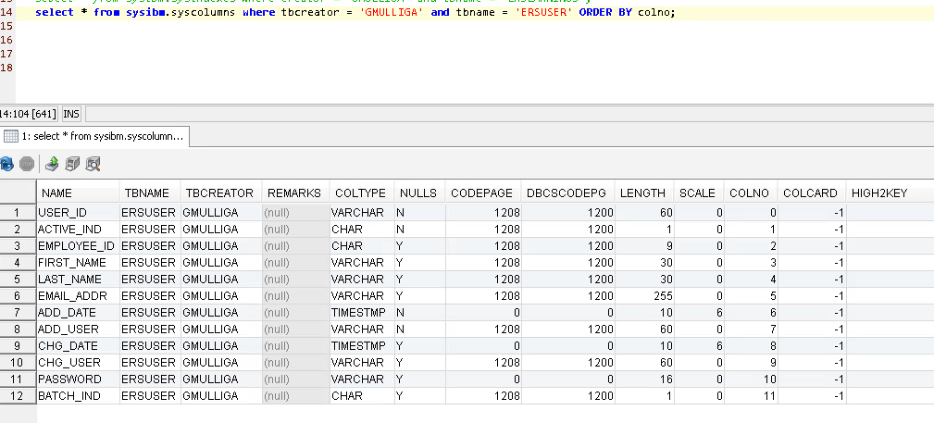

-- ALTER TABLE ERSCriteriaEmployee DROP CONSTRAINT ERSCriteriaEmployee_PK
ALTER TABLE ERSCRITERIAEMPLOYEE DROP CONSTRAINT ERS_CE_PK

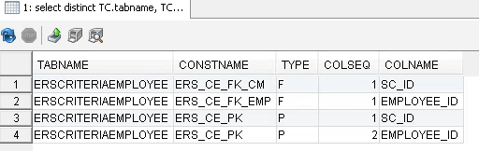

-- ALTER TABLE ERSCriteriaEmployee ALTER COLUMN EMPLOYEE_ID varchar(11) NOT NULL;
ALTER TABLE ERSCRITERIAEMPLOYEE ALTER COLUMN EMPLOYEE_ID SET DATA TYPE varchar(11);
ALTER TABLE ERSCRITERIAEMPLOYEE ALTER COLUMN EMPLOYEE_ID SET NOT NULL;

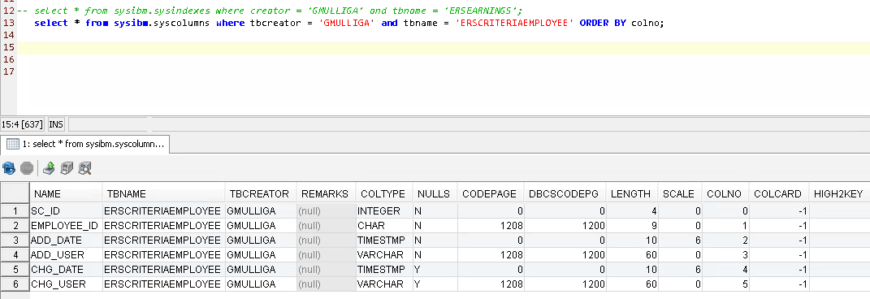

-- ALTER TABLE ERSCriteriaEmployee ADD CONSTRAINT ERSCriteriaEmployee_PK
-- PRIMARY KEY NONCLUSTERED (SC_ID ASC, Employee_ID)

ALTER TABLE ERSCRITERIAEMPLOYEE ADD CONSTRAINT ERS_CE_PK
PRIMARY KEY NONCLUSTERED (SC_ID ASC, Employee_ID)

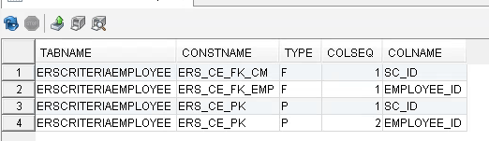

GM: ran it as shown above:
failed with 07:50:18 [ALTER - 0 row(s), 0.000 secs] [Error Code: -104, SQL State: 42601] DB2 SQL error: SQLCODE: -104, SQLSTATE: 42601, SQLERRMC: NONCLUSTERED;yee_PK
PRIMARY KEY;<space>42601 is often a syntax error. Earlier we fixed a SQLCODE: -104, SQLSTATE: 42601 by splitting the operation into two commands, the second being SET NOT NULL

42601 | A character, token, or clause is invalid or missing.

Then we deleted the NONCLUSTERED and the ASC args, reran it, and got a different error

[Error Code: -668, SQL State: 57016] DB2 SQL error: SQLCODE: -668, SQLSTATE: 57016, SQLERRMC: 7;ERSDEV2.ERSCRITERIAEMPLOYEE

n DB2, you may face this error. This error means that the access to the table is restricted. Do not be worry if you see this error because it may happen after the ALTER TABLE DROP COLUMN command.
In order to fix this error, you need to run the REORG command as follows:
REORG TABLE [YOUR_TABLE_NAME]
After running this command, you will be able to access the table.

So we ran the reorg
CALL SYSPROC.ADMIN_CMD ('REORG TABLE ERSCRITERIAEMPLOYEE');
Then reran:
ALTER TABLE ERSCRITERIAEMPLOYEE ADD CONSTRAINT ERS_CE_PK
PRIMARY KEY (SC_ID , Employee_ID)
Result? It worked.

Existing PK is being dropped because it contains employee id.

-- ALTER TABLE ERSLatePay DROP CONSTRAINT ERSLatePay_PK
ALTER TABLE ERSLATEPAY DROP CONSTRAINT ERSLatePay_PK
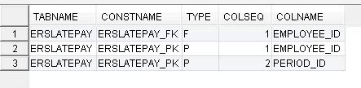

-- ALTER TABLE ERSLatePay ALTER COLUMN EMPLOYEE_ID varchar(11) NOT NULL;

ALTER TABLE ERSLATEPAY ALTER COLUMN EMPLOYEE_ID SET DATA TYPE varchar(11);
ALTER TABLE ERSLATEPAY ALTER COLUMN EMPLOYEE_ID SET NOT NULL;
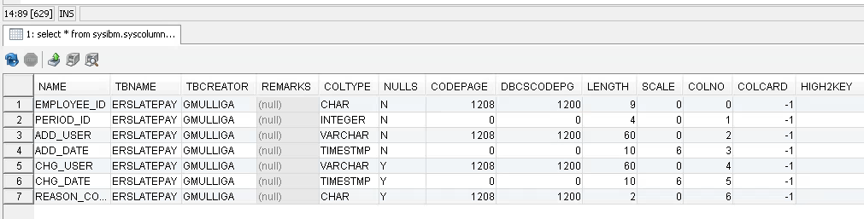

Step 2 (continued): Employee Update from char(9) to varchar(11)

-- ALTER TABLE ERSLatePay ADD CONSTRAINT ERSLatePay_PK PRIMARY KEY(Employee_ID,Period_ID)
ALTER TABLE ERSLATEPAY ADD CONSTRAINT ERSLATEPAY_PK PRIMARY KEY(Employee_ID,Period_ID)

GM: failed with 57016 - needs reorg
[Error Code: -668, SQL State: 57016] DB2 SQL error: SQLCODE: -668, SQLSTATE: 57016, SQLERRMC: 7;ERSDEV2.ERSCRITERIAEMPLOYEE

After the reorg, reran it and it worked.
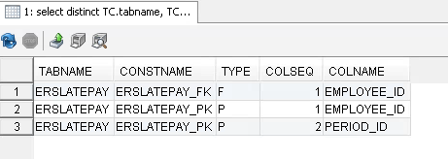

-- ALTER TABLE ERSPI DROP CONSTRAINT ERSPI_PK
ALTER TABLE ERSPI DROP CONSTRAINT ERSPI_PK
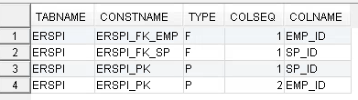

-- ALTER TABLE ERSPI ALTER COLUMN EMP_ID varchar(11) NOT NULL;
ALTER TABLE ERSPI ALTER COLUMN EMP_ID SET DATA TYPE varchar(11) ;
ALTER TABLE ERSPI ALTER COLUMN EMP_ID SET NOT NULL;

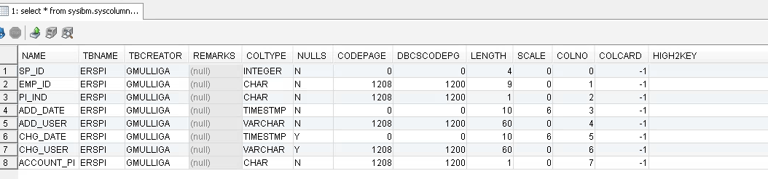

resumed here on Wednesday 1/31:

-- ALTER TABLE ERSPI ADD CONSTRAINT ERSPI_PK PRIMARY KEY (SP_ID, Emp_ID)
ALTER TABLE ERSPI ADD CONSTRAINT ERSPI_PK PRIMARY KEY (SP_ID, Emp_ID)

GM: This 'ALTER TABLE XXX ADD CONSTRAINT YYY' fails for a different reason than the previous one:
42889 | The table already has a primary key.

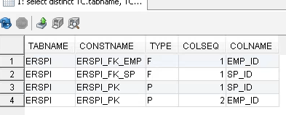

-- ALTER TABLE ERSExcludeUserToken DROP CONSTRAINT ERSExcludeUserToken_PK
ALTER TABLE ERSEXCLUDEUSERTOKEN DROP CONSTRAINT ERS_EUToken_PK

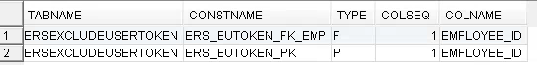

-- ALTER TABLE ERSExcludeUserToken ALTER COLUMN EMPLOYEE_ID varchar(11) not null;
ALTER TABLE ERSEXCLUDEUSERTOKEN ALTER COLUMN EMPLOYEE_ID SET DATA TYPE varchar(11);
ALTER TABLE ERSEXCLUDEUSERTOKEN ALTER COLUMN EMPLOYEE_ID SET NOT NULL;

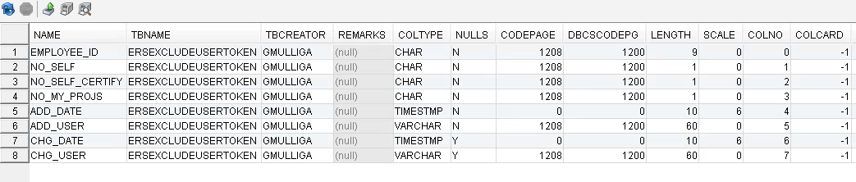

-- ALTER TABLE ERSExcludeUserToken ADD CONSTRAINT ERSExcludeUserToken_PK
-- PRIMARY KEY NONCLUSTERED (Employee_ID ASC)

ALTER TABLE ERSEXCLUDEUSERTOKEN ADD CONSTRAINT ERS_ERSEUTOKEN_PK
PRIMARY KEY NONCLUSTERED (Employee_ID ASC)
42601 | A character, token, or clause is invalid or missing.
1. Removed NONCLUSTERED and ran again: received 42601 again
2. Removed both NONCLUSTERED and ACS ran again: received 57016
3. Ran Reorg.
4. Ran as in 2 above: WORKED!

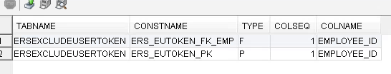

-- DROP INDEX ERSActualER.ERS_AER_UNIQ
DROP INDEX ERS_AER_UNQ

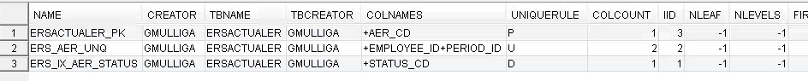

-- ALTER TABLE ERSActualER ALTER COLUMN Employee_ID varchar(11) not null;
ALTER TABLE ERSACTUALER ALTER COLUMN Employee_ID SET DATA TYPE varchar(11);
ALTER TABLE ERSACTUALER ALTER COLUMN Employee_ID SET NOT NULL;

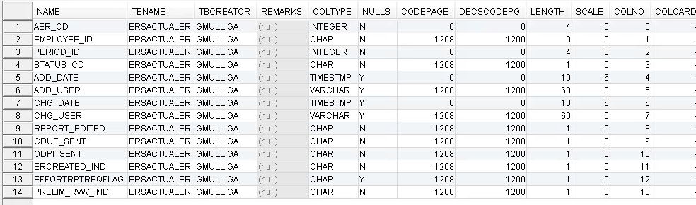

-- CREATE UNIQUE NONCLUSTERED INDEX ERS_AER_UNIQ ON ERSActualER( employee_id, period_id );
CREATE UNIQUE NONCLUSTERED INDEX ERS_AER_UNQ ON ERSACTUALER( employee_id, period_id );

GM: As constituted above, it failed with:
42601 | A character, token, or clause is invalid or missing.

But it worked after removing the NONCLUSTERED:
CREATE UNIQUE INDEX ERS_AER_UNQ ON ERSACTUALER( employee_id, period_id );

NONCLUSTERED is the default in DB2. Its presence will cause the command to fail so remove NONCLUSTERED.

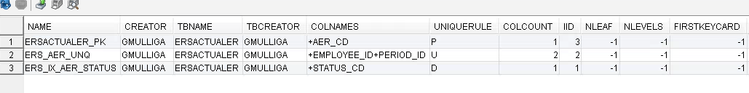

-- ALTER TABLE ERSIncludeEmpl DROP CONSTRAINT ERSIncludeEmpl_PK
ALTER TABLE ERSINCLUDEEMPL DROP CONSTRAINT ERSINCLUDEEMPL_PK
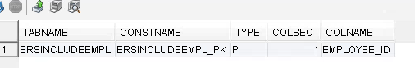

- ALTER TABLE ERSIncludeEmpl ALTER COLUMN Employee_ID varchar(11) not null;
ALTER TABLE ERSINCLUDEEMPL ALTER COLUMN Employee_ID SET DATA TYPE varchar(11);
ALTER TABLE ERSINCLUDEEMPL ALTER COLUMN Employee_ID SET not null;

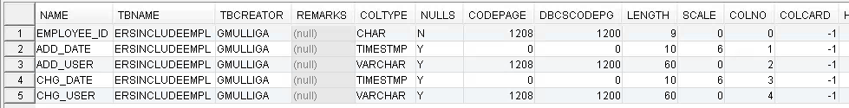

-- ALTER TABLE ERSIncludeEmpl ADD CONSTRAINT ERSIncludeEmpl_PK
-- PRIMARY KEY NONCLUSTERED (Employee_ID ASC)

1. Ran the following; rec'd 42601:
ALTER TABLE ERSIncludeEmpl ADD CONSTRAINT ERSIncludeEmpl_PK
PRIMARY KEY NONCLUSTERED (Employee_ID ASC)

2. Removed NONCLUSTERED and ran again: received 42601 again
ALTER TABLE ERSIncludeEmpl ADD CONSTRAINT ERSIncludeEmpl_PK
PRIMARY KEY (Employee_ID ASC)

3. Removed both NONCLUSTERED and ACS ran again: received 57016
ALTER TABLE ERSIncludeEmpl ADD CONSTRAINT ERSIncludeEmpl_PK
PRIMARY KEY (Employee_ID)

4. Ran Reorg.
5. Ran as in 2 above: WORKED!
-- ALTER TABLE ERSPIEmplTank DROP CONSTRAINT ERSPIEmplTank_PK
ALTER TABLE ERSPIEMPLTANK DROP CONSTRAINT ERSPIEmplTank_PK

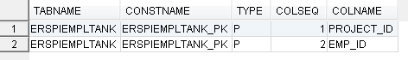

-- ALTER TABLE ERSPIEmplTank ALTER COLUMN Emp_ID varchar(11) not null;

ALTER TABLE ERSPIEMPLTANK ALTER COLUMN Emp_ID SET DATA TYPE varchar(11);
ALTER TABLE ERSPIEMPLTANK ALTER COLUMN Emp_ID SET not null;

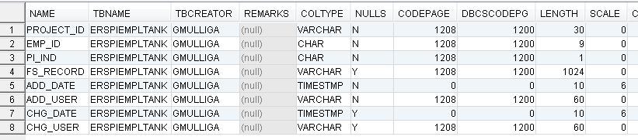

-- ALTER TABLE ERSPIEmplTank ADD CONSTRAINT ERSPIEmplTank_PK PRIMARY KEY NONCLUSTERED (Project_ID ASC, Emp_ID)

ALTER TABLE ERSPIEmplTank ADD CONSTRAINT ERSPIEmplTank_PK PRIMARY KEY NONCLUSTERED (Project_ID ASC, Emp_ID)

1. Ran as shown above and rec'd 42601.
2. Removed ASC, reran, and still rec'd 42601.
3. Removed NONCLUSTERED, reran, and got 57016.
4. Regorg'd and reran as shown in 3, and IT WORKED!

-- ALTER TABLE ERSPilotParticipant DROP CONSTRAINT ERSPilotPart_PK
ALTER TABLE ERSPILOTPARTICIPANT DROP CONSTRAINT ERSPilotPart_PK

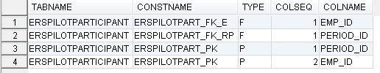

-- ALTER TABLE ERSPilotParticipant ALTER COLUMN emp_id varchar(11) not null;

ALTER TABLE ERSPILOTPARTICIPANT ALTER COLUMN emp_id SET DATA TYPE varchar(11);
ALTER TABLE ERSPILOTPARTICIPANT ALTER COLUMN emp_id SET not null;

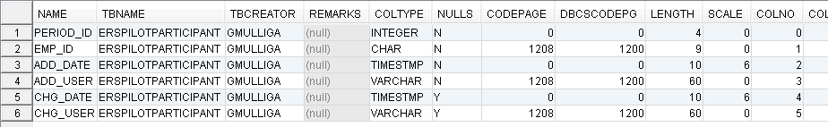

-- ALTER TABLE ERSPilotParticipant ADD CONSTRAINT ERSPilotPart_PK
-- PRIMARY KEY NONCLUSTERED (period_id, Emp_ID)

ALTER TABLE ERSPILOTPARTICIPANT ADD CONSTRAINT ERSPilotPart_PK
PRIMARY KEY NONCLUSTERED (period_id, Emp_ID)

GM: failed with 42601

42601 | A character, token, or clause is invalid or missing.

1. Removed NONCLUSTERED and reran as shown next:

ALTER TABLE ERSPILOTPARTICIPANT ADD CONSTRAINT ERSPilotPart_PK
PRIMARY KEY (period_id, Emp_ID)

Rec'd 57016

2. Reorg'd, and reran as shown in 1, and it worked.

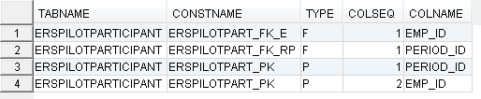

resumed here on Thursday 2/1

-- ALTER TABLE ERSEMPL ADD CONSTRAINT ERSEmpl_PK PRIMARY KEY(Employee_ID);
ALTER TABLE ERSEmpl ADD CONSTRAINT ERSEmpl_PK PRIMARY KEY(Employee_ID);

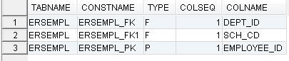

-- ALTER TABLE ERSCSEmpl ADD CONSTRAINT ERSCSEmpl_fk_emp
-- FOREIGN KEY (Employee_ID) REFERENCES ERSEmpl (Employee_ID);

ALTER TABLE ERSCSEMPL ADD CONSTRAINT ERSCSEmpl_fk_emp
FOREIGN KEY (Employee_ID) REFERENCES ERSEmpl (Employee_ID);

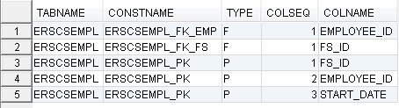

-- ALTER TABLE ERSCriteriaEmployee ADD CONSTRAINT ERS_CE_FK_EMP
-- FOREIGN KEY (Employee_ID) REFERENCES ERSEmpl (Employee_ID);

ALTER TABLE ERSCRITERIAEMPLOYEE ADD CONSTRAINT ERS_CE_FK_EMP
FOREIGN KEY (Employee_ID) REFERENCES ERSEmpl (Employee_ID);

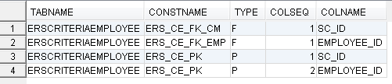

Step 2 (continued): Employee Update from char(9) to varchar(11)

-- ALTER TABLE ERSLatePay ADD CONSTRAINT ERSLatePay_FK
-- FOREIGN KEY (Employee_ID) REFERENCES ERSEmpl (Employee_ID);

ALTER TABLE ERSLATEPAY ADD CONSTRAINT ERSLatePay_FK
FOREIGN KEY (Employee_ID) REFERENCES ERSEmpl (Employee_ID);

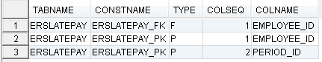

-- ALTER TABLE ERSExcludeUserToken ADD CONSTRAINT ERS_EUTOKEN_FK_EMP
-- FOREIGN KEY (EMPLOYEE_ID) REFERENCES ERSEmpl (Employee_ID);

ALTER TABLE ERSEXCLUDEUSERTOKEN ADD CONSTRAINT ERS_EUTOKEN_FK_EMP
FOREIGN KEY (EMPLOYEE_ID) REFERENCES ERSEmpl (Employee_ID);

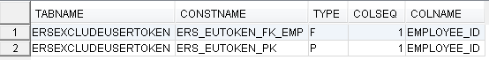

-- ALTER TABLE ERSPilotParticipant ADD CONSTRAINT ERSPilotPart_FK_E
-- FOREIGN KEY (EMP_ID) REFERENCES ERSEmpl (Employee_ID);

ALTER TABLE ERSPILOTPARTICIPANT ADD CONSTRAINT ERSPilotPart_FK_E
FOREIGN KEY (EMP_ID) REFERENCES ERSEmpl (Employee_ID);

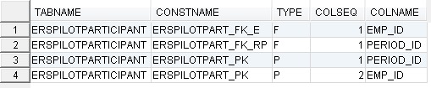

-- ALTER TABLE ERSPI ADD CONSTRAINT ERSPI_FK_EMP FOREIGN KEY (EMP_ID)
-- REFERENCES ERSEmpl (Employee_ID);

ALTER TABLE ERSPI ADD CONSTRAINT ERSPI_FK_EMP FOREIGN KEY (EMP_ID)
REFERENCES ERSEmpl (Employee_ID);

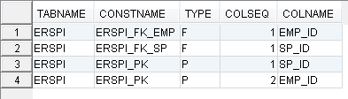

-- ALTER TABLE ERSUser ADD CONSTRAINT ERSUser_fk_emp
-- FOREIGN KEY (Employee_ID) REFERENCES ERSEmpl (Employee_ID);

ALTER TABLE ERSUSER ADD CONSTRAINT ERSUser_fk_emp
FOREIGN KEY (Employee_ID) REFERENCES ERSEmpl (Employee_ID);

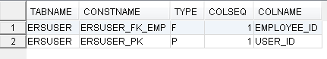

-- ALTER TABLE ERSEarnings ADD CONSTRAINT ERSEarn_FK_emp
-- FOREIGN KEY (Employee_ID) REFERENCES ERSEmpl (Employee_ID);

ALTER TABLE ERSEARNINGS ADD CONSTRAINT ERSEarn_FK_emp
FOREIGN KEY (Employee_ID) REFERENCES ERSEmpl (Employee_ID);

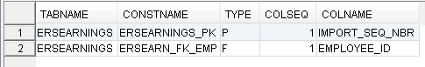

Step3: Supplemental Employee Updates
-- DROP INDEX ERSArchivedReport.ersar_eid
DROP INDEX ERSARCHIVEDREPORT_INDEX2

Gm: The original index name contained 'eid', which may stand for Employee ID, so I selected ERSARCHIVEDREPORT_INDEX2.

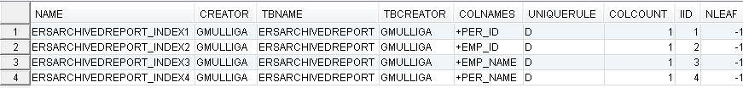

-- ALTER TABLE ERSArchivedReport ALTER COLUMN EMP_ID varchar(11) not null;

ALTER TABLE ERSARCHIVEDREPORT ALTER COLUMN EMP_ID SET DATA TYPE varchar(11);
ALTER TABLE ERSARCHIVEDREPORT ALTER COLUMN EMP_ID SET NOT NULL;

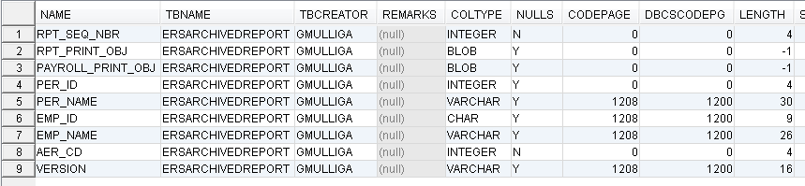

-- CREATE INDEX ersar_eid ON ERSArchivedReport( emp_id )
CREATE INDEX ERSARCHIVEDREPORT_INDEX2 ON ERSArchivedReport( emp_id )

Step 4: Clean Employee IDs
-- update ersempl set employee_id=ltrim(employee_id)
update ERSEMPL set employee_id=trim(employee_id) (Note this is trim and that's all we need)

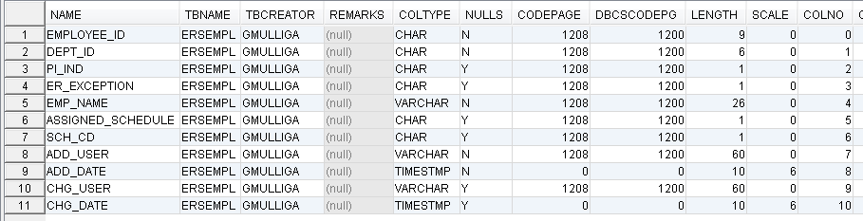

Any other tables ? TBD for GM

GM: Since many of the changes are to convert empl_id from 9 char to 11 varchar, here are all the tables containing cols like '%EMP%' and also of length = 9.

a. GMULLIGA - after loading & before running migration script. Tables known to be in this script's commands statements are highlighted

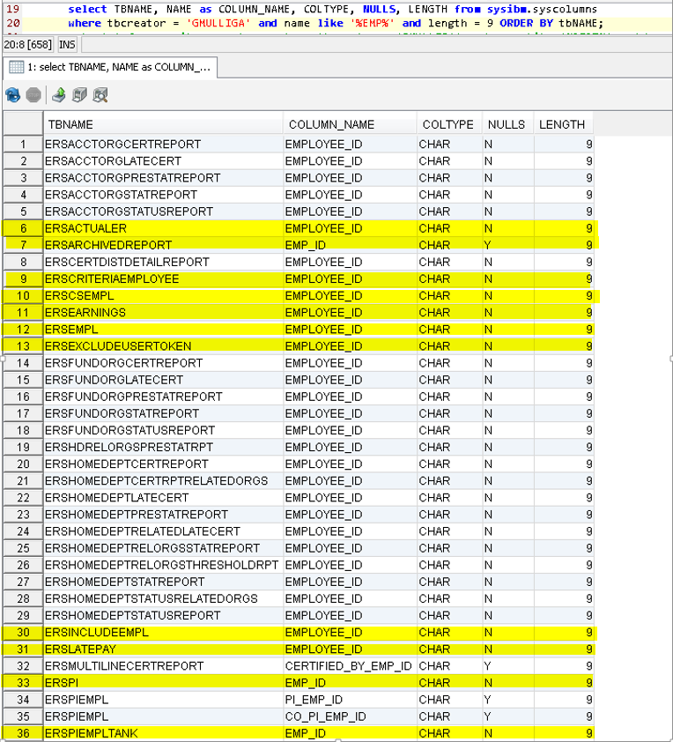
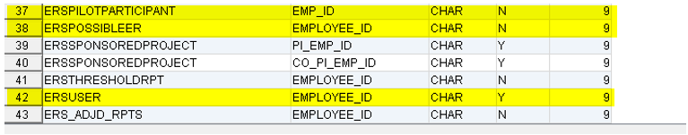

b. ERSDEV2 - After migration script. Many tables that weren't operated on by the script are now gone from the list. Need to ask Slava to load ERSDEV2 again and see if they reappear in the list.

Step 5: Home Department Updates
Home Department Update char(6) to varchar(10)
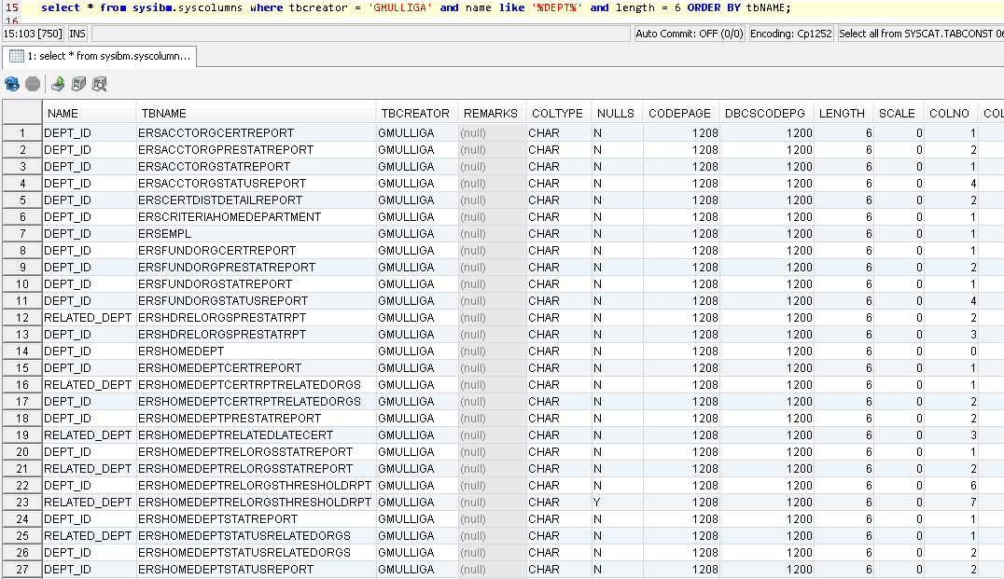

DB2: Execute DB2 Scripts in this order (SQL Server script below is more thorough)

-- ALTER TABLE ERSHOMEDEPT DROP CONSTRAINT ERSHomeDept_PK;
ALTER TABLE ERSHOMEDEPT DROP CONSTRAINT ERSHomeDept_PK;
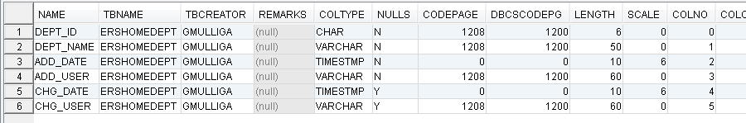

-- ALTER TABLE ERSHOMEDEPT ALTER COLUMN DEPT_ID SET DATA TYPE varchar(10);
ALTER TABLE ERSHOMEDEPT ALTER COLUMN DEPT_ID SET DATA TYPE varchar(10);

-- ALTER TABLE ERSHOMEDEPT ADD CONSTRAINT ERSHomeDept_PK PRIMARY KEY(DEPT_ID);
ALTER TABLE ERSHOMEDEPT ADD CONSTRAINT ERSHomeDept_PK PRIMARY KEY(DEPT_ID);

CALL SYSPROC.ADMIN_CMD ('REORG TABLE ERSHOMEDEPT ');

1/29/2018:
1. We ran this:
-- CREATE INDEX ERSEARNINGS_IDX ON ERSEARNINGS (Employee_ID ASC, Pay_Per_End_Date ASC);
It failed with SQLCODE -668, SQLSTATE 50716 running

2. Larry remembered he had previously had to run REORG before it would let him create indexes. So
we ran this:
CALL SYSPROC.ADMIN_CMD ('REORG TABLE ERSEARNINGS');
It ran for 3-4 minutes and returned successfully.

3. We ran:
CREATE INDEX ERSEARNINGS_IDX ON ERSEARNINGS (Employee_ID ASC, Pay_Per_End_Date ASC);
That ran for a few minutes, then finished successfully

-- ALTER TABLE ERSCriteriaHomeDepartment ALTER COLUMN DEPT_ID SET DATA TYPE varchar(10);
ALTER TABLE ERSCRITERIAHOMEDEPARTMENT ALTER COLUMN DEPT_ID SET DATA TYPE varchar(10);

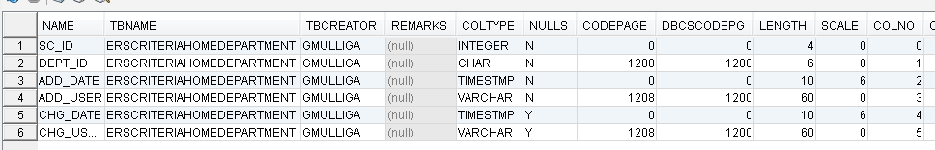

CALL SYSPROC.ADMIN_CMD ('REORG TABLE ERSCriteriaHomeDepartment ');

-- ALTER TABLE ERSSchDept ALTER COLUMN DEPT_ID SET DATA TYPE varchar(10);
ALTER TABLE ERSSCHDEPT ALTER COLUMN DEPT_ID SET DATA TYPE varchar(10);
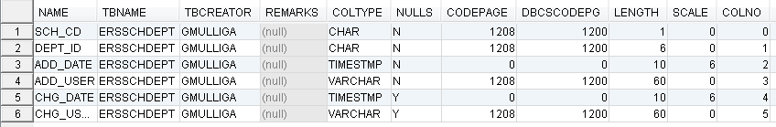

CALL SYSPROC.ADMIN_CMD ('REORG TABLE ERSSchDept ');

-- ALTER TABLE ERSEmpl ALTER COLUMN DEPT_ID SET DATA TYPE varchar(10);
ALTER TABLE ERSEMPL ALTER COLUMN DEPT_ID SET DATA TYPE varchar(10);
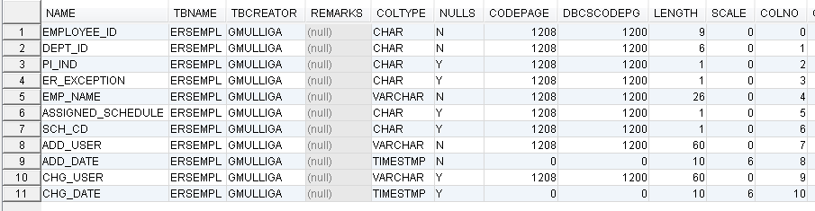

CALL SYSPROC.ADMIN_CMD ('REORG TABLE ERSEmpl ');
-- ALTER TABLE ERSORGDEPT ALTER COLUMN DEPT_ID SET DATA TYPE varchar(10);
ALTER TABLE ERSORGDEPT ALTER COLUMN DEPT_ID SET DATA TYPE varchar(10);

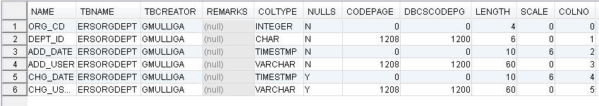

CALL SYSPROC.ADMIN_CMD ('REORG TABLE ERSORGDEPT ');

MS SQL SERVER: Execute Microsoft SQL Server Scripts in this order

-- ALTER TABLE ERSCriteriaHomeDepartment DROP CONSTRAINT ERSCriteriaHomeDepartment_PK
ALTER TABLE ERSCRITERIAHOMEDEPARTMENT DROP CONSTRAINT ERS_CHD_PK

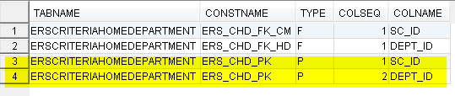
GM: the PK has two columns, SC_ID and DEPT_ID. Both should be dropped before DEPT_ID can be expanded Dropping the constraint will drop the composite key.

-- ALTER TABLE ERSCriteriaHomeDepartment DROP CONSTRAINT ERSCriteriaHomeDepartment_FK
ALTER TABLE ERSCRITERIAHOMEDEPARTMENT DROP CONSTRAINT ERS_CHD_FK_HD

GM: Yes, drop the constraint on DEPT_ID and add it back later.

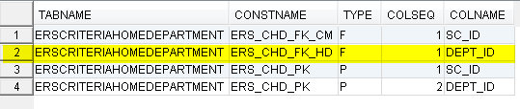

-- ALTER TABLE ERSOrgDept DROP CONSTRAINT ERSOrgDept_PK
ALTER TABLE ERSORGDEPT DROP CONSTRAINT ERSORGDEPTPK

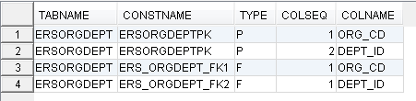

GM: The existing PK is named ERSORGDEPTPK

-- ALTER TABLE ERSOrgDept DROP CONSTRAINT ERSOrgDept_FK1
ALTER TABLE ERSORGDEPT DROP CONSTRAINT ERS_OrgDept_FK2

GM: there are two FKs, one on ORG_CD and one on DEPT_ID. This one is on DEPT_ID, constraint is named ERS_ORGDEPT_FK2. But FK2 was already dropped on approx. p 9, so this is redundant and no need to run. Skip.

Also UCSD's ERS_ORGDEPT_FK1 is on ORG_CD so maybe it doesn’t need to be dropped since UCPath may not be changing ORG_CD.

TBD Don’t run this page. It was already deleted earlier. Additionally, we only want to delete FK2 (DEPT) not FK1 (ORG), so removed the FK1 drops

--ALTER TABLE ERSOrgDept DROP CONSTRAINT ERSOrgDept_FK1 -- Already removed in Step2 but ORG_CD isn’t changing for Path so ORG_CD constraints should stay.

-- ALTER TABLE ERSEmpl DROP CONSTRAINT ERSEmpl_FK
ALTER TABLE ERSEMPL DROP CONSTRAINT ERSEmpl_FK

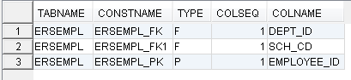

GM: likely dropped on p.15. But keep this page since needs to be dropped.

GM: FK1 is on SCH_CD and Path is not changing SCH_CD so I think it can stay. Don’t delete.

-- ALTER TABLE ERSEmpl DROP CONSTRAINT ERSEmpl_FK1
ALTER TABLE ERSEMPL DROP CONSTRAINT ERSEmpl_FK1

-- ALTER TABLE ERSHOMEDEPT DROP CONSTRAINT ERSHomeDept_PK;
ALTER TABLE ERSHOMEDEPT DROP CONSTRAINT ERSHomeDept_PK;

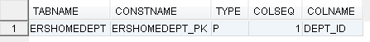

-- ALTER TABLE ERSHOMEDEPT ALTER COLUMN DEPT_ID varchar(10) NOT NULL;
ALTER TABLE ERSHOMEDEPT ALTER COLUMN DEPT_ID SET DATA TYPE varchar(10);
ALTER TABLE ERSHOMEDEPT ALTER COLUMN DEPT_ID SET NOT NULL;

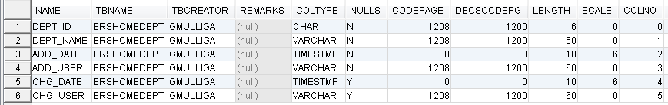

-- ALTER TABLE ERSHOMEDEPT ADD CONSTRAINT ERSHomeDept_PK PRIMARY KEY(DEPT_ID);
ALTER TABLE ERSHOMEDEPT ADD CONSTRAINT ERSHomeDept_PK PRIMARY KEY(DEPT_ID);

-- ALTER TABLE ERSEmpl ALTER COLUMN DEPT_ID varchar(10) NOT NULL;
ALTER TABLE ERSEMPL ALTER COLUMN DEPT_ID SET DATA TYPE varchar(10);
ALTER TABLE ERSEMPL ALTER COLUMN DEPT_ID SET NOT NULL;

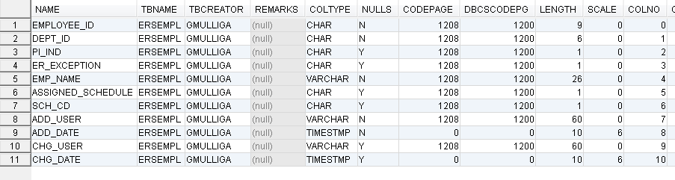

-- ALTER TABLE [dbo].[ERSEmpl] WITH CHECK ADD CONSTRAINT [ERSEmpl_FK]
-- FOREIGN KEY([Dept_ID]) REFERENCES [dbo].[ERSHomeDept] ([Dept_ID])

ALTER TABLE ERSEMPL ADD CONSTRAINT ERSEmpl_FK
FOREIGN KEY (Dept_ID) REFERENCES ERSHomeDept (Dept_ID)

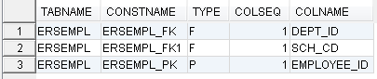

GM: this may not be needed - removed the 'WITH CHECK' from the declaration. See below.

-- ALTER TABLE [dbo].[ERSEmpl] CHECK CONSTRAINT [ERSEmpl_FK]
ALTER TABLE [dbo].[ERSEmpl] CHECK CONSTRAINT [ERSEmpl_FK]

GM: This and the constraint declaration before it look like code that DB Visualizer generated to recreate the constraint if needed. My research findings:

A "CHECK CONSTRAINT" is a restriction placed on the allowable values that a column can contain, like [1-5], or ['This', 'That']. If the Check Constraint is turned on, only the values in the brackets [ ] will be accepted. When the constraint is declared with "NOCHECK" the validation is turned off. In that case an additional statement is needed to turn it on like this:

ALTER TABLE [dbo].[ERSEmpl] CHECK CONSTRAINT [ERSEmpl_FK]

But this constraint was declared with CHECK, not NOCHECK. It is already turned on. This "CHECK CONSTRAINT" statement seems redundant. Trying to run it returns 42601.

Another q: The link below shows an example where a range of values [FK_T2_T1] is declared with NOCHECK. The declaration on the previous page does not specify a range of values in a [ ] clause. Apparently that means that all values will be allowed.

In sum, since the preceding statement declares it with CHECK, there seems to be no need to run this "CHECK CONSTRAINT" statement.

See https://dba.stackexchange.com/questions/24297/alter-table-check-constraint1

Step 5 (continued): Home Department Updates

GM: don't run this; see below.

-- ALTER TABLE [dbo].[ERSEmpl] WITH CHECK ADD CONSTRAINT [ERSEmpl_FK1]
-- FOREIGN KEY([Sch_CD]) REFERENCES [dbo].[ERSSchType] ([Sch_CD])

GM: ERSEMPL_FK1 is on SCH_CD. Path isn’t changing SCH_CD so this constraint should not have been dropped earlier and therefore not now be added back.

ALTER TABLE [dbo].[ERSEmpl] CHECK CONSTRAINT [ERSEmpl_FK1]

GM: Since the "ALTER TABLE … WITH CHECK … ADD CONSTRAINT" will not be run, the "ALTER TABLE … CHECK CONSTRAINT" won't be run either. FYI the "ALTER TABLE … CHECK CONSTRAINT" statement is not needed when the constraint is added WITH CHECK. See "restriction placed on the allowable values" in this document for more information.

-- ALTER TABLE ERSOrgDept ALTER COLUMN DEPT_ID varchar(10) NOT NULL

ALTER TABLE ERSORGDEPT ALTER COLUMN DEPT_ID SET DATA TYPE varchar(10);
ALTER TABLE ERSORGDEPT ALTER COLUMN DEPT_ID SET NOT NULL

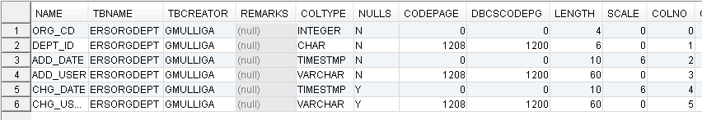

-- ALTER TABLE ERSOrgDept ADD CONSTRAINT ERSOrgDept_PK PRIMARY KEY(Org_CD, Dept_ID)
ALTER TABLE ERSORGDEPT ADD CONSTRAINT ERSORGDEPTPK PRIMARY KEY(Org_CD, Dept_ID)

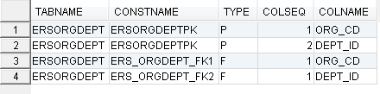

-- ALTER TABLE ERSOrgDept WITH CHECK ADD CONSTRAINT [ERSOrgDept_FK]
-- FOREIGN KEY([Org_CD]) REFERENCES ERSOrganization ([Org_CD])

GM: Don't run. It looks like this should be FK1 since its on ORG_CD. I think since Path isn’t changing ORG_CD, this constraint should not have been dropped earlier and therefore doesn’t need to be added back now.

GM: Don't run the following CHECK CONSTRAINT. See "restriction placed on the allowable values" in this document for more information.

-- ALTER TABLE ERSOrgDept CHECK CONSTRAINT ERSOrgDept_FK
ALTER TABLE ERSOrgDept CHECK CONSTRAINT ERSOrgDept_FK

-- ALTER TABLE ERSOrgDept WITH CHECK ADD CONSTRAINT [ERSOrgDept_FK1]
-- FOREIGN KEY([Dept_ID]) REFERENCES ERSHomeDept([Dept_ID])

ALTER TABLE ERSOrgDept ADD CONSTRAINT ERSORGDEPT_FK2
FOREIGN KEY (Dept_ID) REFERENCES ERSHomeDept (Dept_ID)

GM: This is FK2 since it's on DEPT_ID

GM: Don't run the following CHECK CONSTRAINT. See "restriction placed on the allowable values" in this document for more information.
-- ALTER TABLE ERSOrgDept CHECK CONSTRAINT ERSOrgDept_FK1
ALTER TABLE ERSOrgDept CHECK CONSTRAINT ERSORGDEPT_FK2

-- ALTER TABLE ERSCriteriaHomeDepartment ALTER COLUMN DEPT_ID varchar(10)
ALTER TABLE ERSCRITERIAHOMEDEPARTMENT ALTER COLUMN DEPT_ID SET DATA TYPE varchar(10)

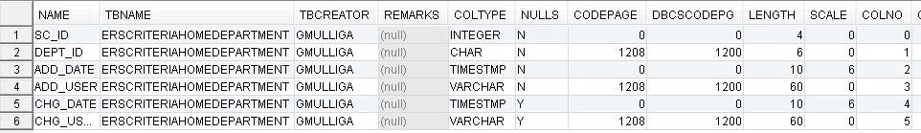

GM: yes, drop this constraint since its composite key contains DEPT_ID

-- ALTER TABLE ERSSchDept DROP CONSTRAINT ERSSchDept_PK
ALTER TABLE ERSSCHDEPT DROP CONSTRAINT ERSSchDept_PK

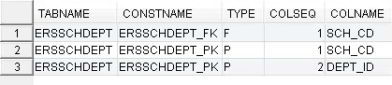

-- ALTER TABLE ERSSchDept ALTER COLUMN DEPT_ID varchar(10) not null;

ALTER TABLE ERSSCHDEPT ALTER COLUMN DEPT_ID SET DATA TYPE varchar(10);
ALTER TABLE ERSSCHDEPT ALTER COLUMN DEPT_ID SET NOT NULL;

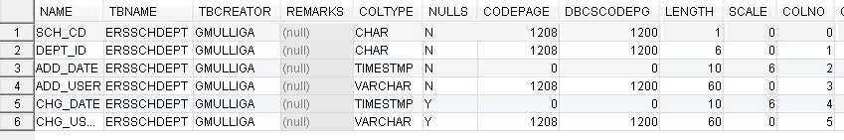

-- ALTER TABLE ERSSchDept ADD CONSTRAINT ERSSchDept_PK
-- PRIMARY KEY NONCLUSTERED (Sch_CD ASC, Dept_ID ASC)

ALTER TABLE ERSSchDept ADD CONSTRAINT ERSSchDept_PK
PRIMARY KEY (Sch_CD, Dept_ID)

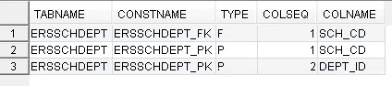
ALTER TABLE ERSSCHDEPT ADD CONSTRAINT ERSSchDept_PK
PRIMARY KEY NONCLUSTERED (Sch_CD ASC, Dept_ID ASC)

ALTER TABLE ERSSCHDEPT ADD CONSTRAINT ERSSchDept_PK
PRIMARY KEY (Sch_CD, Dept_ID)

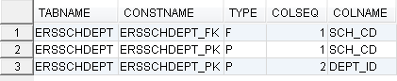

-- ALTER TABLE ERSCriteriaHomeDepartment ALTER COLUMN DEPT_ID varchar(10) NOT NULL;
ALTER TABLE ERSCRITERIAHOMEDEPARTMENT ALTER COLUMN DEPT_ID SET DATA TYPE varchar(10)
ALTER TABLE ERSCRITERIAHOMEDEPARTMENT ALTER COLUMN DEPT_ID SET NOT NULL;

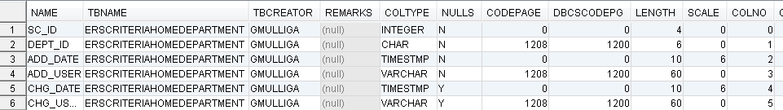

-- ALTER TABLE ERSCriteriaHomeDepartment ADD CONSTRAINT [ERSCriteriaHomeDepartment_PK]
-- PRIMARY KEY NONCLUSTERED ([SC_ID] ASC, [Dept_ID] ASC)

ALTER TABLE ERSCRITERIAHOMEDEPARTMENT ADD CONSTRAINT ERS_CHD_PK
PRIMARY KEY (SC_ID, DEPT_ID)

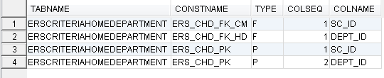

-- ALTER TABLE ERSCriteriaHomeDepartment WITH CHECK ADD CONSTRAINT
-- [ERSCriteriaHomeDepartment_FK] FOREIGN KEY([Dept_ID])
-- REFERENCES [dbo].[ERSHomeDept] ([Dept_ID])

ALTER TABLE ERSCRITERIAHOMEDEPARTMENT ADD CONSTRAINT
ERS_CHD_FK_HD FOREIGN KEY (DEPT_ID)
REFERENCES ERSHOMEDEPT (DEPT_ID)

GM: Don't run the following CHECK CONSTRAINT. See "restriction placed on the allowable values" in this document for more information.

-- ALTER TABLE ERSCriteriaHomeDepartment CHECK CONSTRAINT [ERSCriteriaHomeDepartment_FK
ALTER TABLE ERSCRITERIAHOMEDEPARTMENT CHECK CONSTRAINT [ERS_CHD_FK_HD]

Step 5 (continued): Home Department Updates

GM: Find out if Path is changing SC_ID and therefore if this is needed.

-- ALTER TABLE ERSCriteriaHomeDepartment WITH CHECK ADD CONSTRAINT
-- [ERSCriteriaHomeDepartment_FK1] FOREIGN KEY([SC_ID])
-- REFERENCES [dbo].[ERSCriteriaMaster] ([SC_ID])

ALTER TABLE ERSCRITERIAHOMEDEPARTMENT ADD CONSTRAINT
ERS_CHD_FK_CM FOREIGN KEY(SC_ID)
REFERENCES ERSCRITERIAMASTER (SC_ID)

GM: Don't run the following CHECK CONSTRAINT. See "restriction placed on the allowable values" in this document for more information.

-- ALTER TABLE ERSCriteriaHomeDepartment CHECK CONSTRAINT [ERSCriteriaHomeDepartment_FK1]
ALTER TABLE ERSCRITERIAHOMEDEPARTMENT CHECK CONSTRAINT [ERS_CHD_FK_CM]

-- UPDATE ERSHOMEDEPT set DEPT_ID=ltrim(DEPT_ID)
UPDATE ERSHOMEDEPT set DEPT_ID=TRIM(DEPT_ID)

Step 6: Add new Labor Ledger columns to ERSEARNINGS table.
GM: Before adding new columns, see existing columns below, first in column number sequence, then in column name sequence

1. Before. Ordered by column number sequence
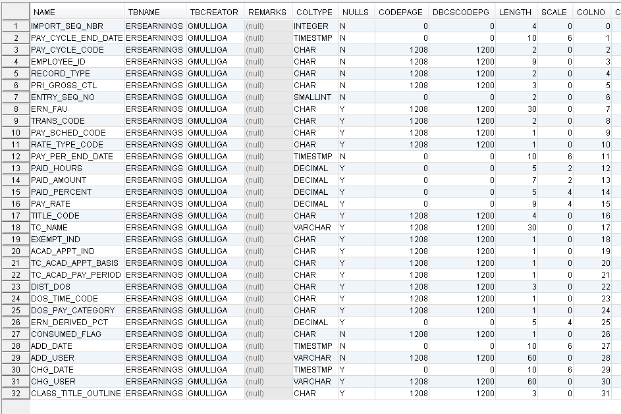

2. Before. Ordered by column name.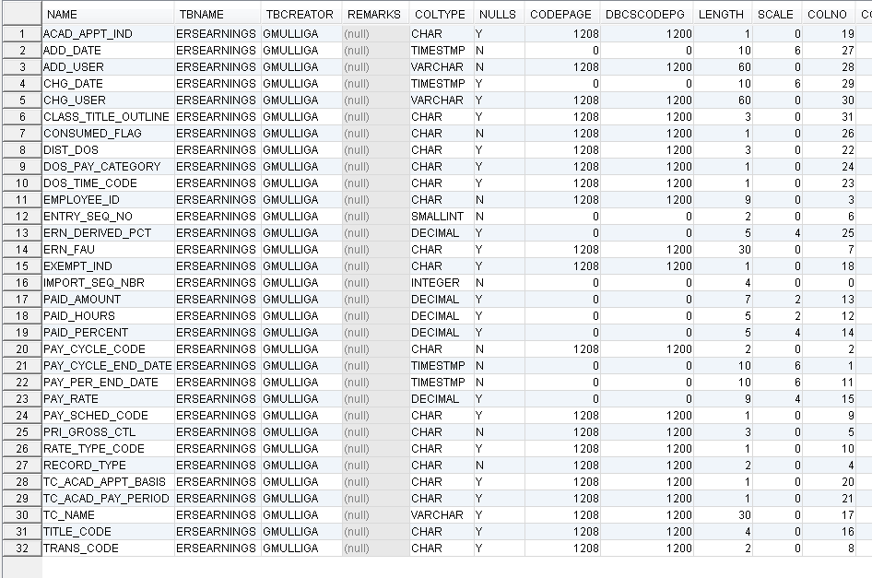

-- Run the following command in DB2 environments only (used several times above to fix 57016 errors)
-- CALL SYSPROC.ADMIN_CMD ('REORG TABLE ersearnings');
CALL SYSPROC.ADMIN_CMD ('REORG TABLE ERSEARNINGS');

-- The following 12 ALTER DROP commands are not necessary if columns do not exist in ERSEarnings
alter table ersearnings drop column RUN_ID
GM: no such column so do not run

alter table ersearnings drop column EMPL_RCD
GM: no such column so do not run

alter table ersearnings drop column EFFDT
GM: no such column so do not run

alter table ersearnings drop column EFF_SEQ
GM: no such column so do not run

alter table ersearnings drop column OFF_CYCLE
GM: no such column so do not run

alter table ersearnings drop column RUN_ID_EARN
GM: no such column so do not run

alter table ersearnings drop column ADDL_SEQ
GM: no such column so do not run

alter table ersearnings drop column JOURNAL_ID
GM: no such column so do not run

alter table ersearnings drop column JOURNAL_LINE
GM: no such column so do not run

alter table ersearnings drop column JOURNAL_LINE_REF
GM: no such column so do not run

alter table ersearnings drop column BUSINESS_UNIT
GM: no such column so do not run

alter table ersearnings drop column PAY_CAT
GM: no such column so do not run

alter table ersearnings drop column TIME_CODE
GM: no such column so do not run

GM: all the following columns don’t exist so run the statements to add them. These had 'drop' statements.

-- alter table ersearnings add Run_Id varchar(10)
alter table ERSEARNINGS add Run_Id varchar(10)

-- alter table ersearnings add Empl_Rcd integer
alter table ERSEARNINGS add Empl_Rcd integer

-- alter table ersearnings add Eff_Date datetime -- DB2 should be TIMESTAMP
alter table ERSEARNINGS add Eff_Date TIMESTAMP

-- alter table ersearnings add Eff_Seq integer
alter table ERSEARNINGS add Eff_Seq integer

-- alter table ersearnings add Off_Cycle varchar(1)
alter table ERSEARNINGS add Off_Cycle varchar(1)

-- alter table ersearnings add Run_Id_Earn varchar(10)
alter table ERSEARNINGS add Run_Id_Earn varchar(10)

-- alter table ersearnings add Addl_Seq varchar(10)
alter table ERSEARNINGS add Addl_Seq varchar(10)

-- alter table ersearnings add Journal_Id varchar(10)
alter table ERSEARNINGS add Journal_Id varchar(10)

-- alter table ersearnings add Journal_Line varchar(10)
alter table ERSEARNINGS add Journal_Line varchar(10)

-- alter table ersearnings add Journal_Line_Ref varchar(10)
alter table ERSEARNINGS add Journal_Line_Ref varchar(10)

-- alter table ersearnings add Business_Unit varchar(5)
alter table ERSEARNINGS add Business_Unit varchar(5)

-- alter table ersearnings add Pay_Cat varchar(2)
alter table ERSEARNINGS add Pay_Cat varchar(2)

-- alter table ersearnings add Time_Code varchar(2)
alter table ERSEARNINGS add Time_Code varchar(2)

GM: These did not have 'drop' statements above but still need to be run also to add the columns.
-- alter table ersearnings add Restatement varchar(1)
alter table ERSEARNINGS add Restatement varchar(1)

-- alter table ersearnings add Interface varchar(1)
alter table ERSEARNINGS add Interface varchar(1)

-- Alter TABLE ERSEARNINGS ALTER COLUMN DOS_TIME_CODE varchar(2);
Alter TABLE ERSEARNINGS ALTER COLUMN DOS_TIME_CODE SET DATA TYPE varchar(2);
GM: change from 1 to 2

-- Alter TABLE ERSEARNINGS ALTER COLUMN DOS_PAY_CATEGORY varchar(2);
Alter TABLE ERSEARNINGS ALTER COLUMN DOS_PAY_CATEGORY SET DATA TYPE varchar(2);
GM: change from 1 to 2

-- Alter TABLE ERSEARNINGS ALTER COLUMN TITLE_CODE varchar(6)
Alter TABLE ERSEARNINGS ALTER COLUMN TITLE_CODE SET DATA TYPE varchar(6)
GM: change from 4 to 6

GM: After adding the new columns and changing the lengths of some existing columns, here is what the ERSEARNINGS table looked like, first in column number sequence, then in column name sequence.

1. After. Ordered by column number sequence
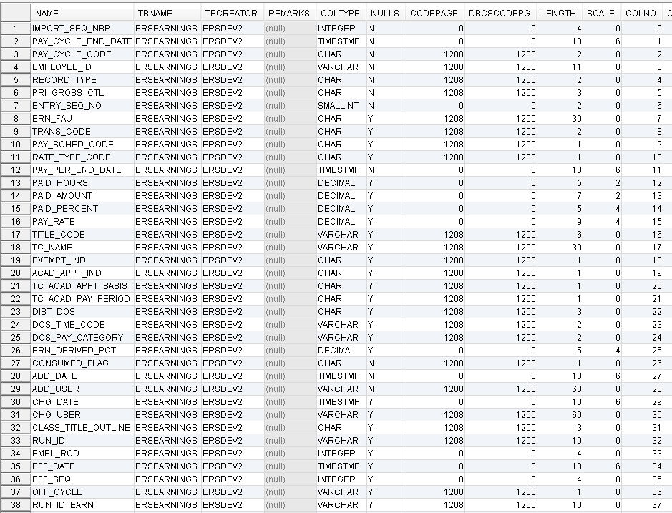
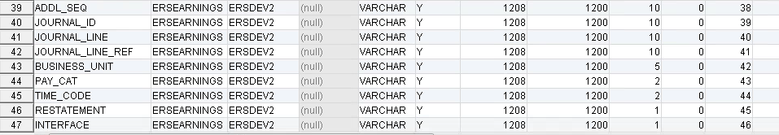

2. After. Ordered by column name sequence
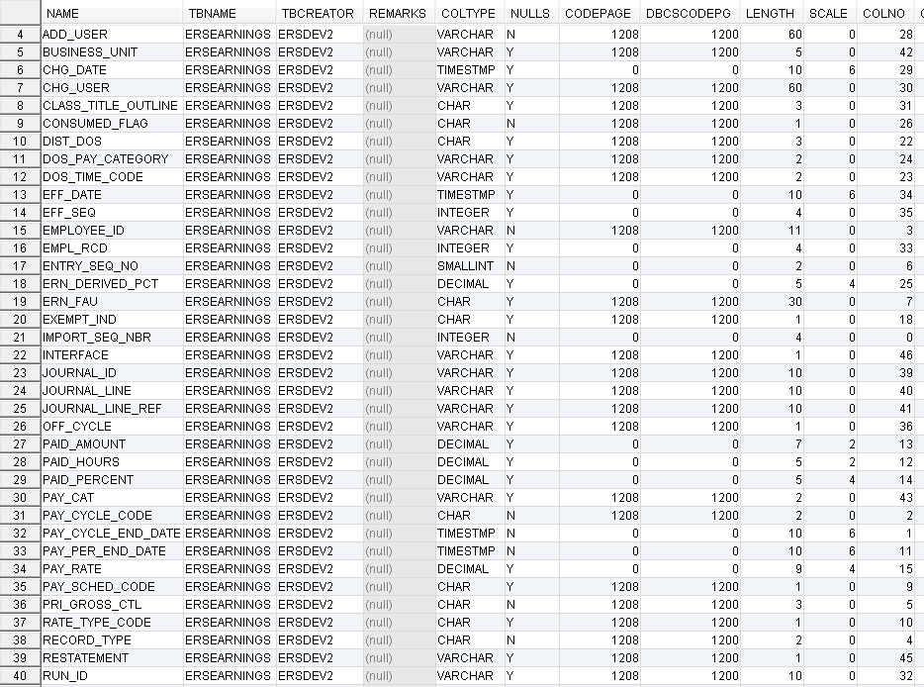
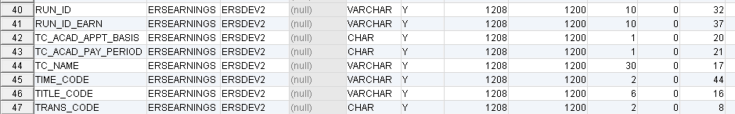

Step 6 (continued): Add new Labor Ledger (I-129) columns to ERSEARNINGS table.

-- Initialize restatement and interface columns
-- perform the following update one year at a time (otherwise transaction log will fill and query will fail)

GM: No rows for 2003-2006. Start with 2007

-- update ersearnings set restatement='N', interface='P' where year(Pay_Cycle_End_Date) = 2003
update ERSEARNINGS set RESTATEMENT='N', INTERFACE='P' where year(PAY_CYCLE_END_DATE) = 2003

-- update ersearnings set restatement='N', interface='P' where year(Pay_Cycle_End_Date) = 2004
update ERSEARNINGS set RESTATEMENT='N', INTERFACE='P' where year(PAY_CYCLE_END_DATE) = 2004

-- update ersearnings set restatement='N', interface='P' where year(Pay_Cycle_End_Date) = 2005
update ERSEARNINGS set RESTATEMENT='N', INTERFACE='P' where year(PAY_CYCLE_END_DATE) = 2005

-- update ersearnings set restatement='N', interface='P' where year(Pay_Cycle_End_Date) = 2006
update ERSEARNINGS set RESTATEMENT='N', INTERFACE='P' where year(PAY_CYCLE_END_DATE) = 2006

GM: UCSD has data starting only in 2007, not for 2003-2006.
a. I tried to run the 2007 command below, and got -668, 57016.

b. Tried to run reorg. Got 15:51:31 [CALL - 0 row(s), 0.000 secs] [Error Code: -289, SQL State: 57011] DB2 SQL error: SQLCODE: -289, SQLSTATE: 57011, SQLERRMC: ERSTS802
... 1 statement(s) executed, 0 row(s) affected, exec/fetch time: 0.000/0.000 sec [0 successful, 0 warnings, 1 errors]

c. Slava fixed it by extending the tablespace.

-- update ersearnings set restatement='N', interface='P' where year(Pay_Cycle_End_Date) = 2007
update ERSEARNINGS set RESTATEMENT='N', INTERFACE='P' where year(PAY_CYCLE_END_DATE) = 2007

GM: 2007 is done. Skipped the rest for now since we won't be testing with UCSD.

-- update ersearnings set restatement='N', interface='P' where year(Pay_Cycle_End_Date) = 2008
update ERSEARNINGS set RESTATEMENT='N', INTERFACE='P' where year(PAY_CYCLE_END_DATE) = 2008

-- update ersearnings set restatement='N', interface='P' where year(Pay_Cycle_End_Date) = 2009
update ERSEARNINGS set RESTATEMENT='N', INTERFACE='P' where year(PAY_CYCLE_END_DATE) = 2009

-- update ersearnings set restatement='N', interface='P' where year(Pay_Cycle_End_Date) = 2010
update ERSEARNINGS set RESTATEMENT='N', INTERFACE='P' where year(PAY_CYCLE_END_DATE) = 2010

-- update ersearnings set restatement='N', interface='P' where year(Pay_Cycle_End_Date) = 2011
update ERSEARNINGS set RESTATEMENT='N', INTERFACE='P' where year(PAY_CYCLE_END_DATE) = 2011

-- update ersearnings set restatement='N', interface='P' where year(Pay_Cycle_End_Date) = 2012
update ERSEARNINGS set RESTATEMENT='N', INTERFACE='P' where year(PAY_CYCLE_END_DATE) = 2012

-- update ersearnings set restatement='N', interface='P' where year(Pay_Cycle_End_Date) = 2013
update ERSEARNINGS set RESTATEMENT='N', INTERFACE='P' where year(PAY_CYCLE_END_DATE) = 2013

-- update ersearnings set restatement='N', interface='P' where year(Pay_Cycle_End_Date) = 2014
update ERSEARNINGS set RESTATEMENT='N', INTERFACE='P' where year(PAY_CYCLE_END_DATE) = 2014

-- update ersearnings set restatement='N', interface='P' where year(Pay_Cycle_End_Date) = 2015
update ERSEARNINGS set RESTATEMENT='N', INTERFACE='P' where year(PAY_CYCLE_END_DATE) = 2015

-- update ersearnings set restatement='N', interface='P' where year(Pay_Cycle_End_Date) = 2016
update ERSEARNINGS set RESTATEMENT='N', INTERFACE='P' where year(PAY_CYCLE_END_DATE) = 2016

-- update ersearnings set restatement='N', interface='P' where year(Pay_Cycle_End_Date) = 2017
update ERSEARNINGS set RESTATEMENT='N', INTERFACE='P' where year(PAY_CYCLE_END_DATE) = 2017

update ERSEARNINGS set RESTATEMENT='N', INTERFACE='P' where year(PAY_CYCLE_END_DATE) > 2017

Step 6B: Set database version to 11.0

-- update ersversion set version_id='11.0'
update ERSVERSION set version_id='11.0'

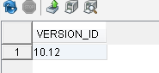

Step 7: ERSCONSTANTS update... + ERSEarnings (set default INTERFACE to 'P' PAR)

Step 7A: Removed because reddundant

Step 7B: Update ERS DOS Codes for Off Quarter processing

GM: the ERSDOSCODE table was empty following the DB load.

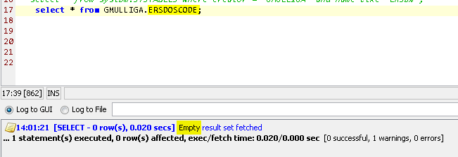

-- insert into ERSDosCode values ('9AC','O',getdate(),'*INSTALL*',null,null)
insert into ERSDOSCODE values ('9AC','O', current timestamp,'*INSTALL*',null,null)

-- insert into ERSDosCode values ('9TC','O',getdate(),'*INSTALL*',null,null)
insert into ERSDOSCODE values ('9TC','O', current timestamp,'*INSTALL*',null,null)

-- insert into ERSDosCode values ('9CC','O',getdate(),'*INSTALL*',null,null)
insert into ERSDOSCODE values ('9CC','O', current timestamp,'*INSTALL*',null,null)

GM: after inserting the above 3 rows:
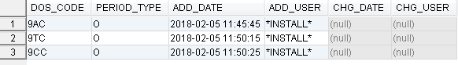

Step 7C: Update ERS DOS Codes for Off Quarter processing

GM: the ERSPAYCAT table was empty following the DB load.

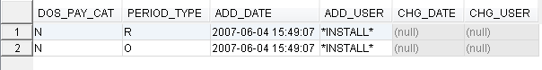

-- insert into ERSPayCat values('1','R',getdate(),'*INSTALL*',null,null) -- regular reporting period
insert into ERSPAYCAT values('1','R', current timestamp,'*INSTALL*',null,null) -- regular reporting period
-- insert into ERSPayCat values('1','O',getdate(),'*INSTALL*',null,null) -- off quarter reporting period
insert into ERSPAYCAT values('1','O', current timestamp,'*INSTALL*',null,null) -- off quarter reporting period

GM: after inserting the above 2 rows:

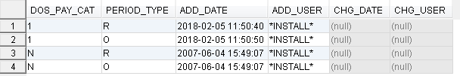

Step 7D: Create Unique PAR Earnings and I-129 Earnings unique indexes for duplicate earning check
I-129

-- DROP INDEX ERSEarnings. ERS_EARNINGS_I129_UNIQUE
DROP INDEX ERSEARNINGS. ERS_EARNINGS_I129_UNIQUE

GM: Although there is no index on the I-129 fields below, earlier in the document we dropped
ERSEARNING_UNQ_IDX, which was on these columns, and never added it back:

PAY_CYCLE_END_DATE
PAY_CYCLE_CODE
EMPLOYEE-ID
RECORD_TYPE
PRI_GROSS_CTL
ENTRY_SEQ_NO

GM: Should the above index have been dropped? Is it changing for Path?

GM: Now we want to create an I-129 index on a different set of fields from ERSEARNING_UNQ_IDX. Here are the I-129 index's fields

Interface
Empl_Rcd
Eff_date
Eff_Seq
Run_Id
Run_Id_Earn
Business_Unit
Off_Cycle
Dist_Dos
Journal_Id
Journal_Line
Journal_Line_Ref
Addl_Seq

-- CREATE NONCLUSTERED INDEX ERS_EARNINGS_I129_UNIQUE ON ERSEARNINGS ( Interface, Empl_Rcd, Eff_date, Eff_Seq, Run_Id, Run_Id_Earn, Business_Unit, -- Off_Cycle, Dist_Dos, Journal_Id, Journal_Line, Journal_Line_Ref, Addl_Seq)

GM: must remove keyword NONCLUSTERED before it will run successfully.

CREATE INDEX ERS_EARNINGS_I129_UNIQUE ON ERSEARNINGS (Interface, Empl_Rcd, Eff_date, Eff_Seq, Run_Id, Run_Id_Earn, Business_Unit, Off_Cycle, Dist_Dos, Journal_Id, Journal_Line, Journal_Line_Ref, Addl_Seq)

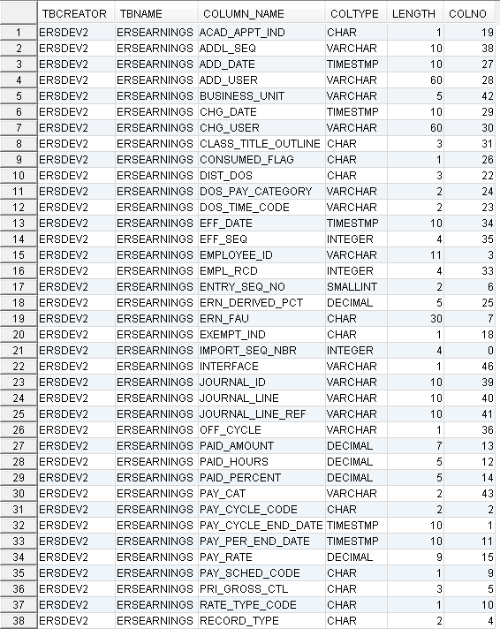
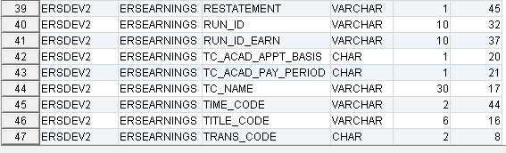

** note that the UNIQUE keyword has been purposely omitted to eliminate potential problems with historical earning uniqueness

GM: after creating the new I-129 index, here are all indexes on ERSEARNINGS:

PAR
-- DROP INDEX ERSEarnings. ERS_EARNINGS_PAR_UNIQUE

GM: Although there is no index on the I-129 fields below, earlier in the document we dropped
ERSEARNING_UNQ_IDX, which was on these columns, and never added it back:

PAY_CYCLE_END_DATE
PAY_CYCLE_CODE
EMPLOYEE-ID
RECORD_TYPE
PRI_GROSS_CTL
ENTRY_SEQ_NO

GM: Should the above index have been dropped? Is it changing for Path?

GM: Now we want to create a ERS_EARNINGS_PAR_UNIQUE index on a different set of fields from ERSEARNING_UNQ_IDX. Here are the PAR index's fields:

Interface
Pay_Cycle_End_Date
Pay_Cycle_Code
Record_Type
Pri_Gross_Ctl
Entry_Seq_No

GM: see below. There's no index named ERS_EARNINGS_PAR_UNIQUE but there is one named
ERSEARNING_UNQ_IDX

-- CREATE NONCLUSTERED INDEX CREATE INDEX ERS_EARNINGS_PAR_UNIQUE ON ERSEARNINGS(Interface, Pay_Cycle_End_Date, Pay_Cycle_Code, Record_Type, Pri_Gross_Ctl, Entry_Seq_No)

CREATE INDEX CREATE INDEX ERS_EARNINGS_PAR_UNIQUE ON ERSEARNINGS(Interface, Pay_Cycle_End_Date, Pay_Cycle_Code, Record_Type, Pri_Gross_Ctl, Entry_Seq_No)

** note that the UNIQUE keyword has been purposely omitted to eliminate potential problems with historical earning uniqueness

GM: after creating the new I-129 index, here are all indexes on ERSEARNINGS:

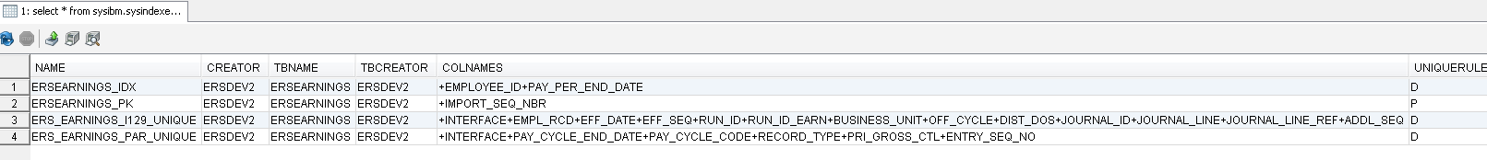

Step 7E: Expand ERSEarnings Paid_Amount, Paid_Hours, and Pay_Rate columns

GM: before changing these 3 columns, they looked like this:
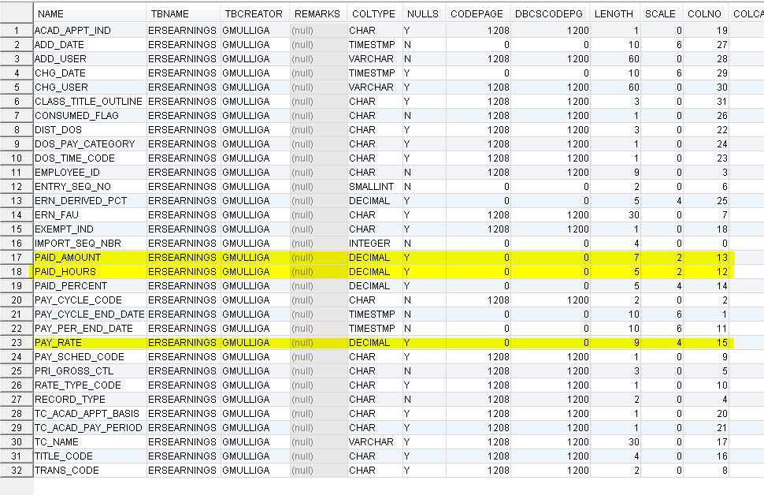

GM: now change the 3 columns with these commands:

-- ALTER TABLE ERSEarnings ALTER COLUMN Paid_Hours decimal(6,2) NOT NULL;

ALTER TABLE ERSEARNINGS ALTER COLUMN Paid_Hours SET DATA TYPE decimal(6,2)
ALTER TABLE ERSEARNINGS ALTER COLUMN Paid_Hours SET NOT NULL;

-- ALTER TABLE ERSEarnings ALTER COLUMN Paid_Amount decimal(12,2) NOT NULL;

ALTER TABLE ERSEARNINGS ALTER COLUMN Paid_Amount SET DATA TYPE decimal(12,2);
ALTER TABLE ERSEARNINGS ALTER COLUMN Paid_Amount SET NOT NULL;

&&& Skip for now

-- ALTER TABLE ERSEarnings ALTER COLUMN Pay_Rate decimal(14,4) NOT NULL;

ALTER TABLE ERSEARNINGS ALTER COLUMN Pay_Rate SET DATA TYPE decimal(14,4);
ALTER TABLE ERSEARNINGS ALTER COLUMN Pay_Rate SET NOT NULL;

a. The above failed with [Error Code: -20054, SQL State: 55019] DB2 SQL error: SQLCODE: -20054, SQLSTATE: 55019, SQLERRMC: ERSDEV2.ERSEARNINGS

Step 7F: Create six digit UCPATH Department ID’s in ERS Scheduler.

GM: skip this. Different from UCLA. UCLA's scheme is more complicated. UCSD doesn’t use ERSSchDeptBU.
ERSSCHDEPT is empty.

-- select * into ERSSchDeptBU from ERSSchDept

CREATE TABLE ERSDEV2.ERSSCHDEPTBU AS (
SELECT *
FROM ERSDEV2.ERSSCHDEPT
) WITH NO DATA

INSERT INTO ERSSchDeptBU
(SELECT * FROM ERSSchDept)

GM: Target table ERSSCHDEPTBU doesn’t exist, but there is a source table named ERSSCHDEPT. Is ERSSCHDEPTBU being newly added by this script or other means?

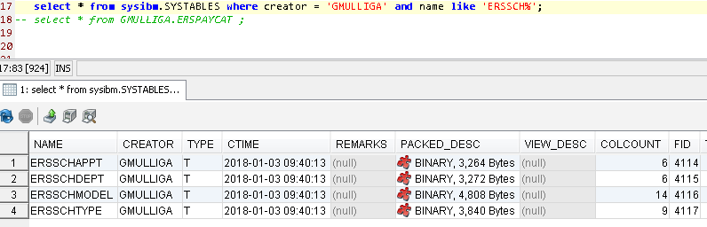

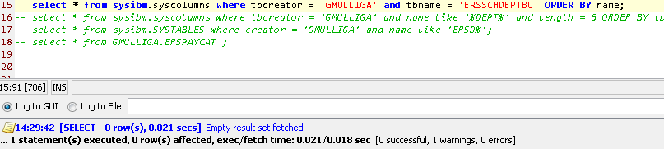

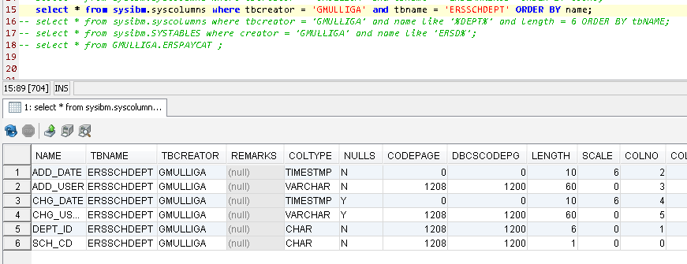

BTW, select * into ERSSchDeptBU from ERSSchDept
is a legal SQL pattern:
select * into T1 from T2

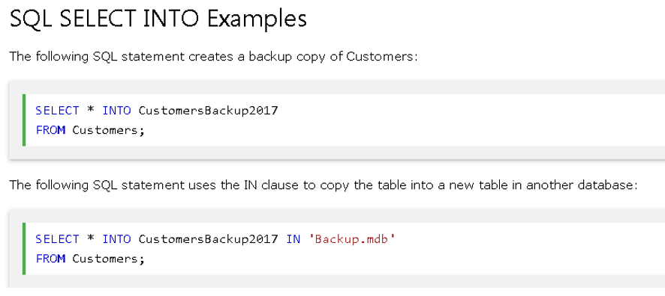

Here are the patterns I've seen:

INSERT INTO PB7DA.PPPBRR
(SELECT * FROM PBUDA.PPPBRR
WHERE BRR_RETIRE_DESCRIP LIKE '%u%');
******************************** Bottom of Da

Step 7G: Add Non-Academic Appointment Indicators (3,B,C)

GM: skip this. Different from UCLA. UCLA's scheme is more complicated. UCSD doesn’t use ERSPERSPGMCODE.

-- insert into ERSPersPgmCode values('4','3',getdate(), 'sys.admin',getdate(),'sys.admin')

insert into ERSPERSPGMCODE values('4','3', CURRENT TIMESTAMP, 'sys.admin', CURRENT TIMESTAMP,'sys.admin')

GM: The above is inserting 6 cols? Don;'t know what 6 cols will be pop'd in a table with more cols. Here's the table:
No, IT ONLY HAS 6.

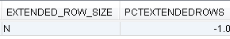

-- insert into ERSPersPgmCode values('4','B',getdate(), 'sys.admin',getdate(),'sys.admin')
insert into ERSPersPgmCode values('4','B',getdate(), 'sys.admin',getdate(),'sys.admin')
GM: The above is inserting 6 cols. Don;'t know what 6 cols will be pop'd in a table with more cols.

-- insert into ERSPersPgmCode values('4','C',getdate(), 'sys.admin',getdate(),'sys.admin')
insert into ERSPersPgmCode values('4','C',getdate(), 'sys.admin',getdate(),'sys.admin')
GM: The above is inserting 6 cols. Don;'t know what 6 cols will be pop'd in a table with more cols.

** NOTE – 4 might not be the ‘non-academic’ identifier for hosted campuses

Step 7H: Update Journal_Line_Ref for I-129 records (set to “PAYROLL”)
&&& skip for now, needs reorg and cant do reorg cause of 57011

-- update ERSEarnings set Journal_Line_Ref ='PAYROLL' where interface='L'
update ERSEARNINGS set Journal_Line_Ref ='PAYROLL' where interface='L'

GM: the ERSEARNINGS table doesn't have a column JOURNAL_LINE_REF. Here's the tabhle:
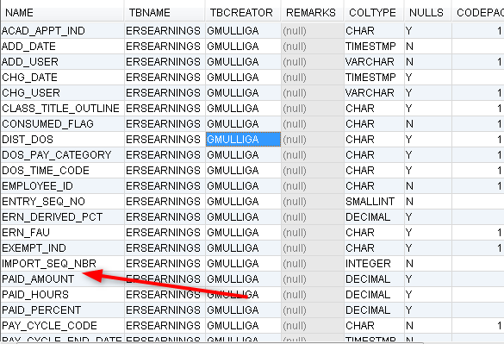

Step 7I: Add UCPATH ‘Leave’ (sick, sebatical,….) as effort bearing to ERSPayCat table.
UCPATH PayCat ‘2’ is not used by PPS so no PPS impact.
PPS uses ‘L’ witch is not effort bearing

-- insert into ERSPayCat values('2','R',getdate(), 'sys.admin',getdate(),'sys.admin')
insert into ERSPAYCAT values('2','R', CURRENT TIMESTAMP, 'sys.admin', CURRENT TIMESTAMP,'sys.admin')

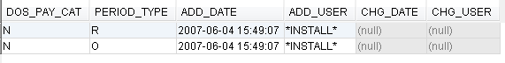

-- insert into ERSPayCat values('2','O',getdate(), 'sys.admin',getdate(),'sys.admin')
insert into ERSPAYCAT values('2','O', CURRENT TIMESTAMP, 'sys.admin', CURRENT TIMESTAMP,'sys.admin')

Step 7J: Add ‘Over The Cap’ to ERSEarnings table.

-- alter table ERSEarnings add Over_The_Cap varchar(10)
alter table ERSEARNINGS add Over_The_Cap varchar(10)

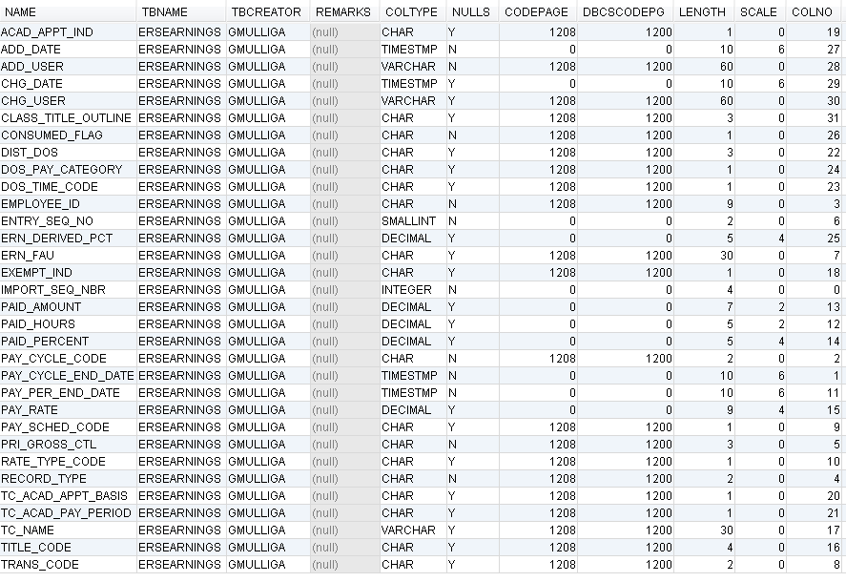

Step 7K: ERSDOSCODE table and ERSPAYCAT table are now indexed using ‘Interface’
(same codes in PPS and I-129 are used, but identify ‘Effort’ differently)

-- alter table ERSTIMECODE add Interface varchar(1)
alter table ERSTIMECODE add Interface varchar(1)

-- alter table ERSPAYCAT add Interface varchar(1)
alter table ERSPAYCAT add Interface varchar(1)

This needs to be confirmed, but setup these tables as shown below….
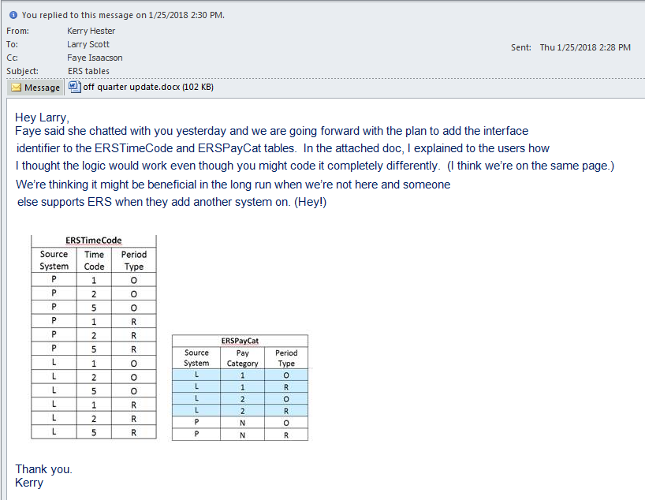

-- MS SQL Commands used to build the above tables (primary key violations)

(GM: watch these tics, the wrong tics can cause -206
Update ERSTimeCode set interface = 'P'

ALTER TABLE ERSTimeCode DROP CONSTRAINT ERSTimeCode_PK

Gm: NO NEED to set varchar. It was done earlier
ALTER TABLE ERSTimeCode ALTER COLUMN Interface Varchar(1) NOT NULL

GM: still need to set not null
ALTER TABLE ERSTimeCode ALTER COLUMN Interface SET NOT NULL

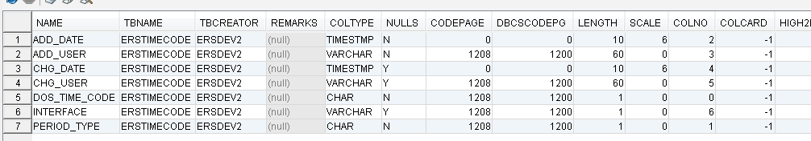

-- ALTER TABLE ERSTimeCode ADD CONSTRAINT ERSTimeCode_PK
-- PRIMARY KEY (DOS_Time_Code, Period_Type, Interface)

ALTER TABLE ERSTimeCode ADD CONSTRAINT ERSTimeCode_PK
PRIMARY KEY (DOS_Time_Code, Period_Type, Interface)

insert into ERSTimeCode values ('1','O', CURRENT TIMESTAMP, '*UPGRADE*',null,null,'L')

insert into ERSTimeCode values ('2','O', current timestamp, '*UPGRADE*',null,null,'L')
insert into ERSTimeCode values ('5','O', current timestamp, '*UPGRADE*',null,null,'L')
insert into ERSTimeCode values ('1','R', current timestamp, '*UPGRADE*',null,null,'L')
insert into ERSTimeCode values ('2','R', current timestamp, '*UPGRADE*',null,null,'L')
insert into ERSTimeCode values ('5','R', current timestamp,'*UPGRADE*',null,null,'L')

-- Update ERSPayCat set interface = ‘P’
Update ERSPayCat set interface = 'P'

-- ALTER TABLE ERSPayCat DROP CONSTRAINT ERSPayCat_PK
ALTER TABLE ERSPayCat DROP CONSTRAINT ERSPayCat_PK

- ALTER TABLE ERSPayCat ALTER COLUMN Interface Varchar(1) NOT NULL

ALTER TABLE ERSPayCat ALTER COLUMN Interface SET DATA TYPE Varchar(1)
ALTER TABLE ERSPayCat ALTER COLUMN Interface SET NOT NULL

--ALTER TABLE ERSPayCat ADD CONSTRAINT ERSPayCat_PK
-- PRIMARY KEY (DOS_Pay_Cat, Period_Type, Interface)

ALTER TABLE ERSPayCat ADD CONSTRAINT ERSPayCat_PK
PRIMARY KEY (DOS_Pay_Cat, Period_Type, Interface)

-- Update ERSPayCat set interface = 'L' where DOS_Pay_Cat='1'
Update ERSPayCat set interface = 'L' where DOS_Pay_Cat='1'
-- insert into ERSPayCat values ('2','O',getdate(),'*UPGRADE*',null,null,'L')
insert into ERSPayCat values ('2','O', CURRENT TIMESTAMP,'*UPGRADE*',null,null,'L')
-- insert into ERSPayCat values ('2','R',getdate(),'*UPGRADE*',null,null,'L')
insert into ERSPayCat values ('2','R', CURRENT TIMESTAMP,'*UPGRADE*',null,null,'L')

Step 7L: Add ‘Over The Cap’ and ‘ Salary Cap’

alter table ersearnings add Over_The_Cap varchar(10) NULL

alter table ersearnings add Cap_Rate Decimal (14, 4) NULL

update ersearnings set cap_rate=0

Step 8: Set system generate key values for ERSEarnings table inserts by PAR & I-129 loads

GM: skip for now, ERSEARNINGS needs a reorg and can't 'cause -668
--select max(Import_Seq_Nbr) from ERSEarnings -- > example 113xxxxx
select max(Import_Seq_Nbr) from ERSEarnings

GM: skip for now, ERSEARNINGS needs a reorg and can't 'cause -668

--ALTER TABLE ERSEarnings ALTER COLUMN Import_Seq_Nbr RESTART WITH 11400000
ALTER TABLE ERSEarnings ALTER COLUMN Import_Seq_Nbr RESTART WITH 17000000

GM: why are the above two lines commented and are they needed?
A: Yes they are needed. Inserts into EARNINGS table automatically increment IMPORT_SEQ_NBR. Must guarantee unique values. Must start with a number bigger than any existing numbers, so 17,000,000

GM: currently the max sequence number is 16295705. What would the RESTART command, assuming it will be run, do to the table?
A: make it 17,000000

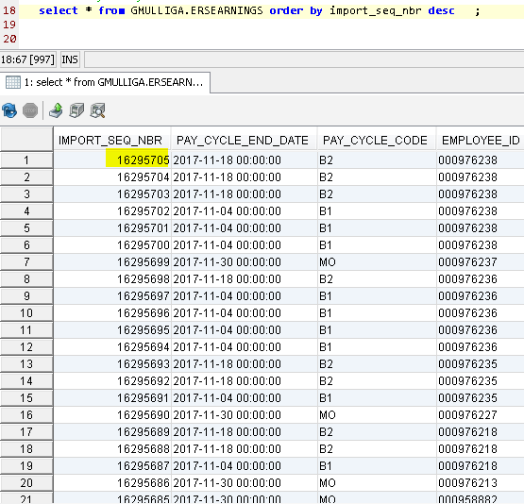
Step 9: Set ERS sys.admin password allowing user to login to ERS
(DO THIS FROM ERS LOGIN SCREEN – S.B. PERFORMED BY .WAR FILE INSTALLER)

-- update ersdb_20150409_data_for_DEV_and_QA_use.dbo. ERSUser
Update ERSUSER (incomplete; see below)

!!! GM: don't run. See 'DO THIS' above
-- set Password = (select password from ersdb_20150116_original.dbo.ERSUser where User_ID = 'sys.admin')
Update ERSUSER set Password = (select password from ERSUser where User_ID = 'sys.admin')

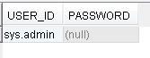

GM: skip all 10.x for now
Step 10: Archive Migration from DTO format to PDF format
This code is contained only in ERS 10.12 B010
The archive code in ERS 10.12 B010 now builds archives in PDF format, not DTO format
All archive code in releases prior to ERS 10.12 B010 build archives in DTO (data) format
The ERS 10.12 B010 batch program to be run is InterfaceArchiveReportMigation10to11.java

Overview
ERS 10.X created archives in DTO format. ERS 11.0 creates archives in PDF format
This step changes the ERS 10.x archives from a DTO (data transfer object) to a PDF format
(necessary to solve the issue of archiving from one version of ERS and restoring to another)
The ERS Archive tables are ERSARCHIVEDREPORT and ERSARCHIVEDFS.
All archive data is contained in ERSARCHIVEDREPORT and ERSARCHIVEDFS

*** IMPORTANT***
Make sure you run this process in a QA environment and verify the archives in a QA environment.
It would be a good precaution, to make a long term backup of the production database.

Process:
These are the steps necessary to convert ERS DTO archives to PDF archives:

10.1: Check for data in database table ERSARCHIVEDREPORT.
If this table is empty, skip this step. No archive migration is necessary.

10.2: Check the year of the archives
<2018 is DTO format. 2018+ is PDF format.
This will tell you if the archives are in a DTO format or PDF format.
If DTO format, migration is necessary. If PDF format, no migration is necessary.

Run this SQL: select distinct year(archived_date) from ERSARCHIVEDREPORT

If you only see year 2018 (or greater), your archives are in PDF format and skip the migration.
If you see year less than 2018, the migration required.

10.3: Preparing for migration
Migration is performed in a non-production environment to minimize ERS production downtime.
Archive migration may run for days.
Load the ERS 10.12 B010 war file to your QA environment
Copy your production ERS database to your QA environment
Verify your QA ERS database connection and ERS code (ERS signon screen display version 10.12 B010)

10.4: Run the migration program
In you QA environment, run ERS batch program InterfaceArchiveReportMigation10to11.java
It is necessary to set your ERS config directory in the classpath (shown in screenshot)

It also is necessary to pass two parameters to the archive migration process.
1: The path to the ERS Jasper report objects (red underline) . Explode you ers.war file to a temp directory
2: The path to your ExternalizedString.xml file (blue underline)

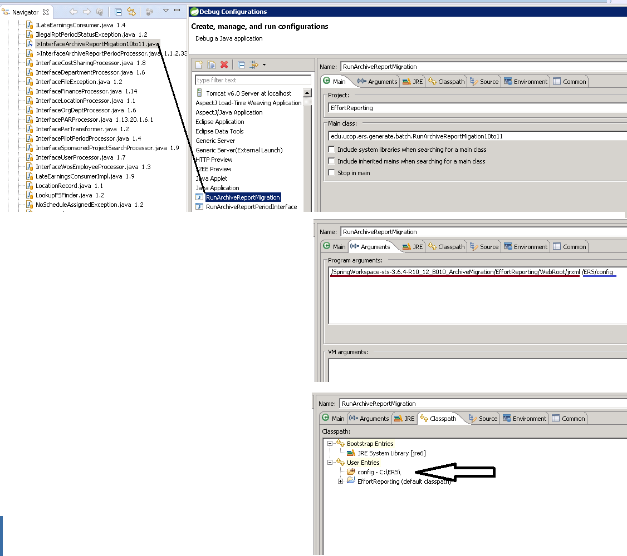

10.5: Replace production DTO archives with QA PDF Archives

Tables ERSARCHIVEDREPORTand ERSARCHIVEDFS in QA environment REPLACE the same tables in production ERS environment . Copy/Replace these tables from QA to PROD

Archive migration program execution comments
The migration program can easily consume all memory on your server causing the process to crash.
To prevent ‘out-of-memory errors’, the migration program processes 100,000 archived effort reports at a time and then stops to releases memory. The migration process commits updates in 5000 archive increments.

As the archive migration run, the DTO pdf is read from table ERSAarchivedReport and converted to PDF (using the JasperReport objects and the campuses customizations in ErternalizedStrings.xml). Once the PDF is built, the DTO in ERSArchivedReports is overlaid with the PDF . The same process is used for the archive payroll report. The process continues until all ERSArchivedReport rows are processed or 100,000 rows are processed.

Larger campuses may have millions of rows in the ERSArchivedReport table, making it necessary to run the migration process 10+ times. Each iteration of the migration process will likely take a few days.

Run this SQL:
select year(archived_date) , count(*) from ERSARCHIVEDREPORT group by year(archived_date)
If you see any archive dates < 2018, run the process again
Once all archive dates < 2018 are cleared, the ERS Archive Migration is complete.

Performance:
When this process was run for UCSB in QA (Jan 2018), it took 15 hours to migrate 100,000 archived effort reports.

Step 11: Closing comments
It is highly recommended that you long term archive a copy of the ERS 10.12 production database
If any issues arise after the UCPATH implementation, it may be necessary to load the ERS 10.12 system in a QA environment to retrieve or repair ERS data.

Done with ERS 11.0 Upgrade !
Appendix 1
Programming Note 1:
Any changes to the ERSEarnings table need to be replicated in ERS 11.0 Java class
DrillDownQuery.java, which is used by DrillDownBuilder.java to construct the payroll report.
See ERSMappings folder, files payrollReport2.png and payrollReport3.png

Programming Note 2:
The following methods should be part of BaseEmployee.java but lost when employee.hbm changed.

Methods were lost when employee.hmb is compiled by hibernate synchronizer
Methods should not be part off employee.hbm
I manually added it back to BaseEmployee.java.
It is called as part of a JUnit test

public void addToUsers (edu.ucop.ers.domain.User user) {
if (null == getUsers()) setUsers(new java.util.HashSet<edu.ucop.ers.domain.User>());
getUsers().add(user);
}

public void addToEarnings (edu.ucop.ers.domain.Earning earning) {
if (null == getEarnings()) setEarnings(new java.util.HashSet<edu.ucop.ers.domain.Earning>());
getEarnings().add(earning);
}

public void addToReportHeaders (edu.ucop.ers.domain.ReportHeader reportHeader) {
if (null == getReportHeaders()) setReportHeaders(
new java.util.HashSet<edu.ucop.ers.domain.ReportHeader>());
getReportHeaders().add(reportHeader);
}

public void addToCostSharingCommitments (edu.ucop.ers.domain.CostSharingCommitment
costSharingCommitment) {
if (null == getCostSharingCommitments()) setCostSharingCommitments(new
java.util.HashSet<edu.ucop.ers.domain.CostSharingCommitment>());
getCostSharingCommitments().add(costSharingCommitment);
}

public void addToPiProjects (edu.ucop.ers.domain.PrincipalInvestigator principalInvestigator) {
if (null == getPiProjects()) setPiProjects(new
java.util.HashSet<edu.ucop.ers.domain.PrincipalInvestigator>());
getPiProjects().add(principalInvestigator);
}

Programming Note 3: LaborLedger Date Format
Labor Ledger record date format sometimes changes requiring format change to

ERSCONSTANTS.java - public static final String DATE_FORMAT_PAR = "MMddyyyy";

Programming Note 4: EarningMatcher.java - method MatchStatus
Checks PayCategory, DOS Code, amd Time Code to determine if an earning should be certified.
This check should be skipped for ERS 11.0

Notice that column 'interface' (P=PAR, L=LaborLedger) has been added to ERSEarnings table.
and code to populate in InterfaceLaborLedgerProcessor, and InterfacePARProcessor

** method MatchStatus determines if a LaborLedger earning should be certified only if derived% >0. This may not be sufficient.

Configuation Note 1: ERSConfig.xml - used in ConfigLoader.java

// which payroll system being used (PPS or PeopleSoft). Default to PeopleSoft
String payrollSystemPps = (String) cfg.getProperty(
ERSConstants.CFG_OPTIONS_PAYROLL_SYSTEM_PPS);
if ( payrollSystemPps != null ) {
ctx.setAttribute( ERSConstants.PAYROLL_SYSTEM_PPS,
new Boolean( bypass11Over12Check ) );
} else {
ctx.setAttribute( ERSConstants.PAYROLL_SYSTEM_PPS,
ERSConstants.FALSE );
}

see ERSConfig.xml
<bypass-11over12-appointment-check>true</bypass-11over12-appointment-check>

JUNIT Note: (JUnits run correctly in EffortReporting R10_11_B001, but not EffortReporting R11_Support)

1: Latheef and Bascar's work
RunUcpathEmployeeConversionTest.java
UcpathEmployeeConversionProcessorTest.java

2: See step 1: Some JUnit required methods are missing from employee.hbm
Methods were lost when employee.hmb is compiled by hibernate synchronizer
Methods should not be part off employee.hbm

3: JUnit TestFundingSrcUniquenessTest is looking for file Z:/interfaces/Test
Files/UCD/fin_systems_interface.31-MAR-2005
File can not be found so JUnit is commented out.

4: JUnit class UcpathEmployeeConversionProcessorTest method testAddEmployee does not run....
has bugs, commented out

5: JUnit RunUcpathEmployeeConversionTest fails - commented out

6: JUnit SearchDeadlockFinder pukes all-over itself

see class: AbstractSavableSearchImpl method:addToCachedSelectedItemsSet( List moreKeys ) {

error is: java.lang.ClassCastException: java.lang.NoSuchMethodException: Unknown property 'dummy'

The following methods have been commented out
- testSaveAndDelete()
- testForDeadlock()
- testSaveAndDeleteAdHoc()

7: JUint class SearchManagerImpl method testCopySearch - added try / catch block to force success

8; JUnit: InterfacePARProcessorTest
Notice junit test class "extends HibernateUnitTester" This sets up the database
* insert_base_test_fixture_data.sql
* insert_standard_test_fixture_data.sql

9: JUnit: InterfaceLaborLedgerTest - needs to be developed
Appendix 2:
These steps were run at UCLA to remove Effort Reports and Earnings prior to 2014.
This shunk the size of the UCLA ERS earnings table from 35M earnings to 12M earnings.
Database size was reduced approximately by half.
This was needed for UCLA database to ‘fit’ on UCOP ERS DEV DB server

delete from [ersdb_2017Oct16_ERS11_PPT2.5_Expanded]..ersearnings
where year(pay_per_end_date) < 2014
and not import_seq_nbr in
(select import_seq_nbr from [ersdb_2017Oct16_ERS11_PPT2.5_Expanded]..ERSEarningsVersion V)

exec ersdb_2017July21_ERS11_IT3_Validate.dbo.RemoveEffortReportsForSinglePeriod 1
- A cursor with the name 'C1' does not exist. [SQLSTATE 34000] (Error 16916) – This is OK, do not stop.
exec ersdb_2017July21_ERS11_IT3_Validate.dbo.RemoveEffortReportsForSinglePeriod 2
exec ersdb_2017July21_ERS11_IT3_Validate.dbo.RemoveEffortReportsForSinglePeriod 3
exec ersdb_2017July21_ERS11_IT3_Validate.dbo.RemoveEffortReportsForSinglePeriod 4
exec ersdb_2017July21_ERS11_IT3_Validate.dbo.RemoveEffortReportsForSinglePeriod 5
exec ersdb_2017July21_ERS11_IT3_Validate.dbo.RemoveEffortReportsForSinglePeriod 6
exec ersdb_2017July21_ERS11_IT3_Validate.dbo.RemoveEffortReportsForSinglePeriod 7
exec ersdb_2017July21_ERS11_IT3_Validate.dbo.RemoveEffortReportsForSinglePeriod 8
exec ersdb_2017July21_ERS11_IT3_Validate.dbo.RemoveEffortReportsForSinglePeriod 9
exec ersdb_2017July21_ERS11_IT3_Validate.dbo.RemoveEffortReportsForSinglePeriod 10

exec ersdb_2017July21_ERS11_IT3_Validate.dbo.RemoveEffortReportsForSinglePeriod 11
exec ersdb_2017July21_ERS11_IT3_Validate.dbo.RemoveEffortReportsForSinglePeriod 12
exec ersdb_2017July21_ERS11_IT3_Validate.dbo.RemoveEffortReportsForSinglePeriod 13
exec ersdb_2017July21_ERS11_IT3_Validate.dbo.RemoveEffortReportsForSinglePeriod 14
exec ersdb_2017July21_ERS11_IT3_Validate.dbo.RemoveEffortReportsForSinglePeriod 15
exec ersdb_2017July21_ERS11_IT3_Validate.dbo.RemoveEffortReportsForSinglePeriod 16
exec ersdb_2017July21_ERS11_IT3_Validate.dbo.RemoveEffortReportsForSinglePeriod 17
exec ersdb_2017July21_ERS11_IT3_Validate.dbo.RemoveEffortReportsForSinglePeriod 18
exec ersdb_2017July21_ERS11_IT3_Validate.dbo.RemoveEffortReportsForSinglePeriod 19
exec ersdb_2017July21_ERS11_IT3_Validate.dbo.RemoveEffortReportsForSinglePeriod 20

exec ersdb_2017July21_ERS11_IT3_Validate.dbo.RemoveEffortReportsForSinglePeriod 21
exec ersdb_2017July21_ERS11_IT3_Validate.dbo.RemoveEffortReportsForSinglePeriod 22
exec ersdb_2017July21_ERS11_IT3_Validate.dbo.RemoveEffortReportsForSinglePeriod 23
exec ersdb_2017July21_ERS11_IT3_Validate.dbo.RemoveEffortReportsForSinglePeriod 24
exec ersdb_2017July21_ERS11_IT3_Validate.dbo.RemoveEffortReportsForSinglePeriod 25
exec ersdb_2017July21_ERS11_IT3_Validate.dbo.RemoveEffortReportsForSinglePeriod 26
exec ersdb_2017July21_ERS11_IT3_Validate.dbo.RemoveEffortReportsForSinglePeriod 27
exec ersdb_2017July21_ERS11_IT3_Validate.dbo.RemoveEffortReportsForSinglePeriod 28
exec ersdb_2017July21_ERS11_IT3_Validate.dbo.RemoveEffortReportsForSinglePeriod 29
exec ersdb_2017July21_ERS11_IT3_Validate.dbo.RemoveEffortReportsForSinglePeriod 30

exec ersdb_2017July21_ERS11_IT3_Validate.dbo.RemoveEffortReportsForSinglePeriod 31
exec ersdb_2017July21_ERS11_IT3_Validate.dbo.RemoveEffortReportsForSinglePeriod 32
exec ersdb_2017July21_ERS11_IT3_Validate.dbo.RemoveEffortReportsForSinglePeriod 33
exec ersdb_2017July21_ERS11_IT3_Validate.dbo.RemoveEffortReportsForSinglePeriod 34
exec ersdb_2017July21_ERS11_IT3_Validate.dbo.RemoveEffortReportsForSinglePeriod 35
exec ersdb_2017July21_ERS11_IT3_Validate.dbo.RemoveEffortReportsForSinglePeriod 36
exec ersdb_2017July21_ERS11_IT3_Validate.dbo.RemoveEffortReportsForSinglePeriod 37
exec ersdb_2017July21_ERS11_IT3_Validate.dbo.RemoveEffortReportsForSinglePeriod 38
exec ersdb_2017July21_ERS11_IT3_Validate.dbo.RemoveEffortReportsForSinglePeriod 39
exec ersdb_2017July21_ERS11_IT3_Validate.dbo.RemoveEffortReportsForSinglePeriod 40

exec ersdb_2017July21_ERS11_IT3_Validate.dbo.RemoveEffortReportsForSinglePeriod 41
exec ersdb_2017July21_ERS11_IT3_Validate.dbo.RemoveEffortReportsForSinglePeriod 42
exec ersdb_2017July21_ERS11_IT3_Validate.dbo.RemoveEffortReportsForSinglePeriod 43
exec ersdb_2017July21_ERS11_IT3_Validate.dbo.RemoveEffortReportsForSinglePeriod 44
exec ersdb_2017July21_ERS11_IT3_Validate.dbo.RemoveEffortReportsForSinglePeriod 45
exec ersdb_2017July21_ERS11_IT3_Validate.dbo.RemoveEffortReportsForSinglePeriod 46
exec ersdb_2017July21_ERS11_IT3_Validate.dbo.RemoveEffortReportsForSinglePeriod 47
exec ersdb_2017July21_ERS11_IT3_Validate.dbo.RemoveEffortReportsForSinglePeriod 48
exec ersdb_2017July21_ERS11_IT3_Validate.dbo.RemoveEffortReportsForSinglePeriod 49
exec ersdb_2017July21_ERS11_IT3_Validate.dbo.RemoveEffortReportsForSinglePeriod 50

exec ersdb_2017July21_ERS11_IT3_Validate.dbo.RemoveEffortReportsForSinglePeriod 51
exec ersdb_2017July21_ERS11_IT3_Validate.dbo.RemoveEffortReportsForSinglePeriod 52
exec ersdb_2017July21_ERS11_IT3_Validate.dbo.RemoveEffortReportsForSinglePeriod 53
exec ersdb_2017July21_ERS11_IT3_Validate.dbo.RemoveEffortReportsForSinglePeriod 54
exec ersdb_2017July21_ERS11_IT3_Validate.dbo.RemoveEffortReportsForSinglePeriod 55
exec ersdb_2017July21_ERS11_IT3_Validate.dbo.RemoveEffortReportsForSinglePeriod 56
exec ersdb_2017July21_ERS11_IT3_Validate.dbo.RemoveEffortReportsForSinglePeriod 57
exec ersdb_2017July21_ERS11_IT3_Validate.dbo.RemoveEffortReportsForSinglePeriod 58
exec ersdb_2017July21_ERS11_IT3_Validate.dbo.RemoveEffortReportsForSinglePeriod 59
exec ersdb_2017July21_ERS11_IT3_Validate.dbo.RemoveEffortReportsForSinglePeriod 60

exec ersdb_2017July21_ERS11_IT3_Validate.dbo.RemoveEffortReportsForSinglePeriod 61
exec ersdb_2017July21_ERS11_IT3_Validate.dbo.RemoveEffortReportsForSinglePeriod 62
exec ersdb_2017July21_ERS11_IT3_Validate.dbo.RemoveEffortReportsForSinglePeriod 63
exec ersdb_2017July21_ERS11_IT3_Validate.dbo.RemoveEffortReportsForSinglePeriod 64
exec ersdb_2017July21_ERS11_IT3_Validate.dbo.RemoveEffortReportsForSinglePeriod 65
exec ersdb_2017July21_ERS11_IT3_Validate.dbo.RemoveEffortReportsForSinglePeriod 66
exec ersdb_2017July21_ERS11_IT3_Validate.dbo.RemoveEffortReportsForSinglePeriod 67
exec ersdb_2017July21_ERS11_IT3_Validate.dbo.RemoveEffortReportsForSinglePeriod 68
exec ersdb_2017July21_ERS11_IT3_Validate.dbo.RemoveEffortReportsForSinglePeriod 69
exec ersdb_2017July21_ERS11_IT3_Validate.dbo.RemoveEffortReportsForSinglePeriod 70

exec ersdb_2017July21_ERS11_IT3_Validate.dbo.RemoveEffortReportsForSinglePeriod 71
exec ersdb_2017July21_ERS11_IT3_Validate.dbo.RemoveEffortReportsForSinglePeriod 72
exec ersdb_2017July21_ERS11_IT3_Validate.dbo.RemoveEffortReportsForSinglePeriod 73
exec ersdb_2017July21_ERS11_IT3_Validate.dbo.RemoveEffortReportsForSinglePeriod 74
exec ersdb_2017July21_ERS11_IT3_Validate.dbo.RemoveEffortReportsForSinglePeriod 75
exec ersdb_2017July21_ERS11_IT3_Validate.dbo.RemoveEffortReportsForSinglePeriod 76
exec ersdb_2017July21_ERS11_IT3_Validate.dbo.RemoveEffortReportsForSinglePeriod 77
exec ersdb_2017July21_ERS11_IT3_Validate.dbo.RemoveEffortReportsForSinglePeriod 78
exec ersdb_2017July21_ERS11_IT3_Validate.dbo.RemoveEffortReportsForSinglePeriod 79
exec ersdb_2017July21_ERS11_IT3_Validate.dbo.RemoveEffortReportsForSinglePeriod 80

exec ersdb_2017July21_ERS11_IT3_Validate.dbo.RemoveEffortReportsForSinglePeriod 81
exec ersdb_2017July21_ERS11_IT3_Validate.dbo.RemoveEffortReportsForSinglePeriod 82
exec ersdb_2017July21_ERS11_IT3_Validate.dbo.RemoveEffortReportsForSinglePeriod 83
exec ersdb_2017July21_ERS11_IT3_Validate.dbo.RemoveEffortReportsForSinglePeriod 84
exec ersdb_2017July21_ERS11_IT3_Validate.dbo.RemoveEffortReportsForSinglePeriod 85
exec ersdb_2017July21_ERS11_IT3_Validate.dbo.RemoveEffortReportsForSinglePeriod 86
exec ersdb_2017July21_ERS11_IT3_Validate.dbo.RemoveEffortReportsForSinglePeriod 87
exec ersdb_2017July21_ERS11_IT3_Validate.dbo.RemoveEffortReportsForSinglePeriod 88
exec ersdb_2017July21_ERS11_IT3_Validate.dbo.RemoveEffortReportsForSinglePeriod 89
exec ersdb_2017July21_ERS11_IT3_Validate.dbo.RemoveEffortReportsForSinglePeriod 90

exec ersdb_2017July21_ERS11_IT3_Validate.dbo.RemoveEffortReportsForSinglePeriod 91
exec ersdb_2017July21_ERS11_IT3_Validate.dbo.RemoveEffortReportsForSinglePeriod 92
exec ersdb_2017July21_ERS11_IT3_Validate.dbo.RemoveEffortReportsForSinglePeriod 93
exec ersdb_2017July21_ERS11_IT3_Validate.dbo.RemoveEffortReportsForSinglePeriod 94
exec ersdb_2017July21_ERS11_IT3_Validate.dbo.RemoveEffortReportsForSinglePeriod 95
exec ersdb_2017July21_ERS11_IT3_Validate.dbo.RemoveEffortReportsForSinglePeriod 96
exec ersdb_2017July21_ERS11_IT3_Validate.dbo.RemoveEffortReportsForSinglePeriod 97
exec ersdb_2017July21_ERS11_IT3_Validate.dbo.RemoveEffortReportsForSinglePeriod 98
exec ersdb_2017July21_ERS11_IT3_Validate.dbo.RemoveEffortReportsForSinglePeriod 99
exec ersdb_2017July21_ERS11_IT3_Validate.dbo.RemoveEffortReportsForSinglePeriod 100

exec ersdb_2017July21_ERS11_IT3_Validate.dbo.RemoveEffortReportsForSinglePeriod 101
exec ersdb_2017July21_ERS11_IT3_Validate.dbo.RemoveEffortReportsForSinglePeriod 102
exec ersdb_2017July21_ERS11_IT3_Validate.dbo.RemoveEffortReportsForSinglePeriod 103
exec ersdb_2017July21_ERS11_IT3_Validate.dbo.RemoveEffortReportsForSinglePeriod 104
exec ersdb_2017July21_ERS11_IT3_Validate.dbo.RemoveEffortReportsForSinglePeriod 105
exec ersdb_2017July21_ERS11_IT3_Validate.dbo.RemoveEffortReportsForSinglePeriod 106
exec ersdb_2017July21_ERS11_IT3_Validate.dbo.RemoveEffortReportsForSinglePeriod 107
exec ersdb_2017July21_ERS11_IT3_Validate.dbo.RemoveEffortReportsForSinglePeriod 108
exec ersdb_2017July21_ERS11_IT3_Validate.dbo.RemoveEffortReportsForSinglePeriod 109
exec ersdb_2017July21_ERS11_IT3_Validate.dbo.RemoveEffortReportsForSinglePeriod 110

exec ersdb_2017July21_ERS11_IT3_Validate.dbo.RemoveEffortReportsForSinglePeriod 111
exec ersdb_2017July21_ERS11_IT3_Validate.dbo.RemoveEffortReportsForSinglePeriod 112
exec ersdb_2017July21_ERS11_IT3_Validate.dbo.RemoveEffortReportsForSinglePeriod 113
exec ersdb_2017July21_ERS11_IT3_Validate.dbo.RemoveEffortReportsForSinglePeriod 114
exec ersdb_2017July21_ERS11_IT3_Validate.dbo.RemoveEffortReportsForSinglePeriod 115
exec ersdb_2017July21_ERS11_IT3_Validate.dbo.RemoveEffortReportsForSinglePeriod 116
exec ersdb_2017July21_ERS11_IT3_Validate.dbo.RemoveEffortReportsForSinglePeriod 117
exec ersdb_2017July21_ERS11_IT3_Validate.dbo.RemoveEffortReportsForSinglePeriod 118
exec ersdb_2017July21_ERS11_IT3_Validate.dbo.RemoveEffortReportsForSinglePeriod 119
exec ersdb_2017July21_ERS11_IT3_Validate.dbo.RemoveEffortReportsForSinglePeriod 120

exec ersdb_2017July21_ERS11_IT3_Validate.dbo.RemoveEffortReportsForSinglePeriod 121
exec ersdb_2017July21_ERS11_IT3_Validate.dbo.RemoveEffortReportsForSinglePeriod 122
exec ersdb_2017July21_ERS11_IT3_Validate.dbo.RemoveEffortReportsForSinglePeriod 123
exec ersdb_2017July21_ERS11_IT3_Validate.dbo.RemoveEffortReportsForSinglePeriod 124
exec ersdb_2017July21_ERS11_IT3_Validate.dbo.RemoveEffortReportsForSinglePeriod 125
exec ersdb_2017July21_ERS11_IT3_Validate.dbo.RemoveEffortReportsForSinglePeriod 126
exec ersdb_2017July21_ERS11_IT3_Validate.dbo.RemoveEffortReportsForSinglePeriod 127
exec ersdb_2017July21_ERS11_IT3_Validate.dbo.RemoveEffortReportsForSinglePeriod 128
exec ersdb_2017July21_ERS11_IT3_Validate.dbo.RemoveEffortReportsForSinglePeriod 129
exec ersdb_2017July21_ERS11_IT3_Validate.dbo.RemoveEffortReportsForSinglePeriod 130

delete from [ersdb_2017Oct16_ERS11_PPT2.5_Expanded]..ersearnings
where year(pay_per_end_date) < 2014
and not import_seq_nbr in
(select import_seq_nbr from [ersdb_2017Oct16_ERS11_PPT2.5_Expanded]..ERSEarningsVersion V)

Appendix 1
Programming Note 1:
Any changes to the ERSEarnings table need to be replicated in ERS 11.0 Java class
DrillDownQuery.java, which is used by DrillDownBuilder.java to construct the payroll report.
See ERSMappings folder, files payrollReport2.png and payrollReport3.png

Programming Note 2:
The following methods should be part of BaseEmployee.java but lost when employee.hbm changed.

Methods were lost when employee.hmb is compiled by hibernate synchronizer
Methods should not be part off employee.hbm
I manually added it back to BaseEmployee.java.
It is called as part of a JUnit test

public void addToUsers (edu.ucop.ers.domain.User user) {
if (null == getUsers()) setUsers(new java.util.HashSet<edu.ucop.ers.domain.User>());
getUsers().add(user);
}

public void addToEarnings (edu.ucop.ers.domain.Earning earning) {
if (null == getEarnings()) setEarnings(new java.util.HashSet<edu.ucop.ers.domain.Earning>());
getEarnings().add(earning);
}

public void addToReportHeaders (edu.ucop.ers.domain.ReportHeader reportHeader) {
if (null == getReportHeaders()) setReportHeaders(
new java.util.HashSet<edu.ucop.ers.domain.ReportHeader>());
getReportHeaders().add(reportHeader);
}

public void addToCostSharingCommitments (edu.ucop.ers.domain.CostSharingCommitment
costSharingCommitment) {
if (null == getCostSharingCommitments()) setCostSharingCommitments(new
java.util.HashSet<edu.ucop.ers.domain.CostSharingCommitment>());
getCostSharingCommitments().add(costSharingCommitment);
}

public void addToPiProjects (edu.ucop.ers.domain.PrincipalInvestigator principalInvestigator) {
if (null == getPiProjects()) setPiProjects(new
java.util.HashSet<edu.ucop.ers.domain.PrincipalInvestigator>());
getPiProjects().add(principalInvestigator);
}

Programming Note 3: LaborLedger Date Format
Labor Ledger record date format sometimes changes requiring format change to

ERSCONSTANTS.java - public static final String DATE_FORMAT_PAR = "MMddyyyy";

Programming Note 4: EarningMatcher.java - method MatchStatus
Checks PayCategory, DOS Code, amd Time Code to determine if an earning should be certified.
This check should be skipped for ERS 11.0

Notice that column 'interface' (P=PAR, L=LaborLedger) has been added to ERSEarnings table.
and code to populate in InterfaceLaborLedgerProcessor, and InterfacePARProcessor

** method MatchStatus determines if a LaborLedger earning should be certified only if derived% >0. This may not be sufficient.

Configuation Note 1: ERSConfig.xml - used in ConfigLoader.java

// which payroll system being used (PPS or PeopleSoft). Default to PeopleSoft
String payrollSystemPps = (String) cfg.getProperty(
ERSConstants.CFG_OPTIONS_PAYROLL_SYSTEM_PPS);
if ( payrollSystemPps != null ) {
ctx.setAttribute( ERSConstants.PAYROLL_SYSTEM_PPS,
new Boolean( bypass11Over12Check ) );
} else {
ctx.setAttribute( ERSConstants.PAYROLL_SYSTEM_PPS,
ERSConstants.FALSE );
}

see ERSConfig.xml
<bypass-11over12-appointment-check>true</bypass-11over12-appointment-check>

JUNIT Note: (JUnits run correctly in EffortReporting R10_11_B001, but not EffortReporting R11_Support)

1: Latheef and Bascar's work
RunUcpathEmployeeConversionTest.java
UcpathEmployeeConversionProcessorTest.java

2: See step 1: Some JUnit required methods are missing from employee.hbm
Methods were lost when employee.hmb is compiled by hibernate synchronizer
Methods should not be part off employee.hbm

3: JUnit TestFundingSrcUniquenessTest is looking for file Z:/interfaces/Test
Files/UCD/fin_systems_interface.31-MAR-2005
File can not be found so JUnit is commented out.

4: JUnit class UcpathEmployeeConversionProcessorTest method testAddEmployee does not run....
has bugs, commented out

5: JUnit RunUcpathEmployeeConversionTest fails - commented out

6: JUnit SearchDeadlockFinder pukes all-over itself

see class: AbstractSavableSearchImpl method:addToCachedSelectedItemsSet( List moreKeys ) {

error is: java.lang.ClassCastException: java.lang.NoSuchMethodException: Unknown property 'dummy'

The following methods have been commented out
- testSaveAndDelete()
- testForDeadlock()
- testSaveAndDeleteAdHoc()

7: JUint class SearchManagerImpl method testCopySearch - added try / catch block to force success

8; JUnit: InterfacePARProcessorTest
Notice junit test class "extends HibernateUnitTester" This sets up the database
* insert_base_test_fixture_data.sql
* insert_standard_test_fixture_data.sql

9: JUnit: InterfaceLaborLedgerTest - needs to be developed
Appendix 2:
These steps were run at UCLA to remove Effort Reports and Earnings prior to 2014.
This shunk the size of the UCLA ERS earnings table from 35M earnings to 12M earnings.
Database size was reduced approximately by half.
This was needed for UCLA database to ‘fit’ on UCOP ERS DEV DB server

delete from [ersdb_2017Oct16_ERS11_PPT2.5_Expanded]..ersearnings
where year(pay_per_end_date) < 2014
and not import_seq_nbr in
(select import_seq_nbr from [ersdb_2017Oct16_ERS11_PPT2.5_Expanded]..ERSEarningsVersion V)

exec ersdb_2017July21_ERS11_IT3_Validate.dbo.RemoveEffortReportsForSinglePeriod 1
- A cursor with the name 'C1' does not exist. [SQLSTATE 34000] (Error 16916) – This is OK, do not stop.
exec ersdb_2017July21_ERS11_IT3_Validate.dbo.RemoveEffortReportsForSinglePeriod 2
exec ersdb_2017July21_ERS11_IT3_Validate.dbo.RemoveEffortReportsForSinglePeriod 3
exec ersdb_2017July21_ERS11_IT3_Validate.dbo.RemoveEffortReportsForSinglePeriod 4
exec ersdb_2017July21_ERS11_IT3_Validate.dbo.RemoveEffortReportsForSinglePeriod 5
exec ersdb_2017July21_ERS11_IT3_Validate.dbo.RemoveEffortReportsForSinglePeriod 6
exec ersdb_2017July21_ERS11_IT3_Validate.dbo.RemoveEffortReportsForSinglePeriod 7
exec ersdb_2017July21_ERS11_IT3_Validate.dbo.RemoveEffortReportsForSinglePeriod 8
exec ersdb_2017July21_ERS11_IT3_Validate.dbo.RemoveEffortReportsForSinglePeriod 9
exec ersdb_2017July21_ERS11_IT3_Validate.dbo.RemoveEffortReportsForSinglePeriod 10

exec ersdb_2017July21_ERS11_IT3_Validate.dbo.RemoveEffortReportsForSinglePeriod 11
exec ersdb_2017July21_ERS11_IT3_Validate.dbo.RemoveEffortReportsForSinglePeriod 12
exec ersdb_2017July21_ERS11_IT3_Validate.dbo.RemoveEffortReportsForSinglePeriod 13
exec ersdb_2017July21_ERS11_IT3_Validate.dbo.RemoveEffortReportsForSinglePeriod 14
exec ersdb_2017July21_ERS11_IT3_Validate.dbo.RemoveEffortReportsForSinglePeriod 15
exec ersdb_2017July21_ERS11_IT3_Validate.dbo.RemoveEffortReportsForSinglePeriod 16
exec ersdb_2017July21_ERS11_IT3_Validate.dbo.RemoveEffortReportsForSinglePeriod 17
exec ersdb_2017July21_ERS11_IT3_Validate.dbo.RemoveEffortReportsForSinglePeriod 18
exec ersdb_2017July21_ERS11_IT3_Validate.dbo.RemoveEffortReportsForSinglePeriod 19
exec ersdb_2017July21_ERS11_IT3_Validate.dbo.RemoveEffortReportsForSinglePeriod 20

exec ersdb_2017July21_ERS11_IT3_Validate.dbo.RemoveEffortReportsForSinglePeriod 21
exec ersdb_2017July21_ERS11_IT3_Validate.dbo.RemoveEffortReportsForSinglePeriod 22
exec ersdb_2017July21_ERS11_IT3_Validate.dbo.RemoveEffortReportsForSinglePeriod 23
exec ersdb_2017July21_ERS11_IT3_Validate.dbo.RemoveEffortReportsForSinglePeriod 24
exec ersdb_2017July21_ERS11_IT3_Validate.dbo.RemoveEffortReportsForSinglePeriod 25
exec ersdb_2017July21_ERS11_IT3_Validate.dbo.RemoveEffortReportsForSinglePeriod 26
exec ersdb_2017July21_ERS11_IT3_Validate.dbo.RemoveEffortReportsForSinglePeriod 27
exec ersdb_2017July21_ERS11_IT3_Validate.dbo.RemoveEffortReportsForSinglePeriod 28
exec ersdb_2017July21_ERS11_IT3_Validate.dbo.RemoveEffortReportsForSinglePeriod 29
exec ersdb_2017July21_ERS11_IT3_Validate.dbo.RemoveEffortReportsForSinglePeriod 30

exec ersdb_2017July21_ERS11_IT3_Validate.dbo.RemoveEffortReportsForSinglePeriod 31
exec ersdb_2017July21_ERS11_IT3_Validate.dbo.RemoveEffortReportsForSinglePeriod 32
exec ersdb_2017July21_ERS11_IT3_Validate.dbo.RemoveEffortReportsForSinglePeriod 33
exec ersdb_2017July21_ERS11_IT3_Validate.dbo.RemoveEffortReportsForSinglePeriod 34
exec ersdb_2017July21_ERS11_IT3_Validate.dbo.RemoveEffortReportsForSinglePeriod 35
exec ersdb_2017July21_ERS11_IT3_Validate.dbo.RemoveEffortReportsForSinglePeriod 36
exec ersdb_2017July21_ERS11_IT3_Validate.dbo.RemoveEffortReportsForSinglePeriod 37
exec ersdb_2017July21_ERS11_IT3_Validate.dbo.RemoveEffortReportsForSinglePeriod 38
exec ersdb_2017July21_ERS11_IT3_Validate.dbo.RemoveEffortReportsForSinglePeriod 39
exec ersdb_2017July21_ERS11_IT3_Validate.dbo.RemoveEffortReportsForSinglePeriod 40

exec ersdb_2017July21_ERS11_IT3_Validate.dbo.RemoveEffortReportsForSinglePeriod 41
exec ersdb_2017July21_ERS11_IT3_Validate.dbo.RemoveEffortReportsForSinglePeriod 42
exec ersdb_2017July21_ERS11_IT3_Validate.dbo.RemoveEffortReportsForSinglePeriod 43
exec ersdb_2017July21_ERS11_IT3_Validate.dbo.RemoveEffortReportsForSinglePeriod 44
exec ersdb_2017July21_ERS11_IT3_Validate.dbo.RemoveEffortReportsForSinglePeriod 45
exec ersdb_2017July21_ERS11_IT3_Validate.dbo.RemoveEffortReportsForSinglePeriod 46
exec ersdb_2017July21_ERS11_IT3_Validate.dbo.RemoveEffortReportsForSinglePeriod 47
exec ersdb_2017July21_ERS11_IT3_Validate.dbo.RemoveEffortReportsForSinglePeriod 48
exec ersdb_2017July21_ERS11_IT3_Validate.dbo.RemoveEffortReportsForSinglePeriod 49
exec ersdb_2017July21_ERS11_IT3_Validate.dbo.RemoveEffortReportsForSinglePeriod 50

exec ersdb_2017July21_ERS11_IT3_Validate.dbo.RemoveEffortReportsForSinglePeriod 51
exec ersdb_2017July21_ERS11_IT3_Validate.dbo.RemoveEffortReportsForSinglePeriod 52
exec ersdb_2017July21_ERS11_IT3_Validate.dbo.RemoveEffortReportsForSinglePeriod 53
exec ersdb_2017July21_ERS11_IT3_Validate.dbo.RemoveEffortReportsForSinglePeriod 54
exec ersdb_2017July21_ERS11_IT3_Validate.dbo.RemoveEffortReportsForSinglePeriod 55
exec ersdb_2017July21_ERS11_IT3_Validate.dbo.RemoveEffortReportsForSinglePeriod 56
exec ersdb_2017July21_ERS11_IT3_Validate.dbo.RemoveEffortReportsForSinglePeriod 57
exec ersdb_2017July21_ERS11_IT3_Validate.dbo.RemoveEffortReportsForSinglePeriod 58
exec ersdb_2017July21_ERS11_IT3_Validate.dbo.RemoveEffortReportsForSinglePeriod 59
exec ersdb_2017July21_ERS11_IT3_Validate.dbo.RemoveEffortReportsForSinglePeriod 60

exec ersdb_2017July21_ERS11_IT3_Validate.dbo.RemoveEffortReportsForSinglePeriod 61
exec ersdb_2017July21_ERS11_IT3_Validate.dbo.RemoveEffortReportsForSinglePeriod 62
exec ersdb_2017July21_ERS11_IT3_Validate.dbo.RemoveEffortReportsForSinglePeriod 63
exec ersdb_2017July21_ERS11_IT3_Validate.dbo.RemoveEffortReportsForSinglePeriod 64
exec ersdb_2017July21_ERS11_IT3_Validate.dbo.RemoveEffortReportsForSinglePeriod 65
exec ersdb_2017July21_ERS11_IT3_Validate.dbo.RemoveEffortReportsForSinglePeriod 66
exec ersdb_2017July21_ERS11_IT3_Validate.dbo.RemoveEffortReportsForSinglePeriod 67
exec ersdb_2017July21_ERS11_IT3_Validate.dbo.RemoveEffortReportsForSinglePeriod 68
exec ersdb_2017July21_ERS11_IT3_Validate.dbo.RemoveEffortReportsForSinglePeriod 69
exec ersdb_2017July21_ERS11_IT3_Validate.dbo.RemoveEffortReportsForSinglePeriod 70

exec ersdb_2017July21_ERS11_IT3_Validate.dbo.RemoveEffortReportsForSinglePeriod 71
exec ersdb_2017July21_ERS11_IT3_Validate.dbo.RemoveEffortReportsForSinglePeriod 72
exec ersdb_2017July21_ERS11_IT3_Validate.dbo.RemoveEffortReportsForSinglePeriod 73
exec ersdb_2017July21_ERS11_IT3_Validate.dbo.RemoveEffortReportsForSinglePeriod 74
exec ersdb_2017July21_ERS11_IT3_Validate.dbo.RemoveEffortReportsForSinglePeriod 75
exec ersdb_2017July21_ERS11_IT3_Validate.dbo.RemoveEffortReportsForSinglePeriod 76
exec ersdb_2017July21_ERS11_IT3_Validate.dbo.RemoveEffortReportsForSinglePeriod 77
exec ersdb_2017July21_ERS11_IT3_Validate.dbo.RemoveEffortReportsForSinglePeriod 78
exec ersdb_2017July21_ERS11_IT3_Validate.dbo.RemoveEffortReportsForSinglePeriod 79
exec ersdb_2017July21_ERS11_IT3_Validate.dbo.RemoveEffortReportsForSinglePeriod 80

exec ersdb_2017July21_ERS11_IT3_Validate.dbo.RemoveEffortReportsForSinglePeriod 81
exec ersdb_2017July21_ERS11_IT3_Validate.dbo.RemoveEffortReportsForSinglePeriod 82
exec ersdb_2017July21_ERS11_IT3_Validate.dbo.RemoveEffortReportsForSinglePeriod 83
exec ersdb_2017July21_ERS11_IT3_Validate.dbo.RemoveEffortReportsForSinglePeriod 84
exec ersdb_2017July21_ERS11_IT3_Validate.dbo.RemoveEffortReportsForSinglePeriod 85
exec ersdb_2017July21_ERS11_IT3_Validate.dbo.RemoveEffortReportsForSinglePeriod 86
exec ersdb_2017July21_ERS11_IT3_Validate.dbo.RemoveEffortReportsForSinglePeriod 87
exec ersdb_2017July21_ERS11_IT3_Validate.dbo.RemoveEffortReportsForSinglePeriod 88
exec ersdb_2017July21_ERS11_IT3_Validate.dbo.RemoveEffortReportsForSinglePeriod 89
exec ersdb_2017July21_ERS11_IT3_Validate.dbo.RemoveEffortReportsForSinglePeriod 90

exec ersdb_2017July21_ERS11_IT3_Validate.dbo.RemoveEffortReportsForSinglePeriod 91
exec ersdb_2017July21_ERS11_IT3_Validate.dbo.RemoveEffortReportsForSinglePeriod 92
exec ersdb_2017July21_ERS11_IT3_Validate.dbo.RemoveEffortReportsForSinglePeriod 93
exec ersdb_2017July21_ERS11_IT3_Validate.dbo.RemoveEffortReportsForSinglePeriod 94
exec ersdb_2017July21_ERS11_IT3_Validate.dbo.RemoveEffortReportsForSinglePeriod 95
exec ersdb_2017July21_ERS11_IT3_Validate.dbo.RemoveEffortReportsForSinglePeriod 96
exec ersdb_2017July21_ERS11_IT3_Validate.dbo.RemoveEffortReportsForSinglePeriod 97
exec ersdb_2017July21_ERS11_IT3_Validate.dbo.RemoveEffortReportsForSinglePeriod 98
exec ersdb_2017July21_ERS11_IT3_Validate.dbo.RemoveEffortReportsForSinglePeriod 99
exec ersdb_2017July21_ERS11_IT3_Validate.dbo.RemoveEffortReportsForSinglePeriod 100

exec ersdb_2017July21_ERS11_IT3_Validate.dbo.RemoveEffortReportsForSinglePeriod 101
exec ersdb_2017July21_ERS11_IT3_Validate.dbo.RemoveEffortReportsForSinglePeriod 102
exec ersdb_2017July21_ERS11_IT3_Validate.dbo.RemoveEffortReportsForSinglePeriod 103
exec ersdb_2017July21_ERS11_IT3_Validate.dbo.RemoveEffortReportsForSinglePeriod 104
exec ersdb_2017July21_ERS11_IT3_Validate.dbo.RemoveEffortReportsForSinglePeriod 105
exec ersdb_2017July21_ERS11_IT3_Validate.dbo.RemoveEffortReportsForSinglePeriod 106
exec ersdb_2017July21_ERS11_IT3_Validate.dbo.RemoveEffortReportsForSinglePeriod 107
exec ersdb_2017July21_ERS11_IT3_Validate.dbo.RemoveEffortReportsForSinglePeriod 108
exec ersdb_2017July21_ERS11_IT3_Validate.dbo.RemoveEffortReportsForSinglePeriod 109
exec ersdb_2017July21_ERS11_IT3_Validate.dbo.RemoveEffortReportsForSinglePeriod 110

exec ersdb_2017July21_ERS11_IT3_Validate.dbo.RemoveEffortReportsForSinglePeriod 111
exec ersdb_2017July21_ERS11_IT3_Validate.dbo.RemoveEffortReportsForSinglePeriod 112
exec ersdb_2017July21_ERS11_IT3_Validate.dbo.RemoveEffortReportsForSinglePeriod 113
exec ersdb_2017July21_ERS11_IT3_Validate.dbo.RemoveEffortReportsForSinglePeriod 114
exec ersdb_2017July21_ERS11_IT3_Validate.dbo.RemoveEffortReportsForSinglePeriod 115
exec ersdb_2017July21_ERS11_IT3_Validate.dbo.RemoveEffortReportsForSinglePeriod 116
exec ersdb_2017July21_ERS11_IT3_Validate.dbo.RemoveEffortReportsForSinglePeriod 117
exec ersdb_2017July21_ERS11_IT3_Validate.dbo.RemoveEffortReportsForSinglePeriod 118
exec ersdb_2017July21_ERS11_IT3_Validate.dbo.RemoveEffortReportsForSinglePeriod 119
exec ersdb_2017July21_ERS11_IT3_Validate.dbo.RemoveEffortReportsForSinglePeriod 120

exec ersdb_2017July21_ERS11_IT3_Validate.dbo.RemoveEffortReportsForSinglePeriod 121
exec ersdb_2017July21_ERS11_IT3_Validate.dbo.RemoveEffortReportsForSinglePeriod 122
exec ersdb_2017July21_ERS11_IT3_Validate.dbo.RemoveEffortReportsForSinglePeriod 123
exec ersdb_2017July21_ERS11_IT3_Validate.dbo.RemoveEffortReportsForSinglePeriod 124
exec ersdb_2017July21_ERS11_IT3_Validate.dbo.RemoveEffortReportsForSinglePeriod 125
exec ersdb_2017July21_ERS11_IT3_Validate.dbo.RemoveEffortReportsForSinglePeriod 126
exec ersdb_2017July21_ERS11_IT3_Validate.dbo.RemoveEffortReportsForSinglePeriod 127
exec ersdb_2017July21_ERS11_IT3_Validate.dbo.RemoveEffortReportsForSinglePeriod 128
exec ersdb_2017July21_ERS11_IT3_Validate.dbo.RemoveEffortReportsForSinglePeriod 129
exec ersdb_2017July21_ERS11_IT3_Validate.dbo.RemoveEffortReportsForSinglePeriod 130

delete from [ersdb_2017Oct16_ERS11_PPT2.5_Expanded]..ersearnings
where year(pay_per_end_date) < 2014
and not import_seq_nbr in
(select import_seq_nbr from [ersdb_2017Oct16_ERS11_PPT2.5_Expanded]..ERSEarningsVersion V)

Appendix 4 - Common DB2 Error Codes

SQLCODE
-205: column-name IS NOT A COLUMN OF TABLE table-name
-289: see 57011
-440: see 42884
-601: name already in use
-668: Access problem. Run reorg, then try again.
-20054 see 55019

SQLSTATE

42601: A character, token, or clause is invalid or missing

42710: name already in use

42703: column-name IS NOT A COLUMN OF TABLE table-name

42704: object not defined

42884: It happened trying to run this command:
insert into ERSDOSCODE values ('9AC','O',getdate(),'*INSTALL*',null,null)
Fixed by removing the 'getdate()' and replacing it with 'CURRENT TIMESTAMP' in the above command

42889: The table already has a primary key

57011: Failed during reorg. Tablespace ran out of space. Slava fixed by extending ERSTS801 tablespace

57016: Access problem. Run reorg, then try again.

55019: It happened trying to run this command:
ALTER TABLE ERSEARNINGS ALTER COLUMN Pay_Rate SET NOT NULL;
Thought it needed re-org'ing, so ran the reorg command, but got a 57011. Slava had just extended the TS for ERSEARNINGS the day before. I opened a new ticket for him to fix it again.

