Version Summary

Version | Date | Author | Description
1.1 | April 2017 | L Scott | Initial document. Cloned from UCLA migration document and modified for Oracle.
1.2 | June 2020 | L Scott | Added PRE and POST ERS 11.0 Steps (page 2)  ERS 10.12 B002 to ERS 11.0 Boo6 AND ERS 11.0 B006 to ERS 11.0 B007  Executed this upgrade script at UCOP to verify script prior to execution at UCD  Streamlined steps 7-10
1.3 | August 2020 | L Scott | Oracle (unlike DB2 and MS SQL Server) considered an empty character ‘’ to be the same as a NULL character. ERS Earnings.PRI_GROSS_CTL and ERSEmpl.PPS_Employee_ID can not be null and required a value  When migration is complete, perform these last steps  1: ALTER TABLE ERSEarnings MODIFY PRI_GROSS_CTL DEFAULT ON NULL 'U';  2: ALTER TABLE ERSEmpl MODIFY PPS_EMPLOYEE_ID CHAR(9) NULL;

PRE and POST ERS 11.0 Update

===========================================================================================

STEP1 – UPDATE to ERS 10.12 B010

INSERT INTO ERSAppointment ( ID, CODE_CONCAT, NAME )
Values ( 4, '13', '9/10' );

ALTER TABLE ERSARCHIVEDREPORT
ADD archive_date DATE -- ORACLE

update ERSARCHIVEDREPORT set archive_date = TO_DATE('01/01/2014', 'MM/DD/YYYY');

update ERSVERSION set version_id = 10.12

===========================================================================================
STEP2 – UPDATE ERS 10.12 B010 to ERS 11.0 B006

Run the attached migration script – I recommend running each step individually to verify no errors.

===========================================================================================
STEP3 – UPDATE ERS 11.0 B006 to ERS 11.0 B007

--This is DB2 syntax. May need to tweak for Oracle
ALTER TABLE ERSOrganization ALTER COLUMN org_id SET DATA TYPE char(10);
ALTER TABLE ERSOrganization ALTER COLUMN porg_id SET DATA TYPE char(10);

===========================================================================================

STEP4 – Larry to migrate UCD archives from DTO (data) to PDF format and send resulting two tables to Arish

This document provides step-by-step instructions to upgrade an Oracle ERS 10.12 B010 database to ERS 11.0 format. Due to dependencies, this document must be executed in the order presented. Step 1 thru Step 10 follow a common order across DB2, Oracle, and MS SQL versions of this documents.

Recommendation: Execute these database SQL commands individually and verify that each statement completes successfully before proceeding to the next statement. This is a longer, but more thorough approach. If statements are executed in blocks, it is easy to miss an error which may have a cascading (bad) effect as more SQL statements are executed.

Step 1: UCD Database Upgrade Prerequisite
Before starting this database upgrade process, make sure your ERS instance is running at release level
ERS 10.12 B010 before proceeding with the following steps.

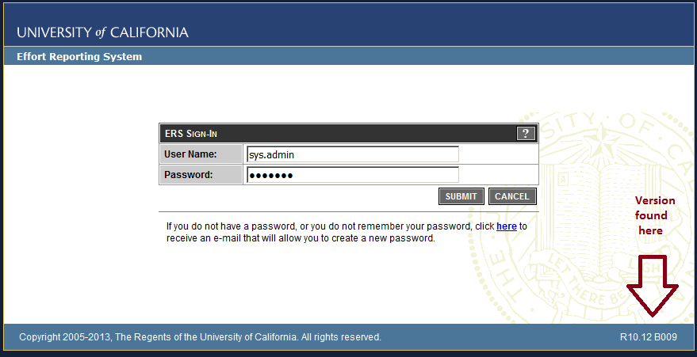

Note: To find constraints on an Oracle table (substitute correct schema name)
select * from all_constraints where r_constraint_name = 'ERSEMPL_PK' and owner=’ ERSUCD11_6’

Step 2: Employee Update from char(9) to varchar(11)

Drop constraints
ALTER TABLE ERSUser DROP CONSTRAINT ERSUser_FK;
ALTER TABLE ERSPilotParticipant DROP CONSTRAINT ERSPilotPart_FK_Emp;
ALTER TABLE ERSPossibleER DROP CONSTRAINT ERSPossibleER_FK; -- does not exist
ALTER TABLE ERSPI DROP CONSTRAINT ERSPI_FK_EMP;
ALTER TABLE ERSLatePay DROP CONSTRAINT ERSLatePay_FK; -- does not exist
ALTER TABLE ERSOrgDept DROP CONSTRAINT ERSOrgDept_FK1;
ALTER TABLE ERSLatePay_Temp DROP CONSTRAINT ERSLatePay_TEMP_FK; -- does not exist
ALTER TABLE ERSExcludeUserToken DROP CONSTRAINT ERSExcludeUserToken_FK;
ALTER TABLE ERSEarnings DROP CONSTRAINT ERSEarnings_FK;
ALTER TABLE ERSCSEmpl DROP CONSTRAINT ERSCSEmpl_FK1;
ALTER TABLE ERSCriteriaEmployee DROP CONSTRAINT ERSCriteriaEmployee_FK;
ALTER TABLE ERSEMPL DROP CONSTRAINT ERSEMPL_FK;
ALTER TABLE ERSEMPL DROP CONSTRAINT ERSEMPL_FK1; -- does not exist
ALTER TABLE ERSCRITERIAEMPLOYEE DROP CONSTRAINT ERSCRITERIAEMPLOYEE_FK1;
ALTER TABLE ERSCSEMPL DROP CONSTRAINT ERSCSEMPL_FK;
ALTER TABLE ERSEmpl DROP CONSTRAINT ERSEmpl_PK;
** Now modify ERSEmpl table
ALTER TABLE ERSEmpl ADD PPS_EMPLOYEE_ID CHAR(9);
UPDATE ERSEmpl set pps_employee_id = employee_id;

--ALTER TABLE ERSEmpl MODIFY PPS_EMPLOYEE_ID CHAR(9) NOT NULL; -- Let UCD Oracle be NULL !!!
ALTER TABLE ERSEmpl MODIFY EMP_NAME varchar(120);
ALTER TABLE ERSEmpl MODIFY EMPLOYEE_ID varchar(11) ;

** ERSEarnings and related tables
** do not run the following commented statements
--select distinct table_name, index_name from dba_ind_columns where table_owner='ERSUCD11_6' and
-- table_name='ERSEARNINGS'
-- ERSEARNINGS_IDX
-- ERSEARNINGS_UNIQUE_IDX
-- ERSEARNINGS_PK

DROP INDEX ERSEARNINGS_IDX;
DROP INDEX ERSEARNINGS_UNIQUE_IDX;
--DROP INDEX ERSEARNINGS_PK ; -- can not be dropped…. Skip statement

ALTER TABLE ERSEarnings MODIFY Employee_ID varchar(11);

-- Received error: ORA-54033: column to be modified is used in a virtual column expression
-- Virtual columns most commonly exist when Extended Statistics has been enabled for your database

-- This query identifies the ‘hidden’ columns
select table_name, column_name, data_default, hidden_column
from user_tab_cols
where table_name = 'ERSEARNINGS'

-- this query identifies the extension names (must run in SQLPLUS)
SELECT EXTENSION_NAME, EXTENSION, OWNER
FROM dba_stat_extensions
WHERE table_name='ERSEARNINGS';

-- These queries remove the extensions (must run in SQLPLUS)
exec DBMS_STATS.DROP_EXTENDED_STATS (ownname=>'ERSUCD4', tabname=>'ERSEARNINGS', extension=>'("PAY_CYCLE_END_DATE","EMPLOYEE_ID")');

exec DBMS_STATS.DROP_EXTENDED_STATS (ownname=>'ERSUCD4', tabname=>'ERSEARNINGS', extension=>'("PAY_CYCLE_END_DATE","EMPLOYEE_ID")');

CREATE INDEX ERSEARNINGS_IDX ON ERSEarnings (Employee_ID ASC, Pay_Per_End_Date ASC);

** Do not recreate index ERSEARNINGS_UNIQUE_IDX here . It will be recreated later for PAR & I-129

ALTER TABLE ERSCSEmpl DROP CONSTRAINT ERSCSEmpl_PK;
ALTER TABLE ERSCSEmpl MODIFY EMPLOYEE_ID varchar(11) ;
ALTER TABLE ERSCSEmpl ADD CONSTRAINT ERSCSEmpl_PK
PRIMARY KEY (FS_ID, Employee_ID, Start_Date);

ALTER TABLE ERSUser MODIFY EMPLOYEE_ID varchar(11);
ALTER TABLE ERSCriteriaEmployee DROP CONSTRAINT ERSCriteriaEmployee_PK;
ALTER TABLE ERSCriteriaEmployee MODIFY EMPLOYEE_ID varchar(11);
ALTER TABLE ERSCriteriaEmployee ADD CONSTRAINT ERSCriteriaEmployee_PK
PRIMARY KEY (SC_ID, Employee_ID);

ALTER TABLE ERSLatePay DROP CONSTRAINT ERSLatePay_PK;
ALTER TABLE ERSLatePay MODIFY EMPLOYEE_ID varchar(11) ;
ALTER TABLE ERSLatePay ADD CONSTRAINT ERSLatePay_PK
PRIMARY KEY(Employee_ID,Period_ID);

ALTER TABLE ERSPI DROP CONSTRAINT ERSPI_PK;
ALTER TABLE ERSPI MODIFY EMP_ID varchar(11);
ALTER TABLE ERSPI ADD CONSTRAINT ERSPI_PK PRIMARY KEY (SP_ID, Emp_ID);

ALTER TABLE ERSExcludeUserToken DROP CONSTRAINT ERSExcludeUserToken_PK;
ALTER TABLE ERSExcludeUserToken MODIFY EMPLOYEE_ID varchar(11);
ALTER TABLE ERSExcludeUserToken ADD CONSTRAINT ERSExcludeUserToken_PK
PRIMARY KEY (Employee_ID);

DROP INDEX ERS_AER_UNIQ;
ALTER TABLE ERSActualER MODIFY Employee_ID varchar(11);
CREATE UNIQUE INDEX ERS_AER_UNIQ ON ERSActualER( employee_id, period_id );

ALTER TABLE ERSIncludeEmpl DROP CONSTRAINT ERSIncludeEmpl_PK
ALTER TABLE ERSIncludeEmpl MODIFY Employee_ID varchar(11);
ALTER TABLE ERSIncludeEmpl ADD CONSTRAINT ERSIncludeEmpl_PK
PRIMARY KEY (Employee_ID);

ALTER TABLE ERSPIEmplTank DROP CONSTRAINT ERSPIEmplTank_PK;
ALTER TABLE ERSPIEmplTank MODIFY Emp_ID varchar(11);
ALTER TABLE ERSPIEmplTank ADD CONSTRAINT ERSPIEmplTank_PK
PRIMARY KEY (Project_ID, Emp_ID);

ALTER TABLE ERSPilotParticipant DROP CONSTRAINT ERSPilotPart_PK;
ALTER TABLE ERSPilotParticipant MODIFY emp_id varchar(11);
ALTER TABLE ERSPilotParticipant ADD CONSTRAINT ERSPilotPart_PK
PRIMARY KEY (period_id, Emp_ID);

ALTER TABLE ERSEmpl ADD CONSTRAINT ERSEmpl_PK PRIMARY KEY(Employee_ID);
ALTER TABLE ERSCSEmpl ADD CONSTRAINT ERSCSEmpl_fk_emp;
FOREIGN KEY (Employee_ID) REFERENCES ERSEmpl (Employee_ID);
ALTER TABLE ERSCriteriaEmployee ADD CONSTRAINT ERS_CE_FK_EMP
FOREIGN KEY (Employee_ID) REFERENCES ERSEmpl (Employee_ID);

ALTER TABLE ERSLatePay ADD CONSTRAINT ERSLatePay_FK
FOREIGN KEY (Employee_ID) REFERENCES ERSEmpl (Employee_ID);
ALTER TABLE ERSExcludeUserToken ADD CONSTRAINT ERS_EUTOKEN_FK_EMP
FOREIGN KEY (EMPLOYEE_ID) REFERENCES ERSEmpl (Employee_ID);
ALTER TABLE ERSPilotParticipant ADD CONSTRAINT ERSPilotPart_FK_E
FOREIGN KEY (EMP_ID) REFERENCES ERSEmpl (Employee_ID);
ALTER TABLE ERSPI ADD CONSTRAINT ERSPI_FK_EMP FOREIGN KEY (EMP_ID)
REFERENCES ERSEmpl (Employee_ID);
ALTER TABLE ERSUser ADD CONSTRAINT ERSUser_fk_emp
FOREIGN KEY (Employee_ID) REFERENCES ERSEmpl (Employee_ID);
ALTER TABLE ERSEarnings ADD CONSTRAINT ERSEarn_FK_emp
FOREIGN KEY (Employee_ID) REFERENCES ERSEmpl (Employee_ID);

Step3: Supplemental Employee Updates
DROP INDEX ersar_eid;
ALTER TABLE ERSArchivedReport MODIFY EMP_ID varchar(11);
ALTER TABLE ERSArchivedReport MODIFY EMP_NAME varchar(120);
CREATE INDEX ersar_eid ON ERSArchivedReport( emp_id );

Step 4: Clean Employee IDs
update ersempl set employee_id=ltrim(employee_id);
update ersempl set employee_id=rtrim(employee_id);

Step 5: Home Department Updates
Home Department Update char(6) to varchar(10)

ALTER TABLE ERSCriteriaHomeDepartment DROP CONSTRAINT ERSCriteriaHomeDepartment_PK;
ALTER TABLE ERSCriteriaHomeDepartment DROP CONSTRAINT ERSCriteriaHomeDepartment_FK;
ALTER TABLE ERSCriteriaHomeDepartment DROP CONSTRAINT ERSCriteriaHomeDepartment_FK1;

ALTER TABLE ERSOrgDept DROP CONSTRAINT ERSOrgDept_PK;
ALTER TABLE ERSOrgDept DROP CONSTRAINT ERSOrgDept_FK;
ALTER TABLE ERSOrgDept DROP CONSTRAINT ERSOrgDept_FK1 -- Already removed in Step2

ALTER TABLE ERSHOMEDEPT DROP CONSTRAINT ERSHomeDept_PK;
ALTER TABLE ERSHOMEDEPT MODIFY DEPT_ID varchar(10);
ALTER TABLE ERSHOMEDEPT ADD CONSTRAINT ERSHomeDept_PK PRIMARY KEY(DEPT_ID);

ALTER TABLE ERSEmpl MODIFY DEPT_ID varchar(10);

ALTER TABLE ERSEmpl ADD CONSTRAINT ERSEmpl_FK
FOREIGN KEY(Dept_ID) REFERENCES ERSHomeDept (Dept_ID);

ALTER TABLE ERSEmpl ADD CONSTRAINT ERSEmpl_FK1
FOREIGN KEY(Sch_CD) REFERENCES ERSSchType (Sch_CD);

ALTER TABLE ERSOrgDept MODIFY DEPT_ID varchar(10) ;

ALTER TABLE ERSOrgDept ADD CONSTRAINT ERSOrgDept_PK
PRIMARY KEY(Org_CD, Dept_ID);

ALTER TABLE ERSOrgDept ADD CONSTRAINT ERSOrgDept_FK
FOREIGN KEY(Org_CD) REFERENCES ERSOrganization (Org_CD);

ALTER TABLE ERSOrgDept ADD CONSTRAINT ERSOrgDept_FK1
FOREIGN KEY(Dept_ID) REFERENCES ERSHomeDept(Dept_ID);
Step 5 (continued): Home Department Updates

ALTER TABLE ERSCriteriaHomeDepartment MODIFY DEPT_ID varchar(10);
ALTER TABLE ERSSchDept DROP CONSTRAINT ERSSchDept_PK ;
ALTER TABLE ERSSchDept MODIFY DEPT_ID varchar(10);

ALTER TABLE ERSSchDept ADD CONSTRAINT ERSSchDept_PK
PRIMARY KEY (Sch_CD, Dept_ID);

ALTER TABLE ERSCriteriaHomeDepartment MODIFY DEPT_ID varchar(10);

ALTER TABLE ERSCriteriaHomeDepartment ADD CONSTRAINT ERSCriteriaHomeDepartment_PK
PRIMARY KEY (SC_ID, Dept_ID);

ALTER TABLE ERSCriteriaHomeDepartment
ADD CONSTRAINT ERSCriteriaHomeDepartment_FK FOREIGN KEY(Dept_ID)
REFERENCES ERSHomeDept (Dept_ID);

ALTER TABLE ERSCriteriaHomeDepartment ADD CONSTRAINT
ERSCriteriaHomeDepartment_FK1 FOREIGN KEY(SC_ID)
REFERENCES ERSCriteriaMaster (SC_ID);

UPDATE ERSHOMEDEPT set DEPT_ID=ltrim(DEPT_ID);
UPDATE ERSHOMEDEPT set DEPT_ID=rtrim(DEPT_ID) ; -- statement failed, constraint violation, continue….

Step 6: Add new Labor Ledger columns to ERSEARNINGS table.

alter table ersearnings add Run_Id varchar(10) ;
alter table ersearnings add Empl_Rcd integer;
alter table ersearnings add Eff_Date timestamp ;
alter table ersearnings add Eff_Seq integer;
alter table ersearnings add Off_Cycle varchar(1);
alter table ersearnings add Run_Id_Earn varchar(10) ;
alter table ersearnings add Addl_Seq varchar(10);
alter table ersearnings add Journal_Id varchar(10);
alter table ersearnings add Journal_Line varchar(10);
alter table ersearnings add Journal_Line_Ref varchar(10);
alter table ersearnings add Business_Unit varchar(5);
alter table ersearnings add Pay_Cat varchar(2);
alter table ersearnings add Time_Code varchar(2);
alter table ersearnings add Restatement varchar(1);
alter table ersearnings add Interface varchar(1);

Alter TABLE ERSEARNINGS MODIFY DOS_TIME_CODE varchar(2);
Alter TABLE ERSEARNINGS MODIFY DOS_PAY_CATEGORY varchar(2);
Alter TABLE ERSEARNINGS MODIFY TITLE_CODE varchar(6)

Step 6 (continued): Add new Labor Ledger (I-129) columns to ERSEARNINGS table.

-- Initialize restatement and interface columns
-- perform the following update one year at a time (otherwise transaction log will fill and query will fail)

update ersearnings set restatement='N', interface='P' where extract(year from Pay_Cycle_End_Date) = 2003;
update ersearnings set restatement='N', interface='P' where extract(year from Pay_Cycle_End_Date) = 2004;
update ersearnings set restatement='N', interface='P' where extract(year from Pay_Cycle_End_Date) = 2005;
update ersearnings set restatement='N', interface='P' where extract(year from Pay_Cycle_End_Date) = 2006;
update ersearnings set restatement='N', interface='P' where extract(year from Pay_Cycle_End_Date) = 2007;
update ersearnings set restatement='N', interface='P' where extract(year from Pay_Cycle_End_Date) = 2008;
update ersearnings set restatement='N', interface='P' where extract(year from Pay_Cycle_End_Date) = 2009;
update ersearnings set restatement='N', interface='P' where extract(year from Pay_Cycle_End_Date) = 2010;
update ersearnings set restatement='N', interface='P' where extract(year from Pay_Cycle_End_Date) = 2011;
update ersearnings set restatement='N', interface='P' where extract(year from Pay_Cycle_End_Date) = 2012;
update ersearnings set restatement='N', interface='P' where extract(year from Pay_Cycle_End_Date) = 2013;
update ersearnings set restatement='N', interface='P' where extract(year from Pay_Cycle_End_Date) = 2014;
update ersearnings set restatement='N', interface='P' where extract(year from Pay_Cycle_End_Date) = 2015;
update ersearnings set restatement='N', interface='P' where extract(year from Pay_Cycle_End_Date) = 2016;
update ersearnings set restatement='N', interface='P' where extract(year from Pay_Cycle_End_Date) = 2017;
update ersearnings set restatement='N', interface='P' where extract(year from Pay_Cycle_End_Date) > 2018;
update ersearnings set restatement='N', interface='P' where extract(year from Pay_Cycle_End_Date) > 2019;
update ersearnings set restatement='N', interface='P' where extract(year from Pay_Cycle_End_Date) > 2020;
update ersearnings set restatement='N', interface='P' where interface is null;

update ersearnings set restatement='N', interface='P' where interface is null;
update ersearnings set restatement='N', interface='P' where interface <>'P'

Step 6B: Set database version to 11.0

update ersversion set version_id='11.0';

Step 7A: UCD does not use OFF QTR reporting and ERSDosCode table is empty.

Skip this step

Step 7B: Build ERSEarnings duplicate earning check for both PAR and I-129 earnings
Create Unique PAR Earnings and I-129 Earnings unique indexes for duplicate earning check

I-129 `
DROP INDEX ERSEarnings. ERS_EARNINGS_I129_UNIQUE; -- ignore if not exists

CREATE INDEX
ERS_EARNINGS_I129_UNIQUE ON ERSEARNINGS(
Interface, Empl_Rcd, Eff_date, Eff_Seq, Run_Id, Run_Id_Earn, Business_Unit,
Off_Cycle, Dist_Dos, Journal_Id, Journal_Line, Journal_Line_Ref, Addl_Seq);

** note that the UNIQUE keyword has been purposely omitted to eliminate potential problems with historical earning uniqueness

PAR
DROP INDEX ERSEarnings. ERS_EARNINGS_PAR_UNIQUE -- ignore if not exists

CREATE INDEX
ERS_EARNINGS_PAR_UNIQUE ON ERSEARNINGS(
Interface, Pay_Cycle_End_Date, Pay_Cycle_Code, Record_Type, Pri_Gross_Ctl, Entry_Seq_No);

** Note: The UNIQUE keyword purposely omitted to eliminate potential problems with historical earning uniqueness

Larry testing – ran out of tablespace….
SELECT * From DBA_DATA_FILES;
Alter tablespace USERS add datafile ‘D:\APP\ORACLE\ORADATA\ORAERS\UCD_Tablespace4.DBF’ size 2000M autoextend on;
Step 8A : Expand ERSEarnings Paid_Amount, Paid_Hours, and Pay_Rate columns

ALTER TABLE ERSEarnings MODIFY Paid_Hours decimal(6,2) NOT NULL;
ALTER TABLE ERSEarnings MODIFY Paid_Amount decimal(12,2) NOT NULL;
ALTER TABLE ERSEarnings MODIFY Pay_Rate decimal(14,4) NOT NULL;

Step 8B: Create six digit UCPATH Department ID’s in ERS Scheduler.

Skip this step. Does not apply to UCD.

Step 8C: Add Non-Academic Appointment Indicators (3,B,C)

insert into ERSPersPgmCode values('3',’2’, sysdate, 'sys.admin', sysdate , 'sys.admin') ;
insert into ERSPersPgmCode values('B', '2', sysdate, 'sys.admin', sysdate , 'sys.admin') ;
insert into ERSPersPgmCode values('C', '2', sysdate , 'sys.admin', sysdate , 'sys.admin');

** Notice column1 & colum2 are flipped from UCD and UCLA

Step 8D: Update Journal_Line_Ref for I-129 records (set to “PAYROLL”)

update ERSEarnings set Journal_Line_Ref ='PAYROLL' where interface='L';

Step 8E: Add ‘Over The Cap’ to ERSEarnings table.

alter table ERSEarnings add Over_The_Cap varchar(10);
alter table ersearnings add Cap_Rate Decimal (14, 4) NULL;

update ersearnings set cap_rate=0 where cap_rate is NULL ;

Step 8F: ERSDOSCODE table and ERSPAYCAT table are now indexed using ‘Interface’
(same codes in PPS and I-129 are used, but identify ‘Effort’ differently)

There appears to be an INDEX and PRIMARY KEY called ERSTIMECODE_PK.
An Oracle ‘catch 22’ would not allow deleting either the index or primary key, citing existence of the other.
The easiest solution is dropping the table and recreating it ….

ERSTimeCode before dropping table.
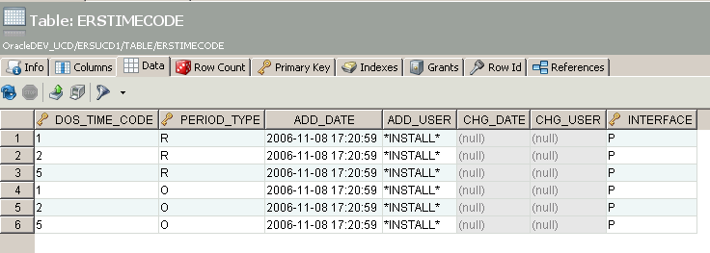

DROP TABLE ERSTimeCode

CREATE TABLE ERSTIMECODE
(
DOS_TIME_CODE CHAR(1 BYTE) NOT NULL,
PERIOD_TYPE CHAR(1 BYTE) NOT NULL,
ADD_DATE DATE NOT NULL,
ADD_USER VARCHAR2(60 BYTE) NOT NULL,
CHG_DATE DATE,
CHG_USER VARCHAR2(60 BYTE)
)

INSERT INTO ERSTimeCode(DOS_Time_Code, Period_Type, Add_Date, Add_User) VALUES('1', 'R', sysdate, '*INSTALL*');
INSERT INTO ERSTimeCode(DOS_Time_Code, Period_Type, Add_Date, Add_User) VALUES('2', 'R', sysdate, '*INSTALL*');
INSERT INTO ERSTimeCode(DOS_Time_Code, Period_Type, Add_Date, Add_User) VALUES('5', 'R', sysdate, '*INSTALL*');
INSERT INTO ERSTimeCode(DOS_Time_Code, Period_Type, Add_Date, Add_User) VALUES('1', 'O', sysdate, '*INSTALL*');
INSERT INTO ERSTimeCode(DOS_Time_Code, Period_Type, Add_Date, Add_User) VALUES('2', 'O', sysdate, '*INSTALL*');
INSERT INTO ERSTimeCode(DOS_Time_Code, Period_Type, Add_Date, Add_User) VALUES('5', 'O', sysdate, '*INSTALL*');

Step 8F (cont):

** Now that ERSTIMECODE table is recreated, perform ERS 11.0 enhancements

ALTER TABLE ERSTIMECODE add Interface varchar(1);

UPDATE ERSTimeCode set interface = 'P';

ALTER TABLE ERSTimeCode ADD CONSTRAINT ERSTimeCode_PK
PRIMARY KEY (DOS_Time_Code, Period_Type, Interface);

insert into ERSTimeCode values ('1','O',sysdate,'*R11*',null,null,'L');
insert into ERSTimeCode values ('2','O',sysdate,'*R11*',null,null,'L');
insert into ERSTimeCode values ('5','O',sysdate,'*R11*',null,null,'L');
insert into ERSTimeCode values ('1','R',sysdate,'*R11*',null,null,'L');
insert into ERSTimeCode values ('2','R',sysdate,'*R11*',null,null,'L');
insert into ERSTimeCode values ('5','R',sysdate,'*R11*',null,null,'L');

Step 8GI:

Now perform same enhancement to ERSPayCat, (drop table and recreate table).

ERSPayCat before enhancement
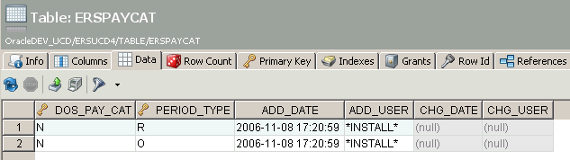

DROP TABLE ERSPaycat

CREATE TABLE ERSPAYCAT
(
DOS_PAY_CAT CHAR(1 BYTE) NOT NULL,
PERIOD_TYPE CHAR(1 BYTE) NOT NULL,
ADD_DATE DATE NOT NULL,
ADD_USER VARCHAR2(60 BYTE) NOT NULL,
CHG_DATE DATE,
CHG_USER VARCHAR2(60 BYTE)
)

INSERT INTO ERSPayCat(DOS_Pay_Cat, Period_Type, Add_Date, Add_User) VALUES('N', 'R', sysdate, '*INSTALL*');
INSERT INTO ERSPayCat(DOS_Pay_Cat, Period_Type, Add_Date, Add_User) VALUES('N', 'O', sysdate, '*INSTALL*');

Step 8G (cont):

** Now that ERSPAYCAT table is recreated, perform ERS 11.0 enhancements

ALTER TABLE ERSPAYCAT add Interface varchar(1);

Update ERSPayCat set interface = 'P';

ALTER TABLE ERSPayCat MODIFY Interface Varchar(1) NOT NULL;

ALTER TABLE ERSPayCat ADD CONSTRAINT ERSPayCat_PK
PRIMARY KEY (DOS_Pay_Cat, Period_Type, Interface);

insert into ERSPayCat values ('1','R',sysdate,'*R11*',null,null,'L');
insert into ERSPayCat values ('1','O',sysdate,'*R11*',null,null,'L');
insert into ERSPayCat values ('2','R',sysdate,'*R11*',null,null,'L');
insert into ERSPayCat values ('2','O',sysdate,'*R11*',null,null,'L');

Step 9: Set ERS sys.admin password allowing user to login to ERS

SKIP THIS STEP AT UCD (database sys.admin profile is already set properly at UCD)

update ERSUser set email_addr='lscott@ucop.edu' where user_id = 'sys.admin'

Go to ERS Login screen and select ‘password reset’ hyperlink

Step 10: WAR file deployment - Set ERS hibernate config file to point to UCD ERS 11.0 database
This is only a reminder….

* Larry will do this for you at UCOP

Step 10: Archive Migration from DTO format to PDF format
This code is can be found in ERS 10.12 B010
ERS 10.12 B010 Archive PDF format eliminates archived data compatibility issues with java classes.
The ERS 10.12 Bxxx archives are not compatible with ERS 11.0.

ERS 10.12 Bxxx stores archive information in a DTO (data) format
ERS 11.0 now stores archive information in a PDF format
The ERS 10.12 B010 archive migration program is RunArchiveReportMigation10to11.java
The ERS Archive tables are ERSARCHIVEDREPORT and ERSARCHIVEDFS.
All archive data is contained in ERSARCHIVEDREPORT and ERSARCHIVEDFS

Prerequisite
ERS 10.12 B010 added column ‘archive_date’ to table ERSArchivedReport .
If this column does not exist in your table, run the following sql

ALTER TABLE ERSARCHIVEDREPORT add archive_date date default null;

UPDATE ERSARCHIVEDREPORT SET archive_date = TO_DATE('12/31/2013', 'MM/DD/YYYY');

Please make long term backup of ERSARCHIVEDREPORT and ERSARCHIVEDFS before starting this process
If there are any migration issues, these backups may be needed to recover.

Suggested Process:
Migration may be performed in a non-production environment to minimize ERS production downtime.
Archive migration may run for many hours

10.1: Load the ERS 10.12 Bxxx war file to your QA environment

10.2: Copy your production ERS database to your QA environment

10.3: Verify your QA ERS database connection and ERS code (ERS signon screen display version 10.12 Bxxx)

10.4: Run the migration program
In the QA environment, run ERS batch program RunArchiveReportMigation10to11.java
It is necessary to set your ERS config directory in the classpath (shown in screenshot below)
Do not run the migration in Spring debug mode. Migration will crash with out of memory issues.

It is also necessary to pass three parameters to the archive migration process.
1: The path to the ERS Jasper report objects (red underline) . Explode your ers.war file to a temp directory
2: The path to your ExternalizedString.xml file (blue underline)
3: The batch size to process = number of archives rows to process in batch run (not database commit size)

Notes
The ‘batch size’ parameter keeps the archive process from consuming too much memory and crashing.
A good starting point is 10000. For 100K archives, run the archive migration process 10 times.
The database commit size is 50 rows. After processing 50 rows, the rows are committed to the database.

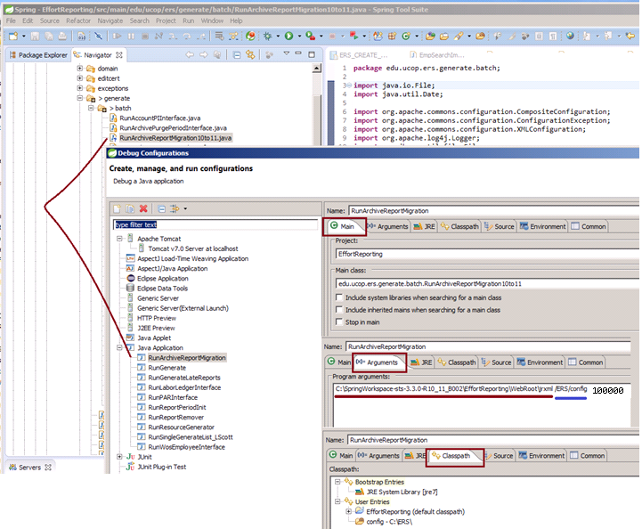

10.5: Replace production DTO archives with QA PDF Archives

Copy / replace the QA ERSARCHIVEDREPORTand ERSARCHIVEDFS tables to production.
Use copy / replace to keep the production indexes intact.

Required order:
1: delete contents of production ERSARCHIVEDFS
2: delete contents of production ERSARCHIVEDREPORT
3: copy ERSARCHIVEDREPORT from QA to PROD
4: copy ERSARCHIVEDFS from QA to PROD

Archive migration program execution comments
The migration program can easily consume all memory on your server causing the process to crash.
To prevent ‘out-of-memory errors’, the migration program processes 100,000 archived effort reports at a time and then stops to releases memory. The migration process commits updates in 5000 archive increments.

As the archive migration run, the DTO pdf is read from table ERSAarchivedReport and converted to PDF (using the JasperReport objects and the campuses customizations in ErternalizedStrings.xml). Once the PDF is built, the DTO in ERSArchivedReports is overlaid with the PDF . The same process is used for the archive payroll report. The process continues until all ERSArchivedReport rows are processed or 100,000 rows are processed.

Larger campuses may have millions of rows in the ERSArchivedReport table, making it necessary to run the migration process 10+ times. Each iteration of the migration process will likely take a few days.

Run this SQL:
select year(archived_date) , count(*) from ERSARCHIVEDREPORT group by year(archived_date)
If you see any archive dates < 2018, run the process again (assumes migration run in 2018)
Once all archive dates < 2018 are cleared, the ERS Archive Migration is complete.

Performance:
When this process was run for UCSB in QA (Jan 2018), it took 15 hours to migrate 100,000 archived effort reports.

Step 11: Closing comments
It is highly recommended that you long term archive a copy of the ERS 10.12 production database
If any issues arise after the UCPATH implementation, it may be necessary to load the ERS 10.12 system in a QA environment to retrieve or repair ERS data.

Done with ERS 11.0 Upgrade !
Appendix 1:

Handy Oracle commands
To find table keys, constraints, and indexes (notice table names are case sensitive)

select * from user_constraints where table_name='ERSEMPL'

select distinct constraint_type from user_constraints where table_name ='ERSEMPL';

R = Referential Constraint/Foreign Key constraint
C = Check Constraint
P = Primary Key
U = Unique Key

select table_name, index_name from dba_ind_columns where table_owner='ERSUCD1' order by Table_Name

select * from user_constraints where table_name ='ERSTIMECODE' -- and OWNER='ERSUCD1'

-- There might be more than one object with the same name making drop statement say ‘object does not exist’
select * from dba_objects where object_name = 'ERS_AER_UNIQ'

** REMEMBER THAT PARAMETERS MAY BE UPPER CASE

